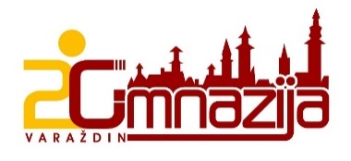  

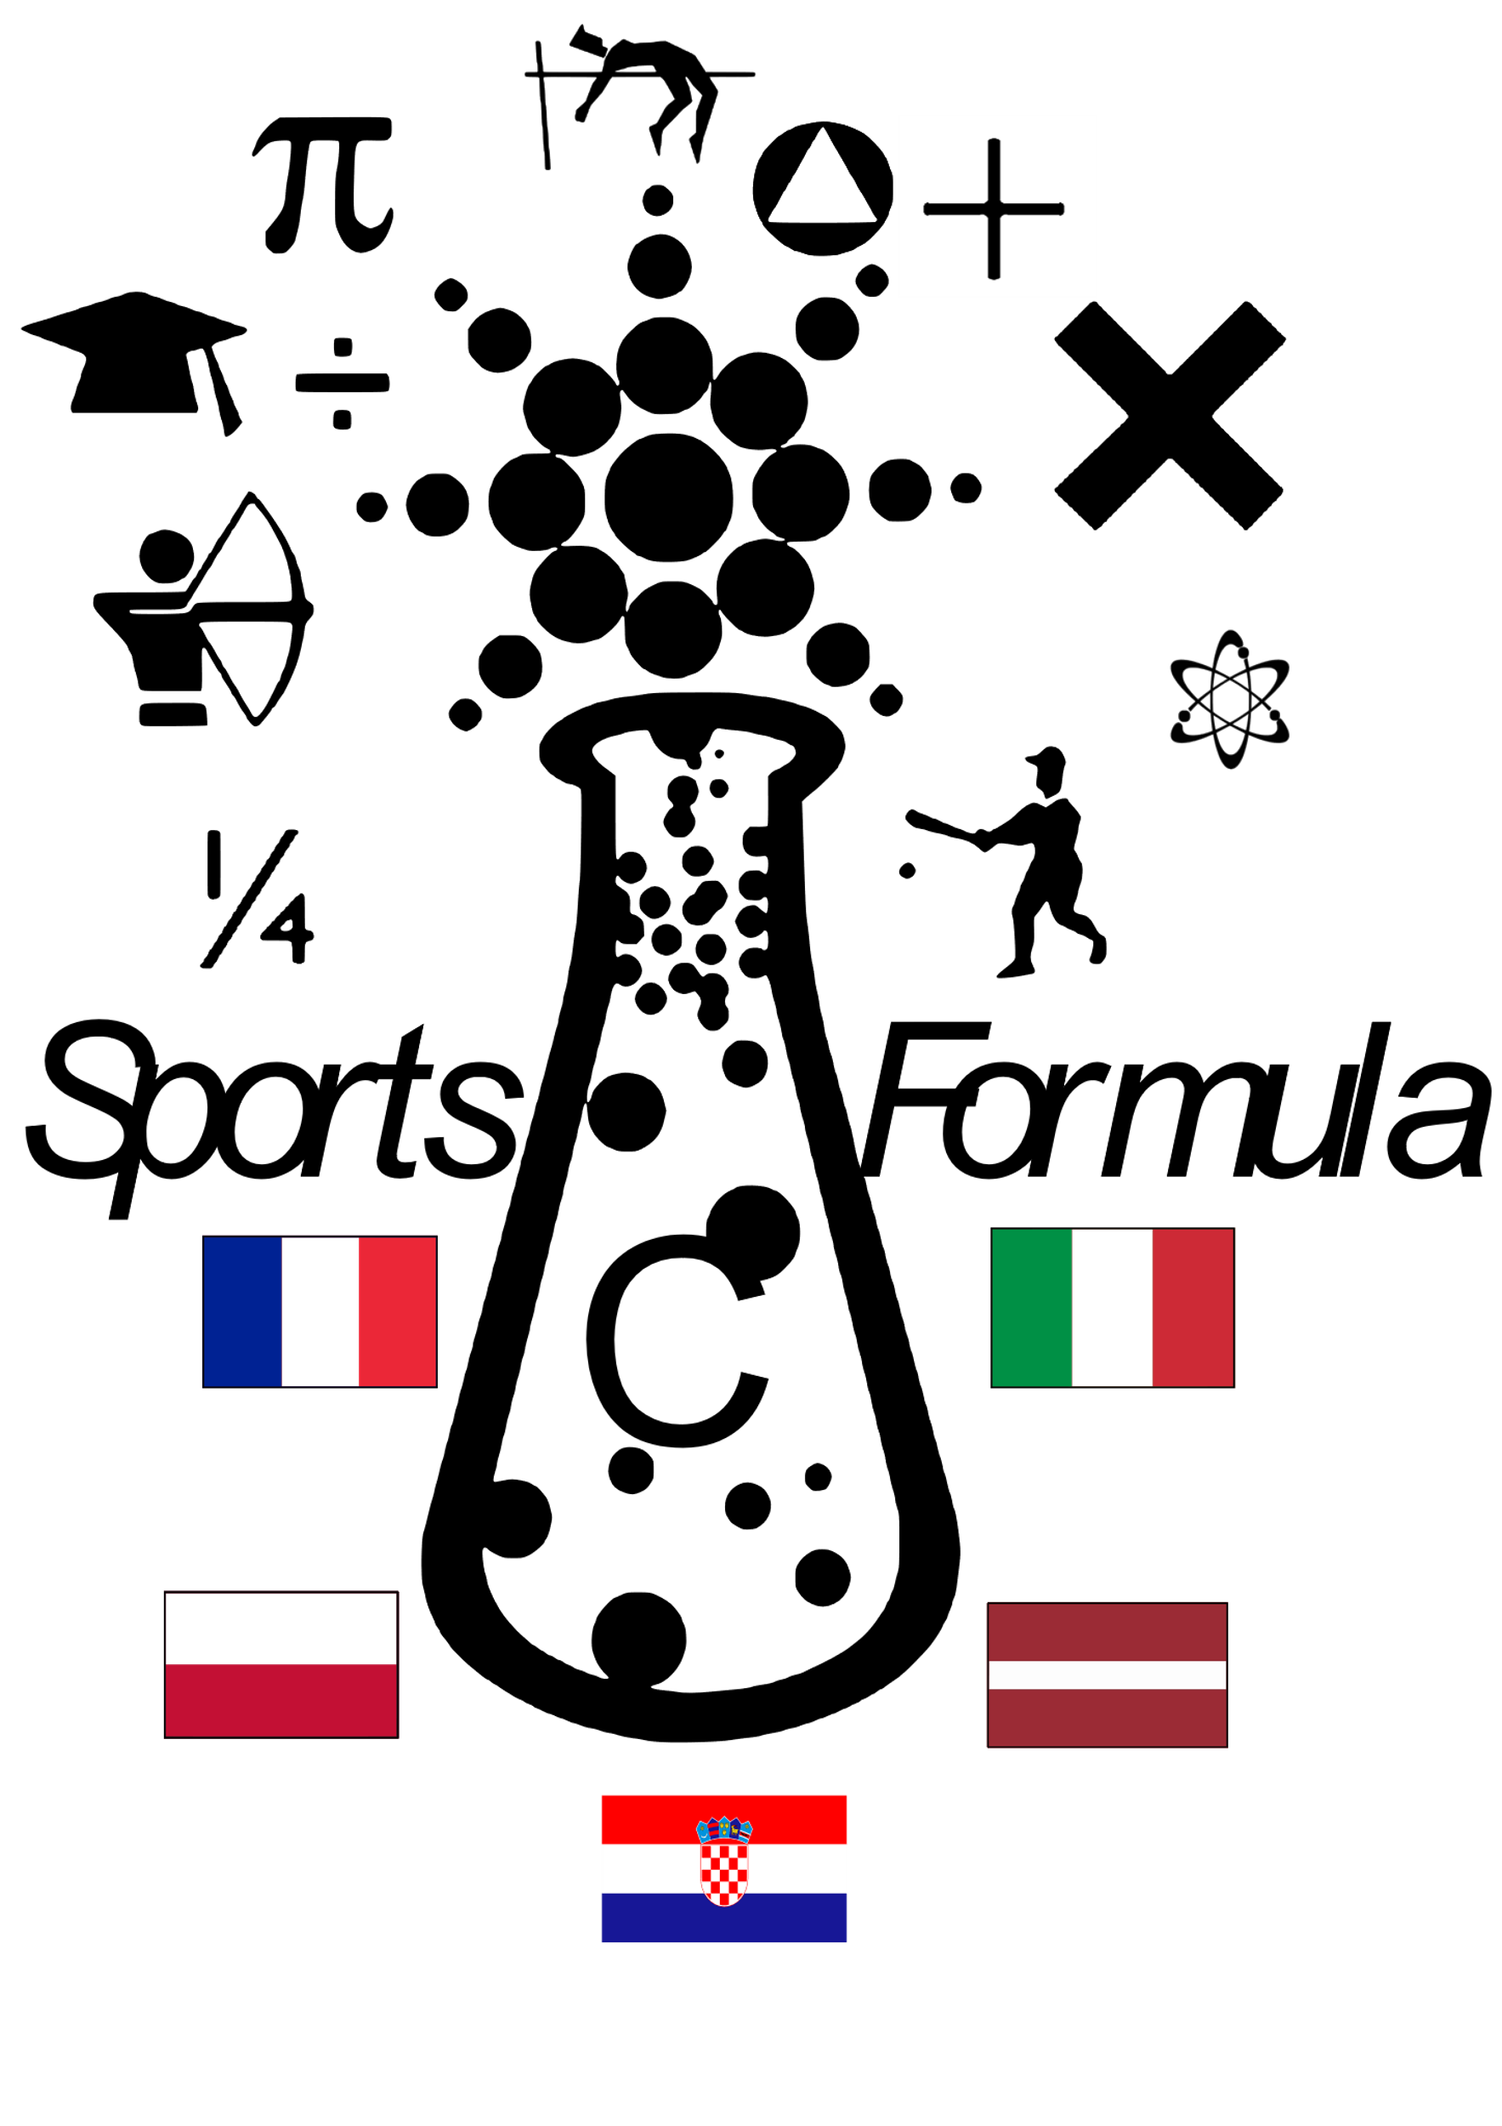

**DIARY OF THE PROJECT WEEK**

**February 4 – 10, 2018, Varaždin, Croatia**

**Partners:**

**Jelgavas 4. Vidusskola**

**Lycée agricole Xavier Bernard**

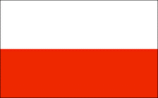**Zespół Szkół Elektronicznych i Licealnych**

**Liceo Scientifico Statale "Edoardo Amaldi"**

**Participants**

|  |  |  |
| --- | --- | --- |
| **TEACHERS** | | |
| **FRANCE** | Nolwenn Ballet  Patricia Baudiffier | |
| **POLAND** | Dariusz Rudzki  Sylwia Chmiel | |
| **ITALY** | Teresa Nani  Manuela Suardi | |
| **LATVIA** | Aina Pitrāne  Līga Nevlana  Elizabete Pavlovska | |
| **CROATIA** | Marijana Horvat  Vlatka Drvarić  Mihaela Habunek  Silva Čubrilo  Danka Jelenčić | |
| **STUDENTS** | | |
| **FRANCE** | Lilou | Durousseau |
| Léa | Garcia |
| Lisa | Martinez |
| Léane | Moreau |
| Julie | Prouteau |
| **POLAND** | Mateusz | Kras |
| Mateusz | Witas |
| Jeremi | Lipiec |
| Kacper | Kołodziej |
| Wojciech | Nadzikiewicz |
| **ITALY** | Teresa | Quadri |
| Marcello | Mangili |
| Nicholas | Cortinovis |
| Simona | Signori |
| Olaf | Pertile |
| Marta | Locatelli |
| Letizia | Bombardieri |
| Denise | Fumagalli |
| **LATVIA** | Marta Emīlija | Kļavkalne |
| Daniela | Gelvere |
| Ņikita | Puķe |
| Artis | Ozols |
| **CROATIA** | Marta | Vincek |
| Nera | Žimbrek |
| Maja | Vučković |
| Veronika | Koprek |
| Ivana | Labaš |
| Elena | Kovaček |
| Alan | Boršćak |
| Lara | Farkaš Višontai |
| Magdalena | Kos |
| Magdalena | Matoc |
| Ivona | Hrastić |
| Elena | Tuđan |
| Katarina | Martinec |
| Vilim | Pagon |
| Daria | Štriga |
| Luna | Labaš |
| Helena | Lalić |
| Martina | Klepač |
| Ana | Rogina |
| Patrik | Mežnarić |
| Iva | Ivanagić |
| Marta | Vincek |
| Nera | Žimbrek |
| Maja | Vučković |
| Veronika | Koprek |
| Ivana | Labaš |
| Elena | Kovaček |

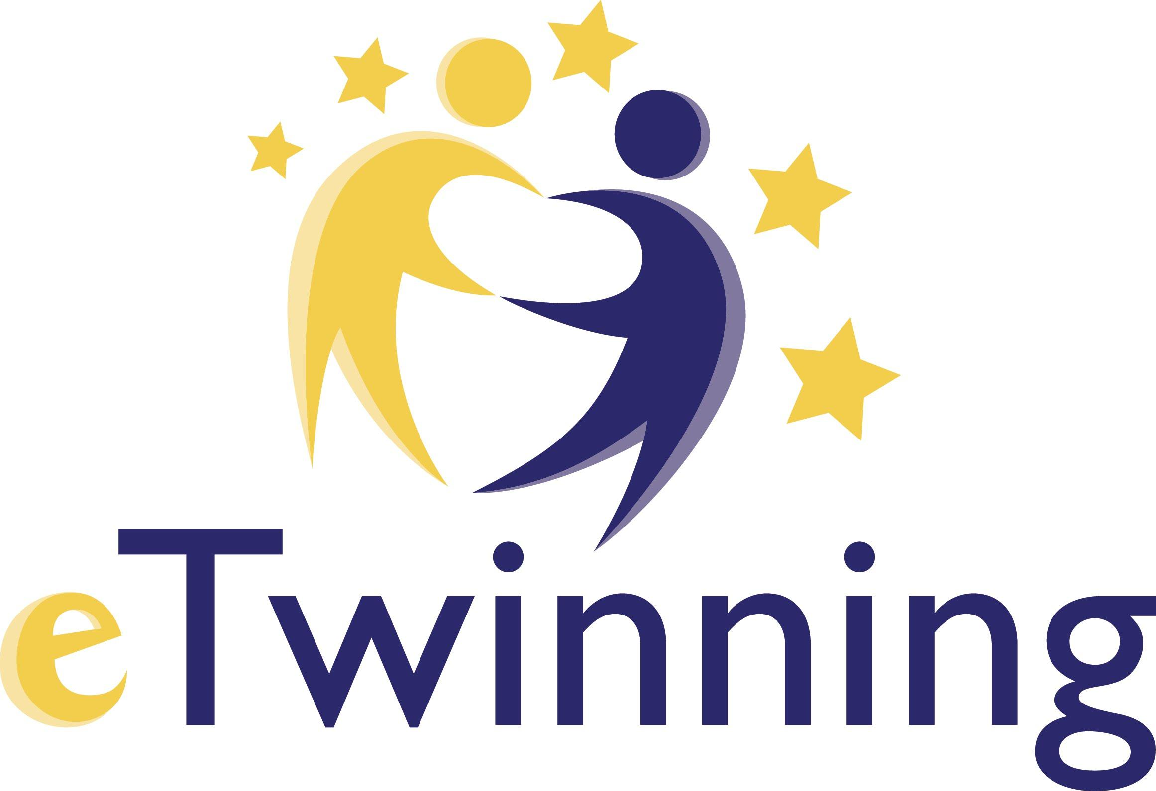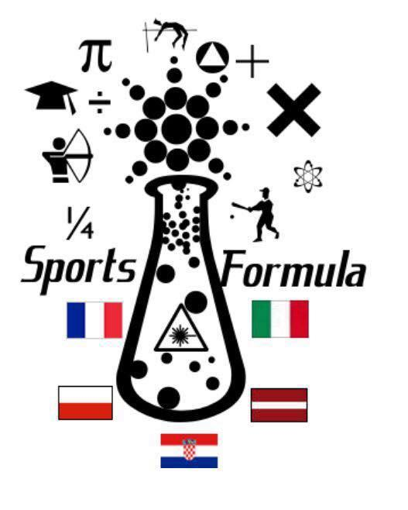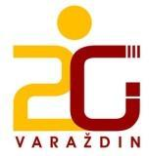

**4-10 February 2018**

**Erasmus+ SPORTS FORMULA**

**MEETING PROGRAM**

|  |  |
| --- | --- |
| **SUNDAY** | Meeting guests in Zagreb (airport) and Varaždin (Italy) |

|  |  |  |
| --- | --- | --- |
| **MONDAY** | **STUDENTS** | **TEACHERS** |
| 8:30 | Meeting at school | |
| 8:30-9:00 | Official welcome and introduction of the teams (room 37) | |
| 9:00-9:55 | Workshop **Get to know each other** (37) | Meeting (room 13) |
| 9:55-10:15 | Coffee break | |
| 10:15-12:40 | Presentation of the homework | |
| 12:40 - 14:00 | Lunch (“Učenički dom”) - all students and teachers | |
| 14:00 - 16:00 | City orientation | Varaždin - Guided tour |
| after 16:00 | Students at their host families | Free time |
|  |  |  |
| **TUESDAY** | **STUDENTS** | **TEACHERS** |
| 7:30 - 9:05 | Group work - creating tasks for e-book |  |
|  |
| 9:10 - 9:55 | Group work - creating tasks for e-book | **Mario Slatki: My healthy nutrition** (13) |
|  |
| 9:55 - 10:15 | coffee break | |
| 10:15 - 11:00 | **D. Jelenčić: Who did it?** - workshop group1 (37), group2 - attending classes | **Meeting** |
| 11:05-11:50 | **D. Jelenčić: Who did it?** - workshop group2 (37), group1 - attending classes |  |
| 11:50-12:40 | **Italian students + acc. (room 22)**  **French students + acc. (room 3)**  **Latvian and Polish students + acc. (30)** | Teachers can visit lessons |
|  |
|  |
| 12:40 - 13:30 | Lunch | |
| 13:30-15:00 | Activities in the gym - dance | |
| 15:00 | Free time | Education |
| 17:00 |  | Erasmus visit - Novi Marof |

|  |  |  |
| --- | --- | --- |
| **WEDNESDAY** | **STUDENTS** | **TEACHERS** |
| 7:30 | Bus trip to Zagreb | |
| 9:15-11:15 | Guided tour in English | |
| 11:15-14:15 | Free time | |
| 14:30 -17:15 | **Escape room** - two groups/ **Tesla: Mind from the future** (not mandatory) | |
| 17:30 | Return to Varaždin | |
|  |  |  |
| **THURSDAY** | **STUDENTS** | **TEACHERS** |
| 7:30 - 9:05 | Students prepare presentations about tasks for e-book |  |
| 9:10-9:55 | **Workshop - Mario Slatki:**  **Healthy sports nutrition formula** (37) | Working on e-book (13) |
| 9:55-10:15 | Coffee break | |
| 10:15-11:00 | **Workshop** - **Terezija Mlinarić**  **Amazing maze of art** (37) | **Education**  **"Data analysis using R"** |
| 11:05-11:50 | Students prepare presentations about tasks for e-book |
| 11:50 –13:30 | Presentations of students work |
| 13:30- 14:15 | Lunch |
| 14:15 - 15:00 | Lunch |
| 15:00-17:00 | “Stari grad” museum + making a video | free time / “Stari grad” museum |
| 18:30 |  | Dinner – “Palatin” |
|  |  |  |
| **FRIDAY** | **STUDENTS** | **TEACHERS** |
| 7:30-8:15 | Students attending classes |  |
| 8:15-9:05 | Students prepare a survey on motivation to learn science subject | **M. Habunek & S. Kelemen Sound & Taste** |
| 9:10-9:55 | Group work: Discussion about e-book and developing ideas | Future plans |
|  | Coffee break | |
| 10:15 – 11:00 | Certificates + a short programme + video | |
| 11:00 - 12:40 | **Mihaela Habunek: Quiz** | |
| 12:40 - 14:00 | Lunch - just students | |
| 16:00-18:00 | Free time | Education for teachers |

|  |  |
| --- | --- |
| **SATURDAY** | **Departure day** |

**Description of the project week in Croatia**

As a part of Erasmus+ Sports Formula project, short-term exchange of pupils and short-term joint staff training event were held in Varaždin, Croatia in February 2018 over the period of five days.

After welcoming the guests from participating countries, Latvia, Italy, France and Poland on Sunday, it was time to follow the official meeting plan.

On Monday all the participants gathered at Druga gimnazija Varaždin where they were officially welcomed by the project coordinator from Croatia who presented the weekly plan and the teams from all the countries introduced themselves. At 9 o'clock the pupils participated in the workshop *Get to know each other* with the aim to discover what they have in common, while the teachers had a meeting in order to discuss what had been done until that moment and what activities need to be done in order to successfully complete the project. After a coffee break, the pupils presented their homework to the teachers. It included presenting different sports and their progress with the e-book for students. The afternoon was dedicated to learning about Varaždin, its cultural heritage, customs and history. The teachers went on a guided tour in English, while the pupils did various orientation tasks to get acquainted with the town in a creative and fun way.

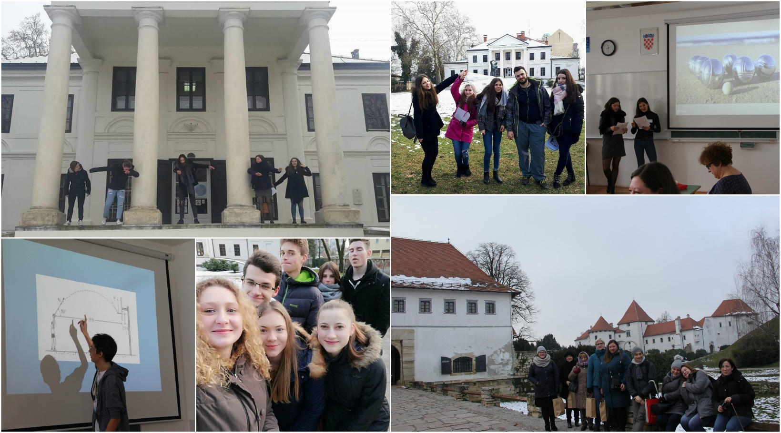

On Tuesday the pupils created tasks for e-book, which is one of the outputs of the project, in international teams. The teachers attended the workshop *My healthy nutrition* held by Mario Slatki, a biology teacher from Druga gimnazija Varaždin. After a short break the pupils attended *Who did it?*, a problem solving workshop held by maths teacher Danka Jelenčić. This entertaining workshop demanded from the participants to employ their maths and detective skills in order to solve a murder. Since the number of the participants was limited, the workshop was held in two smaller groups. While one group attended the workshop, the other visited school lessons with their hosts and vice versa. Visiting the lessons was a way to learn more about Croatian education system first-hand. Italian and French students also attended Italian and French lessons since pupils in Druga gimnazija Varaždin can learn these languages as foreign languages. Meanwhile the teachers had a meeting where they discussed the e-book, intellectual output of the project done by the teachers. In the afternoon the students attended dance lessons at the gym. In the evening the teachers went to Novi Marof where they attended a presentation of another Erasmus+ project done by primary school Podrute.

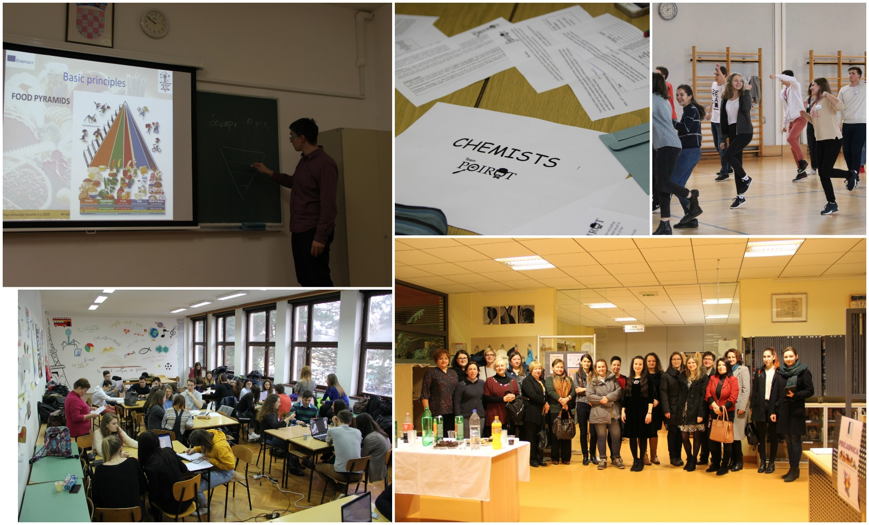

On Wednesday, despite the heavy snow, the participants went on a trip to the capital of Croatia, Zagreb. There they went on a guided tour of the city centre held in English and after some free time, in small teams they went to escape rooms where they employed their maths and logical thinking in order to solve problems. They were robbing banks, saving the world from zombies, fighting count Dracula... Those who were interested could also visit exhibition Nikola Tesla: Mind from the Future.

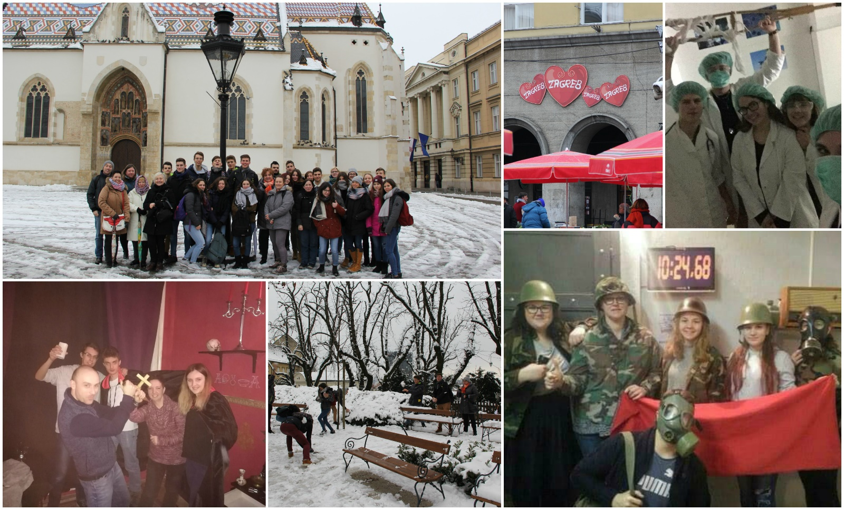

On Thursday pupils prepared presentations with the tasks for e-book they had created two days earlier which they later presented. They also participated in two workshops, Healthy sports nutrition formula held by Mario Slatki, a biology teacher. The aim of the workshop was to raise awareness of the importance of nutrition when doing sports. The other workshop, Amazing Maze of Art, held by Terezija Mlinarić, an art teachers, connected art and maths. In the afternoon the students presented the tasks they had created for the e-book and visited Varaždin city museum *Stari grad.* The teachers attended lecture *Data analysis using „R“*. It was held by professor Jasminka Dobša from University of Zagreb, Faculty of Organisation and Informatics in Varaždin.

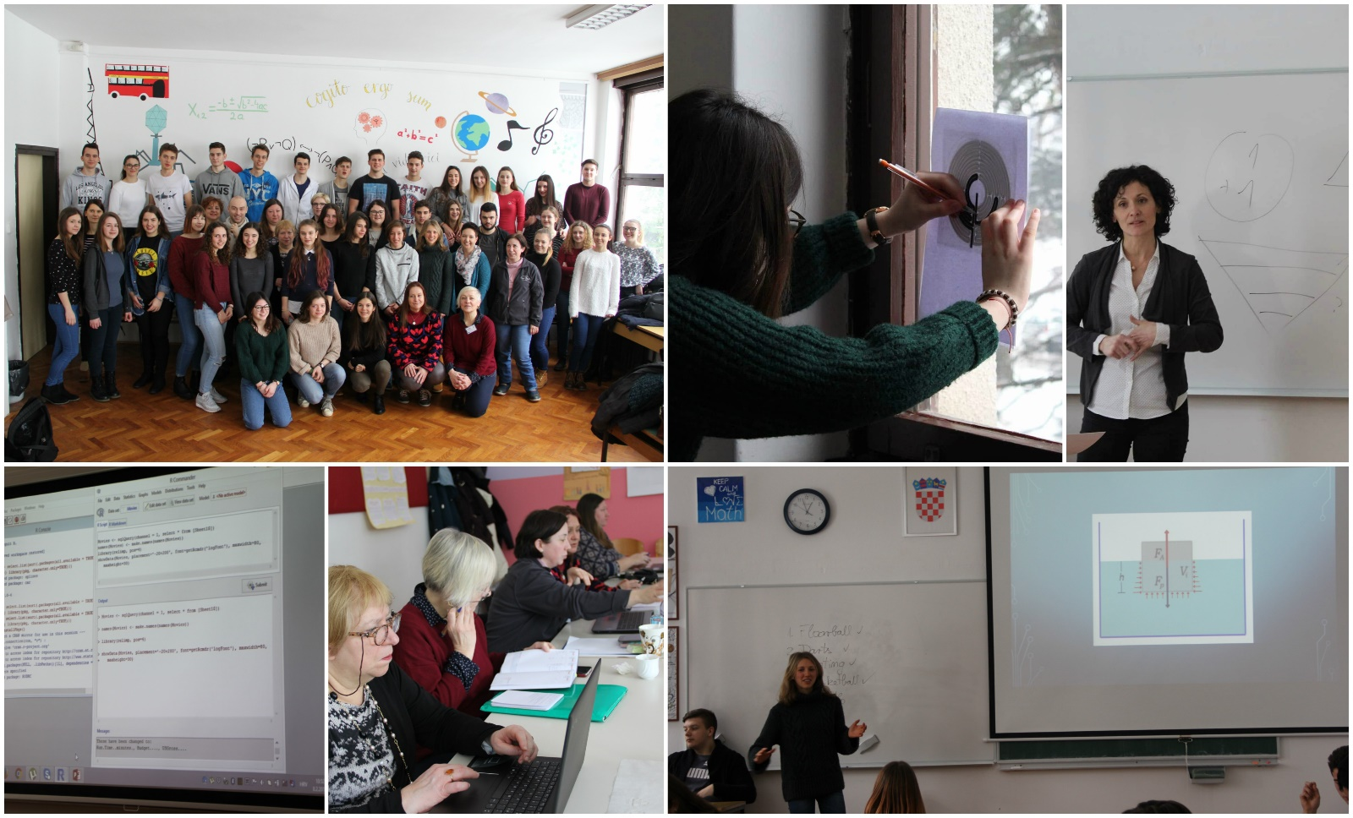

On Friday, after attending lessons with their hosts, the pupils prepared a survey on motivation to learn science subjects. After preparing the survey, which was, according to the project documentation, going to be filled out by the pupils from all participating schools, they continued developing ideas for the e-book. Meanwhile the teachers attended workshop *Sound and taste* held by physics teacher Mihaela Habunek and music teacher Slavica Kelemen. The aim was to show how the taste of chocolate changes when you listen to different music. After the workshop, the teachers discussed future plans and further activities to be done in the project. These activities were followed by a short ceremony which involved a music performance by Croatian pupils, presentation of the video about the project week done by a Croatian pupil and distribution of the certificates of attendance. The ceremony was followed by a quiz where the pupils had a chance to show their general culture knowledge and win some symbolic prices. In the afternoon everybody had some free time to further enjoy Varaždin and Croatia.

On Saturday it was time to leave. The guests returned to their homes carrying new experience, knowledge and friendships with them.

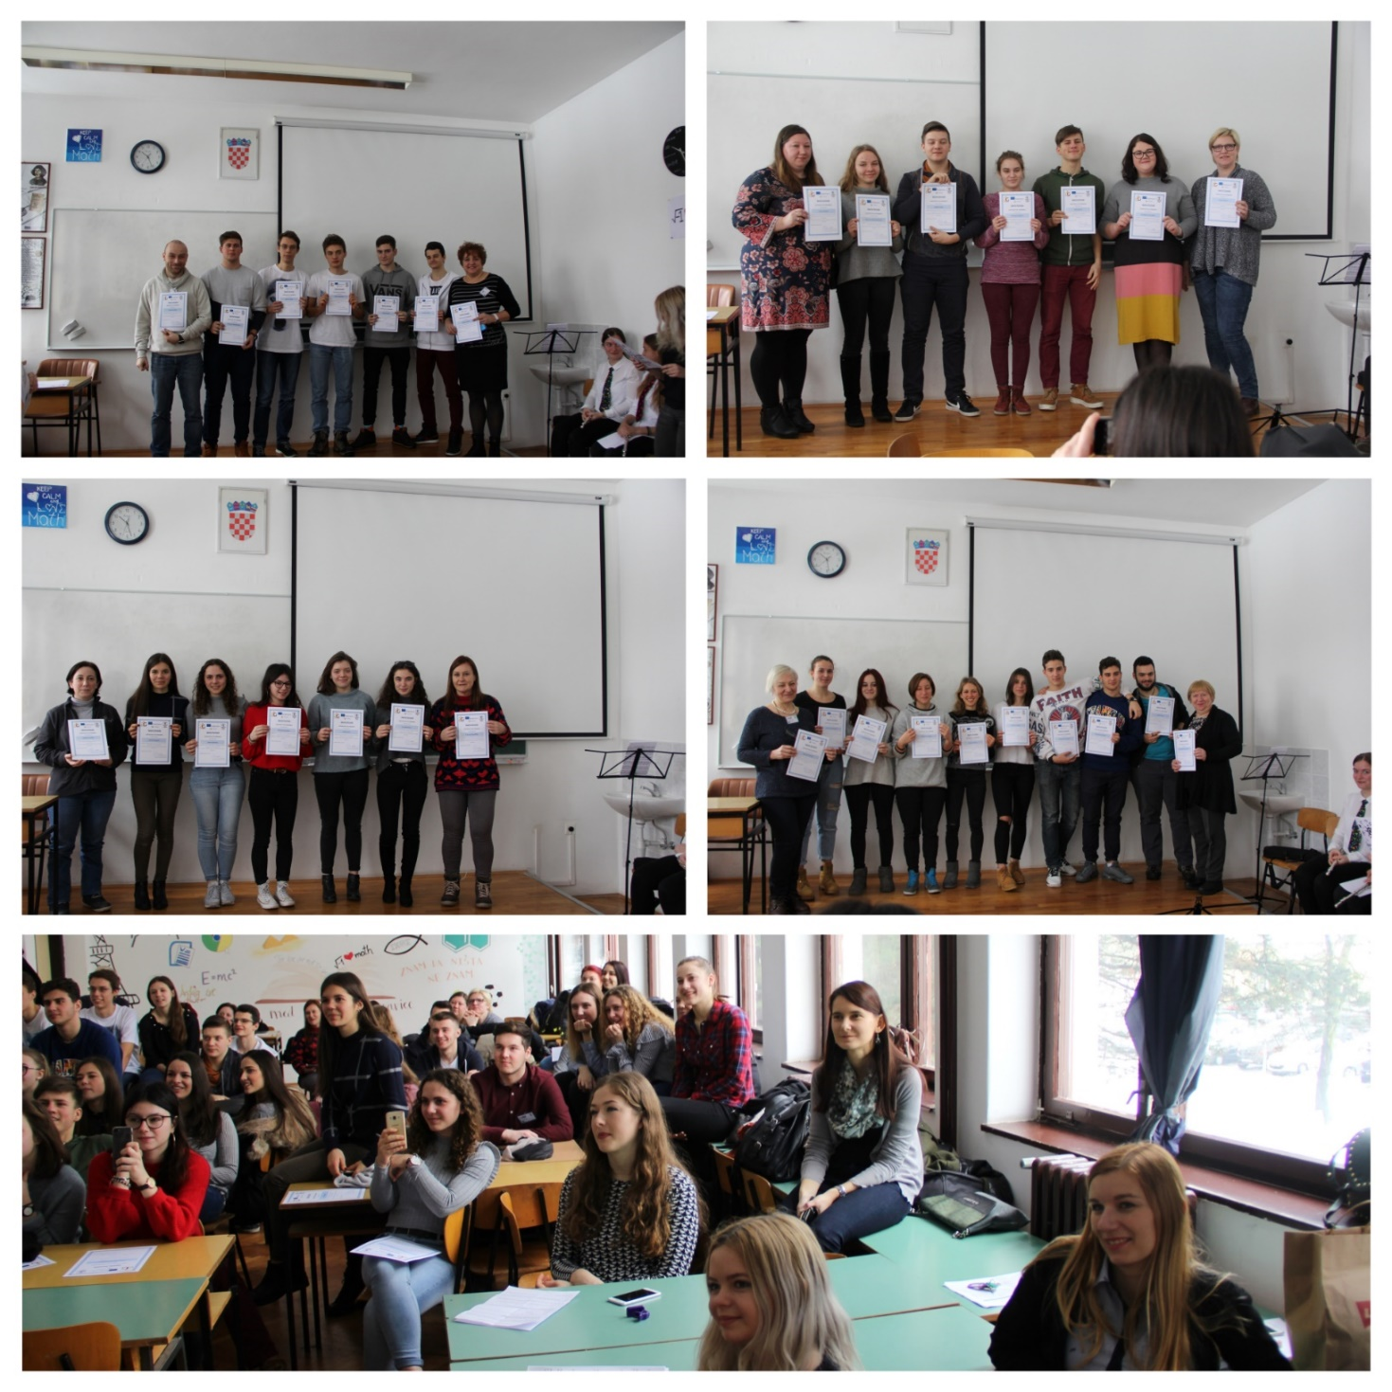

**STUDENTS DIARY**

**MONDAY**

**February 5, 2018**

The first day of the project week at Druga gimnazija started as expected , a lot of unknown people trying to find a “mutual language” and meet those who they were going to spend the rest of the week with. The hosts, their guests and the teachers gathered in classroom 37 to officially start the project week. After the welcome speech of teachers Vlatka Drvarić, Marijana Horvat, Mihaela Habunek and Danka Jelenčić and the president of the students' council of Druga gimnazija Varaždin Matija Koren, the students participated in the workshop with the aim to get to know each other better. They were divided into pairs and the task was to get to know their partner and then to present to everybody what they had remembered from the conversation. After that there was another workshop where students had to present their countries. First were Croatian students who held presentations about Croatia, the city of Varaždin, Druga gimnazija Varaždin, the e-book, handball and darts. After that the Polish, Latvian, French and Italian schools presented what they had prepared. Before lunch at the “Učenički dom” the guests went with their hosts to a regular school lesson. The guests had an opportunity to see how a Croatian lesson looks like and they could also participate in the lesson.

The afternoon was reserved for the orientation in Varaždin. Our student Martina Klepač invested a lot of effort and time to create orientation tasks which all the hosts and guests truly enjoyed. Thanks to this, Varaždin witnessed a fake wedding at villa Bedeković and a French race in the middle of the Old Town. The guests also had a chance to try famous homemade “Varaždinski klipići” and donuts. At the end of the orientation we all gathered at a nearby cafe and finished our first day.

**TUESDAY**

**February 6, 2018**

The second day of our meeting we began productively. Considering that the primary goal of this project is to show there is a connection between science and sports, we created tasks about different sports which are going to be found in the e-book. We worked in groups and that way we learnt a lot from each other.

We have also tried to be detectives with the help of our teacher Danka Jelenčić. She prepared a workshop in which we solved a murder with the help of basic maths knowledge.

After that our guests attended Italian, French and English classes. They gained insight into our lessons and some of them could feel as if they were at home and use their mother tongue.

After lunch we all had fun dancing and realized how (un)talented we were.

**WEDNESDAY**

**February 7, 2018**

On the third day we went on a trip to Zagreb, the capital city of Croatia. We left Varaždin at 7.30 surrounded by snow and arrived to Zagreb around 9. After the guided tour which finished around 11.15 there was plenty of time for shopping, eating and exploring the city. At 2.30 we went to an escape room where teams of players had sixty minutes to solve puzzles and riddles in order to complete a task and leave the room. We had a chance to visit Dracula’s castle, participate in a nuclear war, rob a bank, save the world from zombies and pretend to be Robin Hood and his crew.

When everybody finished, in front of Meštrović Pavilion we exchanged our experiences, concluded that we had a great time and returned to Varaždin around 7 o’clock.

**THURSDAY**

**February 8, 2018.**

On the third day we went on a trip to Zagreb, the capital city of Croatia. We left Varaždin at 7.30 surrounded by snow and arrived to Zagreb around 9. After the guided tour which finished around 11.15 there was plenty of time for shopping, eating and exploring the city. At 2.30 we went to an escape room where teams of players had sixty minutes to solve puzzles and riddles in order to complete a task and leave the room. We had a chance to visit Dracula’s castle, participate in a nuclear war, rob a bank, save the world from zombies and pretend to be Robin Hood and his crew.

When everybody finished, in front of Meštrović Pavilion we exchanged our experiences, concluded that we had a great time and returned to Varaždin around 7 o’clock.

**FRIDAY**

**February 9, 2018**

In the morning the pupils attended lessons with their hosts. After that we all gathered in the classroom and prepared a few questions on how to motivate people to study science. We continued our program with discussion about the meeting in Croatia, new skills we gained and friends we made. For our guests we prepared a short program filled with songs, recitations and thanks. All the participants received certificates of attendance. As the last activity, our teacher Mihaela Habunek made a quiz we all enjoyed immensely. The rest of the day was free, but all the pupils decided to spend it together.

Saturday was a departure day and unfortunately the end of this amazing journey, so we wished our guests a safe trip home.

**EVALUATION OF ERASMUS+ PROJECT Sports Formula, 4th project meeting**

**(Croatia, 4-10 February 2018)**

At the end of the 4th project meeting participants (teachers, students, parents) were invited to participate in the survey to evaluate the project week in Croatia.

The participants submitted their answers as followed:

* 10 parents
* 17 students from countries other than Croatia
* 20 students from Croatia
* 13 teachers

**Questions for parents and their answers:**

The survey was filled out by five parents who hosted students from Italy, one parent who hosted a student from Latvia, three parents who hosted students from France and one parent who hosted a student from Poland.

The diagram below shows answers about how parents were satisfied with the students they hosted.

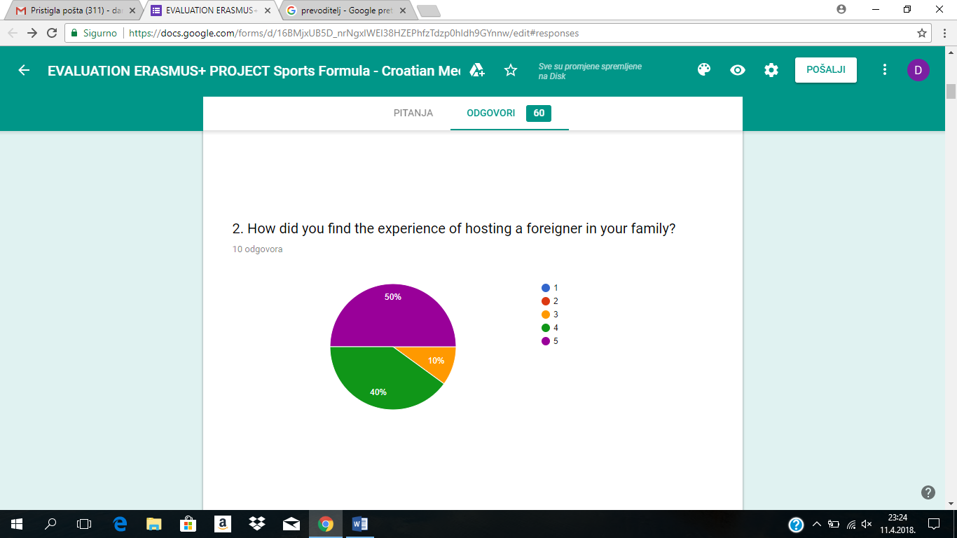

 very bad bad good very good excellent

Parents also added some comments which were quite positive, e.g. “*yery good experience to welcome a guest from another country*“, “*We were really satisfied with our guest. He was polite, decent, he didn't cause any problems and it was a pleasure to host him”.*

In the survey the parents answered that the children improved their communication skills in foreign language, understanding a different culture and even their organisation skills.

The answers about the organization of the meeting are given below:

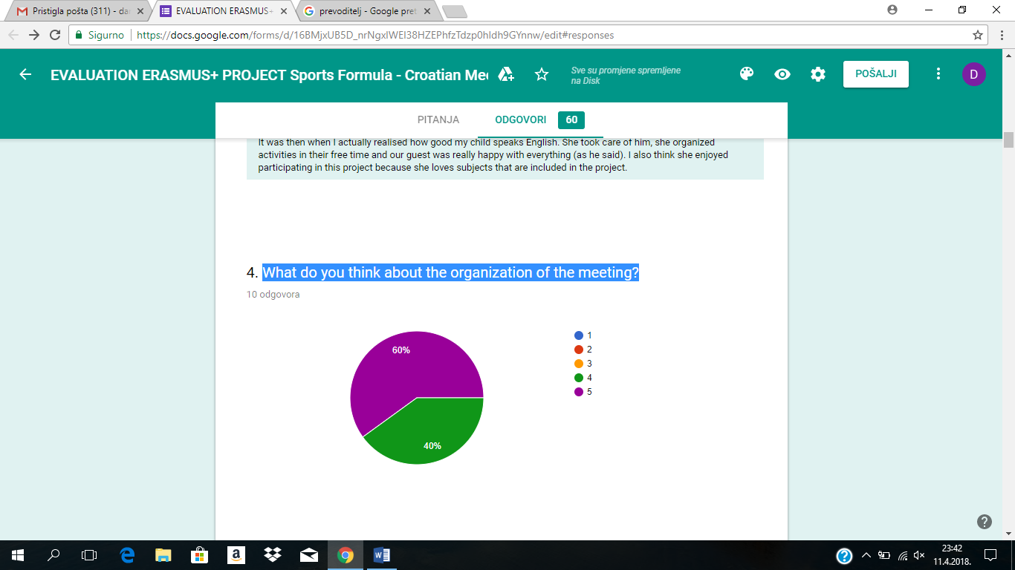

 very bad bad good very good excellent

The final question was about what they liked/disliked about the project meeting in Croatia. They liked hosting students, project organization, and the fact that the project enabled students to socialize, meet new cultures and improve their language skills.

When talking about disliking something, one parent commented that the schedule for students was too busy.

To sum up, parents were very satisfied with the project meeting and if they could, they would gladly host a student in another project.

**Questions for students (from other countries) and their answers:**

The survey was filled out by five students from Poland, five students from Italy, three students from Latvia and four students from France.

According to their answers, the students improved their foreign language communication skills, organization skills, interest and involvement in new projects, understanding a different culture and level of tolerance thanks to the participation in the project.

Most of the students think that this project has enriched their cultural awareness. Some students said that it had showed them everyday life in Croatia. They also had the possibility to meet new people with different points of view and different habits and generally they learned more about other cultures.

Students were also satisfied with the foreign family and the organization of the project meeting in Croatia and 16 of them would definitely participate in another project

They liked meeting new people, a trip to Zagreb, orientation in Varaždin, students, activities and teachers. Some of them disliked food in the canteen and so much time spent working on ebook.

The last question referred toevaluate of the project meeting in Croatia and the answers are given below.

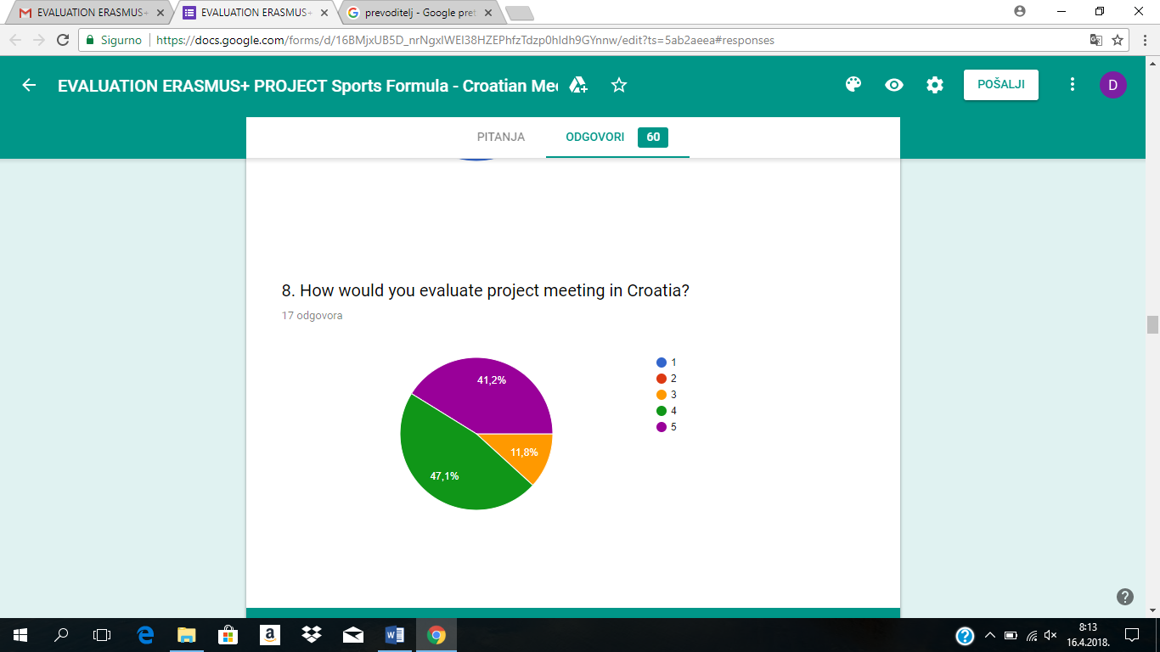

 very bad bad good very good excellent

**Questions for students from Croatia**

The survey was filled out by 16 students from project and four host students only.

HOST STUDENTS

Three students hosted students from Italy and one hosted a student from France. According to their answers, they improved their foreign language communication skills, interest and involvement in new projects and level of tolerance. Three students think that this project meeting has enriched their cultural awareness and one is not sure.

They were mostly satisfied with hosting a foreigner in their family and they would all gladly participate in another project.

PARTICIPANTS

Five participants hosted students from Italy, two from Latvia, four from France and five from Poland.

Their responses are similar to foreign students' answers: thanks to the participation in the project they also improved their foreign language communication skills, organization skills, interest and involvement in new projects, understanding a different culture and level of tolerance.

All students think that this project enriched their cultural awareness and some said that they had learned how to value other cultures and opinions that are quite different from their own.

They were satisfied with hosting a foreigner in their family. They liked workshops, a trip to Zagreb, orientation in Varaždin and meeting new people.

Some students were disappointed with the language skills of some foreign students and also did not like the programme as it was a bit exhausting for them.

The last question referred toevaluate the project meeting in Croatia and the answers are given below. 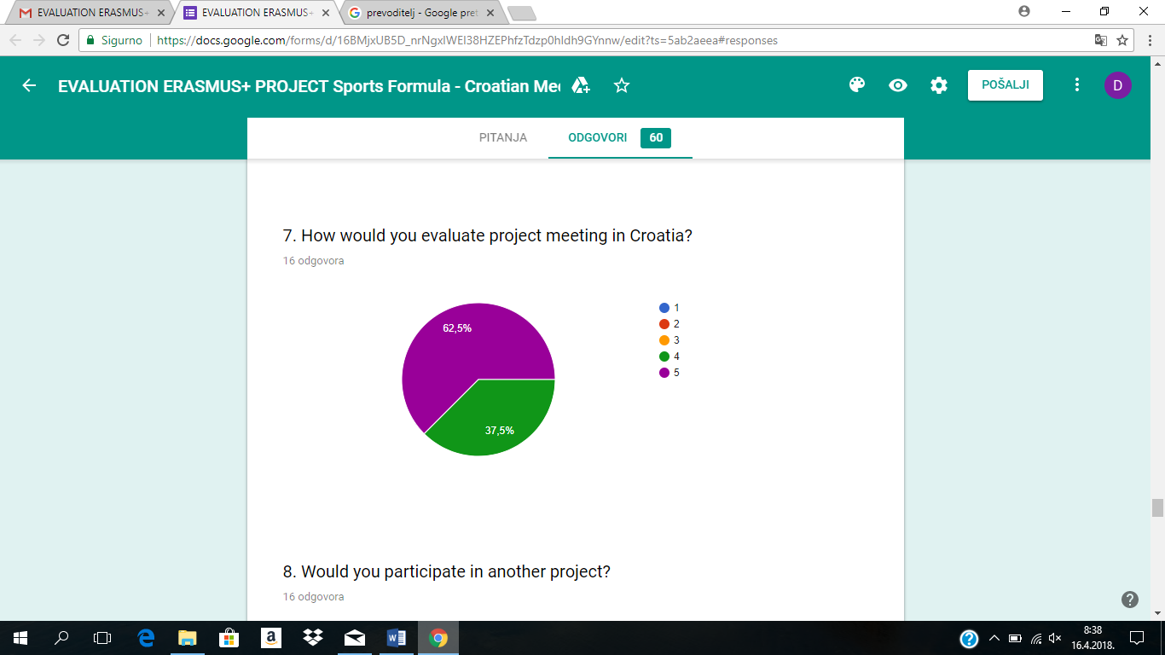

 very bad bad good very good excellent

**Questions for teachers**

The survey was filled out by five teachers from Croatia, two from Poland, two from Italy, two from France and two from Latvia.

The teachers said that this meeting had been an opportunity to improve their language skills, the discussions about teachers’ e-book were productive, the field trips were appropriate and the education about statistical program R was mostly held professionally.

According to the survey, the cooperation between the Croatian teachers and the guest teachers such as the level of professional cooperation were excellent. The cooperation between all the teachers and language interaction between the teachers were very good. Five teachers said that there had been some difficulties due to different language skills and insufficient vocabulary.

When evaluating the benefits for students, the teachers answered that there was an improvement in foreign language skills, in teamwork and in presentation skills. They also said that the students had raised awareness of the problems in the learning process and awareness of how math and science are involved in sport.

When asked what could be done to improve future project meetings, some teachers said that the coordinator should be more involved in the project and that some students have to improve their language skills.

**GREETINGS FROM VARAŽDIN!!**

