MULTIKEY LESSON PLAN

Subject: Physics
Topic: Forces in action
Age of students: 17
Language level: B1/ B2
Time: 45/ 60 minutes
Content aims:
After completing the lesson, the student will be able to:
Distinguish the properties of forces.
Determine the forces acting on a body.
Distinguish when forces have the same direction and sense and when they have opposite sense.
Define Newton’s Laws.
Solve problems using the Newton’s second law.

Apply the equations for constant acceleration

Apply Newton’s relation between force and acceleration to analyse the motion of objects.

Language aims:
After completing the lesson, the student will be able to:
Use new vocabulary within the topics.
Analyse examples of daily life related to Newton’s Laws.

Content-obligatory language | Content-compatible language
Dynamics, interaction, motion  Body, mass, inertia  To exert  Velocity, acceleration, force  Tension, normal, resultant, gravity  Magnitude, modulus, sense  Normal, tangent, displacement, trajectory  axis, axes, plane, pendulum  uniformly, equilibrium | Physics, Action, reaction, movement  Object, weight, resistance  to apply  speed  friction  parallel, perpendicular, direction  distance, length, height  inclined, angle, slide
Materials:
- The presentation ‘Forces in action’
- Student’s worksheets 0 to 3.

Procedure:
0. Previous knowledge about Motion: work in pairs, Worksheet 0.
- Before starting the lesson, students review the main features of motion completing a questionnaire of the Worksheet 0.
- Then, working in pairs, students compare their answers.
- At the end of the lesson, we check the task all together.

1. ‘Forces in action’ presentation: work individually, Worksheet 1.
- Students have the Worksheet 1 which provides students brief information about the presentation.
- Teacher introduces the lesson ‘Forces in action’ to students and explains them some of the main ideas about Dynamics as a part of physics that studies the actions exerted on a body and how these actions affect the movement thereof.
- Then, students listen teacher’s presentation

2. ‘Forces in action’ tasks: teamwork (4), Worksheet 2.
After listening the teacher’s presentation, students, in the same teams, connect the whole parts of the presentation with the main ideas of the ‘Forces in action’ lesson completing the following tasks of the Worksheet 2.

3. ‘Forces in action’ discussion: teamwork (4), Worksheet 3.
Students, in groups of four people, discuss the answers of a guided questionnaire of the Worksheet 3.

4. ‘Forces in action’: Worksheets
Teachers will provide students with the following worksheets 0 to 3

Worksheet 0 | Questionnaire: What do we know about motion?
Before starting the lesson …
0.1. When do we say that a body is in motion?

0.2. Why is a frame of reference needed?

0.3. Indicate the speed at which circulates a car that runs 150 km in 1.5 hours:

a) | 150 km/h | c) | $$\frac{1,5 h}{150 km}=0,01 \frac{km}{h}$$
b) | $$\frac{150 km}{1,5 h}=100 \frac{km}{h}$$ | d) | 150 km·1,5 h = 450 km·h

0.4. Indicate what is the trajectory of the following motions:
a) A falling stone
b) A runner of 100 metres
c) The carriage of a carousel

0.5. A bus, which runs at constant speed, braking in front of a red light in 4 seconds:
a) Before stopping, what kind of movement had the bus?
b) What kind of motion has the bus when it is braking?
c) What is the sign of the acceleration?

Worksheet 1 | ‘Forces in action’: brief information for presentation
While listening teacher’s presentation …
Contents of presentation
1. Why a body changes its speed?
1.1. Properties of forces
2. How can you determine the forces acting on a body?
2.1. Scheme to determine the forces acting on a body
3. What happens if more than a force acts on a body?
3.1. Forces with the same direction and sense
3.2. Forces with the same direction and opposite sense
3.3. Forces forming an angle with the direction of displacement
3.3.1. Example 1: Body sliding down an inclined plane (no friction)
3.3.2. Example 2: Simple pendulum
4. Newton's Laws
4.1. Newton's First Law or The Law of Inertia
4.2.. Newton's Second law or The fundamental Law of dynamics
4.2.1. The Newton
4.3. Newton’s Third Law or Law of Action-Reaction
4.3.1. Example 1
4.3.2. Example 2

Contents of Tasks
Worksheet 0: Questionnaire: What do we know about motion?
Worksheet 1: ‘Forces in action’: Contents
Worksheet 2: ‘Forces in action’ tasks
Worksheet 3: ‘Forces in action’ discussion: guided questionnaire

Worksheet 2 | ‘Forces in action’ tasks
1. Complete the properties of the represented force
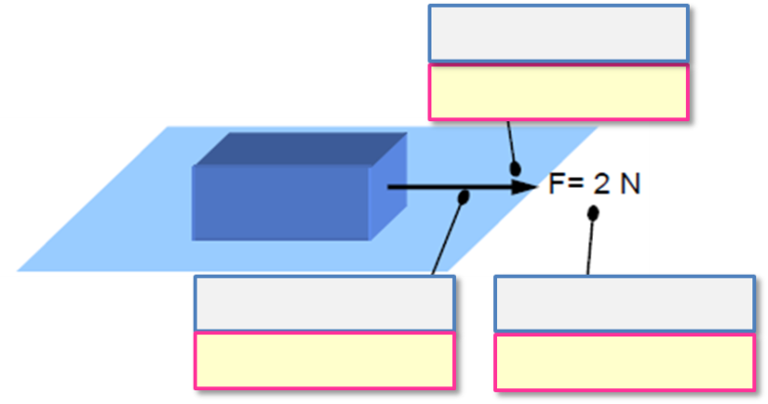
d)
f)
b)
e)
c)
a)
2. Finish the concept map in order to determine the forces acting on a body
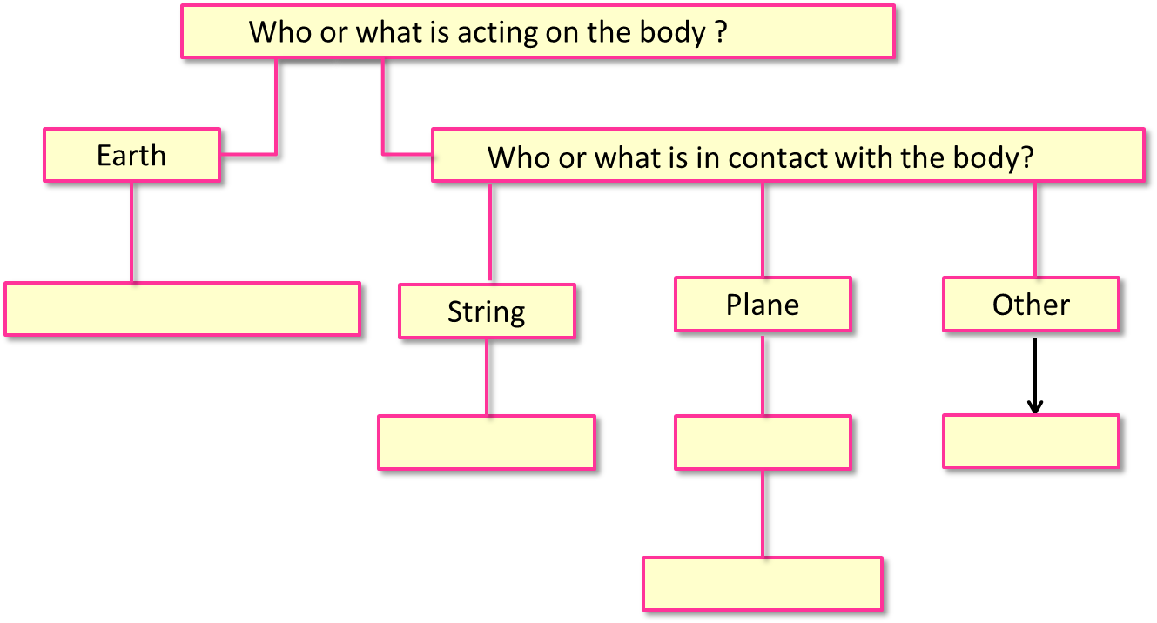
e)
c)
b)
d)
a)
3. Find the resultant force when two forces with the same direction and sense act on a body
a)

4. Find the resultant force when two forces with the same direction and opposite sense act on a body
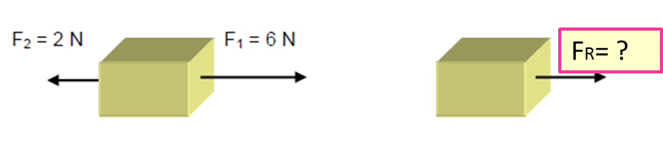
a)
5. Decompose the force which is forming an angle with the direction of displacement for two perpendicular forces
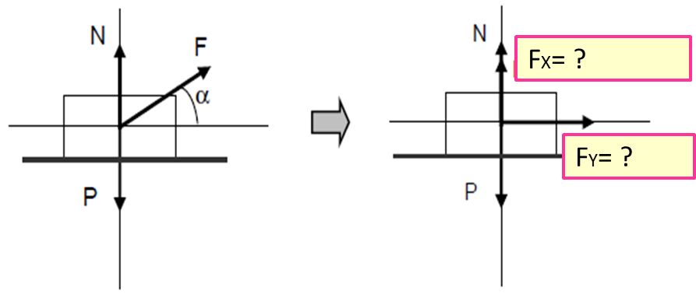
b)
a)
6. Explain the steps recommended to follow to simplify the problem of an object sliding down an inclined plane without friction
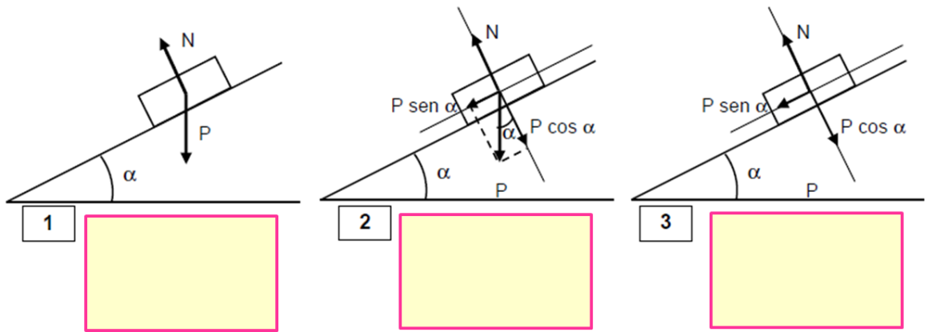

7. Find all the forces acting on this simple pendulum
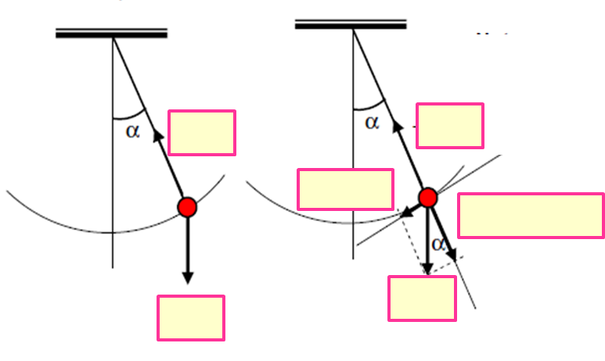
f)
e)
d)
c)
b)
a)
8. Complete the concept map about Newton’s laws
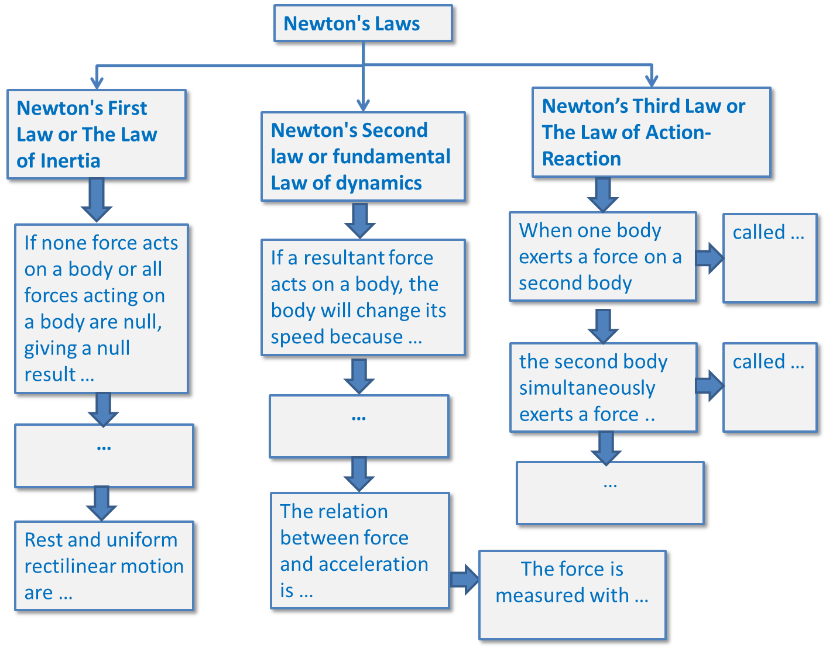
h)
g)
f)
e)
d)
b)
c)
a)

Worksheet 3 | ‘Forces in action’ discussion: guided questionnaire
After listening teacher’s presentation …
1. Why a body changes its speed?
2. What kind of properties the forces present?
3. How can you determine the forces acting on a body?
4. Do you remember the special names given to Some forces?
5. What happens if more than a force acts on a body?
6. Which procedure do we follow to find the resultant force when forces with the same direction and sense come to scene?
7. And what about forces with the same direction and opposite sense?
8. Which procedure do we follow to find the resultant force when we have forces forming an angle with the direction of displacement?
9. According to the Newton's First Law or The Law of Inertia, what happens to the speed of a body if none force acts on it? And if all forces acting on it, giving a null result?
10. What states Newton on its Second law regarding the speed of a body when a resultant force acts on it?
11. Could you express in an equation the relation between applied force and produced acceleration?
12. Could you explain in your own words what is a Newton?
13. According to Newton’s Third Law, explain his Law of Action-Reaction in your own words using examples.
14. Is it possible that action and reaction forces cancel themselves?

4. ‘Forces in action’: Self-assessment grid
Students assess themselves using the provided self -assessment grid.

CATEGORY | Beginning  1 | Developing  2 | Accomplished  3 | Excellent  4 | Score
Worksheet 0 - Questionnaire. | Only 25% correctly answered | Between 25 and 50% correctly answered | Between 50 and 75% correctly answered | All questions correctly answered | … / 8
Worksheet 2 - Task 1 | Only 25% correctly answered | Between 25 and 50% correctly answered | Between 50 and 75% correctly answered | All questions correctly answered | … / 8
Worksheet 2 - Task 2 | Only answers correctly up to one box, but less than two | Only answers correctly two boxes, but less than three | Only answers correctly three boxes, but less than five | All questions correctly answered | … / 8
Worksheet 2 – Tasks 3 to 5 | Only answers correctly up to one box, but less than two | Only answers correctly two boxes, but less than three | Only answers correctly three boxes, but less than four | All questions correctly answered | … / 8
Worksheet 2 – Task 6 | Only answers up to one box, but the steps are not clearly explained | Only answers correctly up to two boxes, but the steps are not clearly explained | All questions answered, but some steps are not clearly explained | All questions correctly answered | … / 8
Worksheet 2 – Task 7 | Only answers correctly up to one box | Only answers correctly up to three boxes | Only answers correctly up to five boxes | All questions correctly answered | … / 8
Worksheet 2 – Task 8 | Only answers correctly up to one box | Only answers correctly up to two boxes | Only answers correctly up to three boxes, but less than five | All questions correctly answered | … / 8
Worksheet 3 - Questionnaire | Only 25% correctly answered | Between 25 and 50% correctly answered | Between 50 and 75% correctly answered | All questions correctly answered | … / 8

