LESSON PLAN
Subject: Science/Physics
Topic: Magnetism
Age of students: 17
Language level: B1
Time: 90/120 minutes

Content aims:
After completing the lesson, the student will be able to:
Relate that electric current creates a magnetic field.
Describe how an electromagnet is made.
Explain the theory of electromagnetism.
Investigate ways to change the strength of an electromagnet.
Create a magnet.
List several items that engineers have designed using electromagnets.

Language aims:
After completing the lesson, the student will be able to:
Use new vocabulary within the topisc.
Discuss magnetic things in his or hers home.
Analyze everyday use of electromagnets.

Pre-requisites:
Pupils have learned about the basics of magnetism

Materials:
Materials needed:
An empty cola can and an aluminum can
A magnet
Enough copper wire so that each group can make a magnet (3 meters per group)
Enough (steel) nails so that each group has one
Enough batteries so that each member of the class has one.
A large quantity of very small nails (brads).

Procedure steps:
1. Make copies of the handouts for each learner in the class and
2. If necessary simplify the language of the text depending on the level of the class (Deller & Price, 2008).
3. exercise
1. MAGNETIC OR NOT –
REFRIGERATOR DOOR **YES**Students are familiar with this.
BED**NO** Students may argue a bed can have metal in it, but most textiles, wood, and foam insulation are not magnetic.
COKE CAN **YES**These are made of steel, but test the one you have in front of pupils.
DOLLAR BILL **YES**The ink has a little bit of iron in it, so that pop and candy machines can tell if its the real thing and not a photocopy.
2. Go over the above list and include in your discussion student observations of things that were magnetic in their home. Give as many students as possible a chance to answer. Lead into the properties of magnets..."Let's organize all this information." ALUMINUM BEER CAN **NO**
Try the magnetism test on cola can and aluminum can and ask pupils why one is attracted and the othher one not?
4. Pupils do exercise 2 and then check their answers in the text. Teacher instructs pupils to underline the words they do not know.
5. Discussion (in mother tongue)-
How could we create a magnet based on what we have read? Introduction to class mini project
6.Mini project (45 minutes)
Teacher creates groups of pupils and tells them they are going to participate in an experiment of building an electromagnet.
Performance Assessment: The best proof of learning is in the production of something useful. The goal is to build the strongest electromagnet you can. Each group reports their finding based on the tests they have done with their magnet. The teacher gives grades based on the amount of effort and the quality of work.
Handout 1:
1.Magnetic or not:
Item | Yes or no
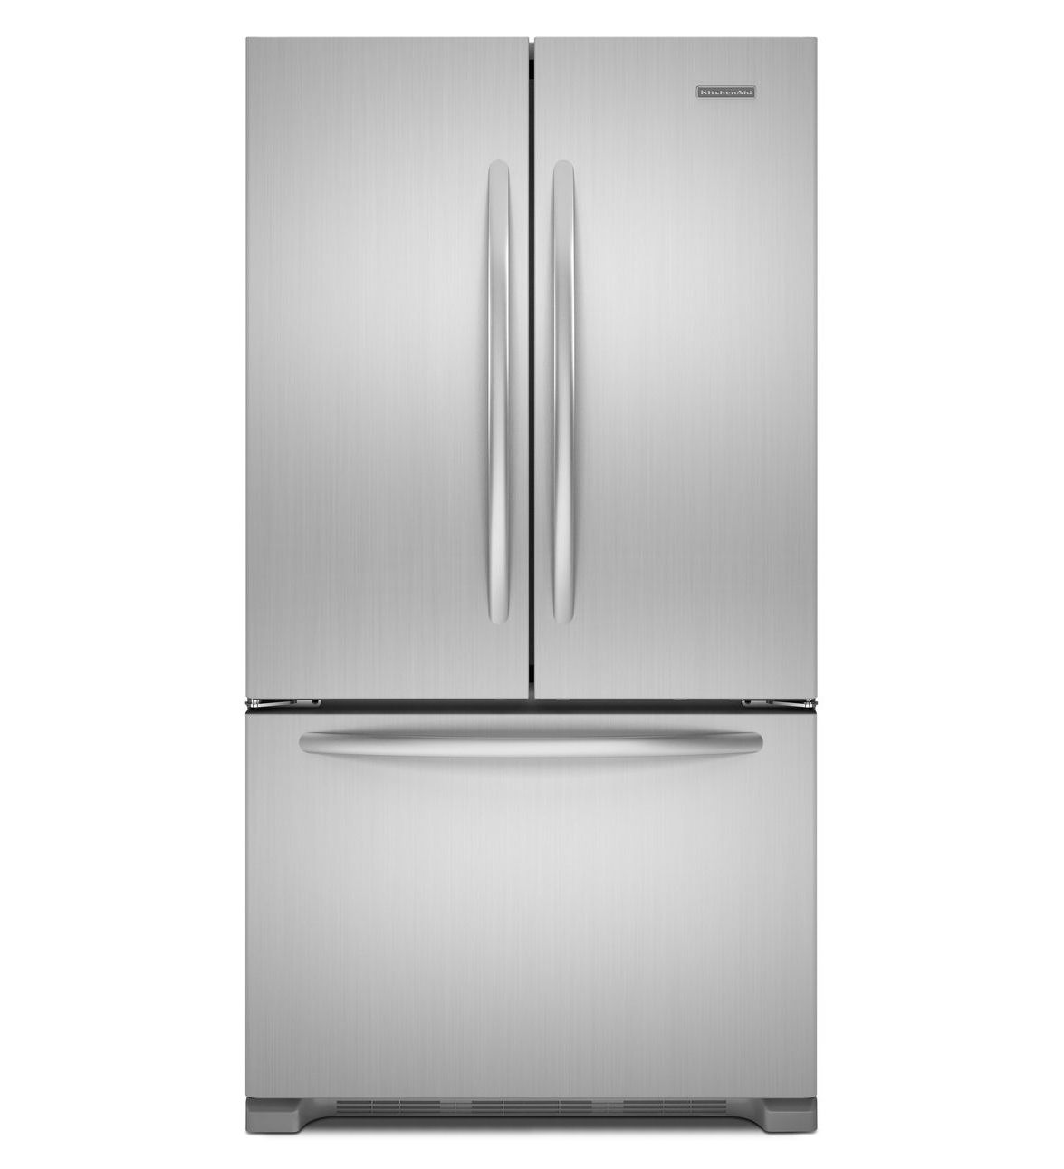
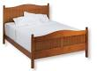
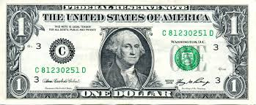

2. Put these words into correct place in the lines below:

Electromagnetism magnetic field electricity generators turbines

______________________ is a theory that combines electricity and magnetism
Changing ___________ produces magnetism.
Every time an electric current flows in a wire, it generates a ___________.
All the electricity we use (with the exception of electricity produced from solar cells) is made by devices called _____________.
Devices that capture kinetic energy from fluids that move past them are called ____________.
3. Read the text and check your answers:
Magnetism and electricity: the theory of electromagnetism

Electromagnets show that you can make magnetism using electricity. In fact, as European scientists discovered in the 19th century, electricity always makes magnetism when it moves about or changes. Every time an electric current flows in a wire, it generates a magnetic field all around it. Changing electricity, in short, produces magnetism.

The reverse is true as well: you can make electricity using a changing pattern of magnetism. That's just as well or you wouldn't be reading these words now. Virtually all the electricity we use (with the exception of electricity produced from solar cells) is made by devices called generators. These use powerful magnets and coils of wire to produce electricity with the help of turbines, devices that capture kinetic energy from fluids that move past them (typically wind, water, or steam made from coal, oil, or nuclear power).

How do you get electricity from magnetism? Simply speaking, you put a metal wire near a magnet (so the wire is inside the magnetic field). Move the wire or move the magnet so the magnetic field inside the wire fluctuates and electricity will flow through the wire. Keep moving the wire or magnet and you'll make electricity continually.

You can see from this that electricity and magnetism are partners. Wherever you find one, the other is never far away. The first person to explain this properly, in the mid-19th century, was a brilliant Scottish physicist named James Clerk Maxwell. His theory summed up everything then known about electricity and magnetism in four relatively simple mathematical formulas. Maxwell's equations, as we now call them, combined electricity and magnetism into a single, powerful theory we call electromagnetism. We now know that electromagnetism is one of the four fundamental forces that control everything that happens in our universe—and that's a powerful idea indeed!

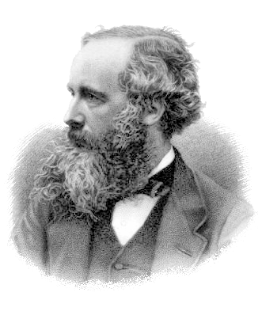
Photo: James Clerk Maxwell. Public domain photo by courtesy of Wikimedia Commons

How could we create a magnet based on what we have read?

Handout 2
CLASS PROJECT

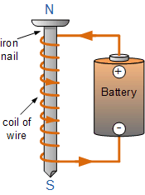
Electromagnets & Magnetic Metals GROUPWORK
1. Begin by winding about half of allotted wire around a steel nail.
Contact the two free ends to the two terminals of the battery. How many nails can you pick up with this electromagnet? Write it down.
2. Coil the rest of the wire onto the nail. Does the winding direction matter? Test the number of nails picked up.
3. How does the wire feel (hot or cold) when it is hooked-up to the battery? Does using the electromagnet deplete the battery rapidly or slowly? Why? How might this be improved on?
4. Slide a different material into the coil (pencil). What happens? Repeat with metals and non-metals. Does it matter if the metal is a poor conductor or good conductor? How can you explain this? Does it matter if the metal is hollow or solid?
5. Try to invent your own experiments to see how you can increase the strenght of your magnet.
Write down your observations in form of a class report.

