LESSON PLAN

Subject: Biology

Topic: Digestion
Age of students: 16-18
Language level: B1/B2
Time: 45/60 min

Lesson 1: Human digestive system
Content aims:

After completing the lesson, the student will be able to:
List internal organs that take part in digestion.
Explain functions of internal organs that take part in digestion.
Illustrate the way digestive system works.
Conclude how we can improve the workout of the intestine.

Language aims:
After completing the lesson, the student will be able to:
Use new vocabulary within the topics.
Describe the processes of digestion using new terms.
Analyze the main ideas and details in texts related to the topic ‘Digestion’.

Vocabulary: abdomen, alimentary canal, digest, digestion, digestive, ingestion, egestion, saliva, mouth cavity, crush, grind, break down, chew, chyme, bolus, gullet(oesophagus), stomach, acid(ic), bile, peristalsis, intestine, mucus, villus/villi, colon, anus, faeces, water-soluble, fat-soluble
Necessary resources: diagrams, texts, worksheets, internet resources .
Learning methods: work with texts, demonstration, visualisation, talk, brainstorm.
Procedure steps:
The teacher announces the topic ”Digestion. Human digestive system”
1.Introducing necessary vocabulary. The teacher discusses and writes on the board all words that could be derived from the word „digest”(DIGESTIVE,DIGESTION.INDIGESTION)
2.Brainstorm activity in pairs: which internal organs take part in digestion?(mouth,teeth, gullet,stomach,small and large intestine, liver,pancreas.)
3.Students are offered a worksheet (handout 1) and fill in the missing words(organs of the digestive system). Then students read out their answers.
4.Students watch a short video (3:48) on digestive system.”Digestive system for kids”.
https://www.youtube.com/watch?v=bFczvJp0bpU

5.After watching activities-students fill in the table.(handout 2)
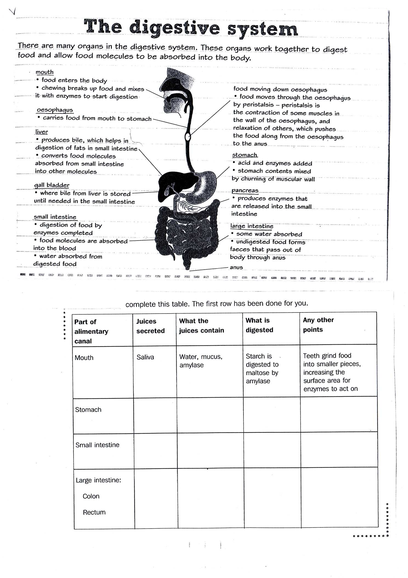Handout 2.↑

Key for the table:↑
Stomach-gastric juice/HCL-hydrochloric acid and protease,pepsi/food(protein molecules are broken down into smaller chains)turns into liquid/bacteria are killed by acid;
Small intestine-bile and pancreatic juice/bile contains salt,pancreatic juice contains sodium hydrogencarbonate and enzymes/starch is broken down to maltose, proteins –into polypeptides, fats-to fatty acids and glycerol/acid is neutralised by sodium hydrogencarbonate, villi absorb the digested food
Large intestine-water is left/water,salts, mucus and rubbed off cells/water and salts pass into blood/undigested fibre exits the alimentary canal.

6. Reflection/speculations on topic:
Teacher asks questions:
- what is the role of teeth?(They break down food physically, grind food)
- how can we improve the workout of the intestine?(We can eat more products containing roughage/fibre).
- why do we need villi in the intestine?(They enlarge the surface of the absorption).

*Source: Keith Kelly,Science.Macmillan,2008.
Lesson 2 : The digestive system.
Content aims:
After completing the lesson, the student will be able to:
Illustrate the way digestive system works.
Evaluate presentation about the digestive system.
Explain the role of the teeth in digestion.

Language aims:
After completing the lesson, the student will be able to:
Use new vocabulary within the topics.
Describe the processes of digestion using new terms.
Analyze the main ideas and details in texts related to the topic ‘Digestion’.

Vocabulary: abdomen,absorb, absorption, alimentary canal, digest, digestion, digestive, ingestion, egestion, saliva, mouth cavity, crush, grind, break down, chew, chyme, bolus, gullet(oesophagus), stomach, acid(ic), bile, peristalsis, intestine, mucus, villus/villi, colon, anus, faeces, water-soluble, fat-soluble

1.Students watch and listen to their peer’s presentation about the digestive system.(15min)

2.Students are asked questions by the presenter.

3.Students ask questions to the presenter.

4.Students evaluate the presentation.

5.Teacher’s evaluation and coments.

Attachment *:
Presentation evaluation
Variant A
 | Criteria | 5  excellent | 4  good | 3  satisfactory | 2  almost satisfactory | 1  unsatisfactory | Score
CONTENT LANGUAGE | Basic concepts /  Principles | Has acquired all the basic concepts and principles of the topic | Has acquired most of the basic concepts and principles of the topic | Has acquired some basic concepts and principles of the topic | Has acquired only a few basic concepts and principles of the topic | Hasn’t acquired none of the basic concepts and principles of the topic
 | Elaboration Evaluation | Well structured, correct and comprehensive explanation; excellent personal evaluation | Generally well structured, correct and adequate explanation; good personal evaluation | Sufficient explanation, with a limited number of errors; limited personal evaluation | The explanation shows major deficiencies in terms of logical structuring and formulation | The explanation is severly deficient in terms of logical structuring and formulation; no personal evaluation
 | Accuracy | Consistent grammatical control and appropriate use of vocabulary | Good grammatical control and generally appropriate use of vocabulary | A few mistakes in grammar and vocabulary use do not lead to misunderstanding | Systematically makes mistakes in grammar and vocabulary use but the message is generally clear | The systematic grammar mistakes and the narrow range of vocabulary makes the message meaningless
 | Fluency & Interaction | Can express him/her self with a natural flow and interact with ease | Can express him/her self and interact with a good degree of fluency | Can express him/her self and interact with a reasonable degree of fluency | Can manage the discourse and the interaction with effort and must be helped | The communication is totally dependent on repetition, rephrasing and repair

Variant B
Presentation quality (8points):
Content(glossary,number of slides,sources)2p
Design 2p
Language 2p
Feedback (tasks or questions to the audience) 2p
Presentation skills ( 8 points)
Language(accuracy) 2p
Posture and Gestures 2p
Contact with the audience 2p
Knowledge of the topic 2p
Questions (4 points) ( the audience asks the presenter questions))
Language(accuracy) 2p
Response (ability to answer listeners’ questions) 2p
Assessment scale (In Latvia – highest mark- 10)
1 | 2 | 3 | 4 | 5 | 6 | 7 | 8 | 9 | 10
2 | 4 | 6 | 9 | 12 | 13 | 15 | 17 | 19 | 20

6. The teacher offers students to do tasks on worksheets.(Worksheet 1, By teacher’s choice)

7.The teacher and students compare answers.
8.The students are offered tasks (1.,2.,3. By teacher’s choice. Task 3 is extremely optional as it is too much in detail about our teeth and demands the introduction of the new vocabulary. Option: it can be given to someone who is going to study dentistry).
Attachments
1. Worksheet for the topic “Digestive system”
(*Source: Keith Kelly,Science.Macmillan,2008.)
2.Handout 2.Tasks 1.,2.,3.)
(*Source: Keith Kelly,Science.Macmillan,2008.)

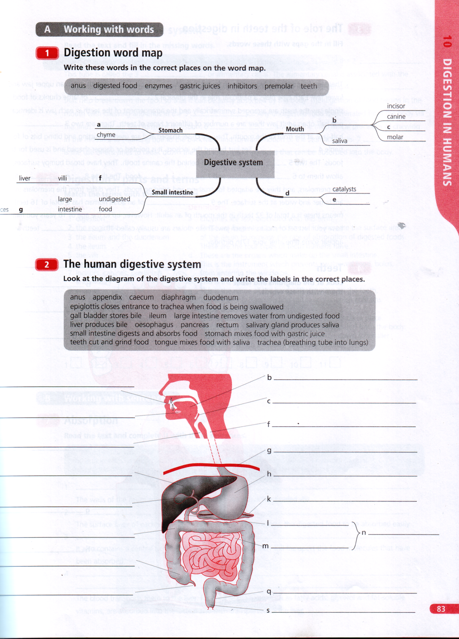

Tasks for vocabulary revision and sentence structure.(Can be used in tests as well)
1.Match the terms with their definitions(Can be cut and read out by students)
1 | digestion | A | enzymes are also described with this term
2 | the epiglottis | B | these are finger like projections which increase the surface area of the ileum to increase the rate of absorption of digested foods
3 | the ileum and the duodenum | C | these are the four types of teeth humans have  the duodenum
4 | the ileum | D | these are the organs which are part of the small intestine
5 | the villi | E | this is the instrument which prevents swallowed food from entering the windpipe
6 | defecation | F | this is the job of inhibitors
7 | defecation | G | this is the name of the hard white coating on the teeth.
8 | incisors, canines, premolars, molars | H | this is the only living portion of the tooth with nerves
9 | the pulp | I | this is where the absorption of digested food takes place
10 | biological catalysts | K | this is the process by which faeces are eliminated from the body
11 | to slow down biological processes | L | this is the process by which food is broken down to smaller molecules, which the body can easily absorb.

2.
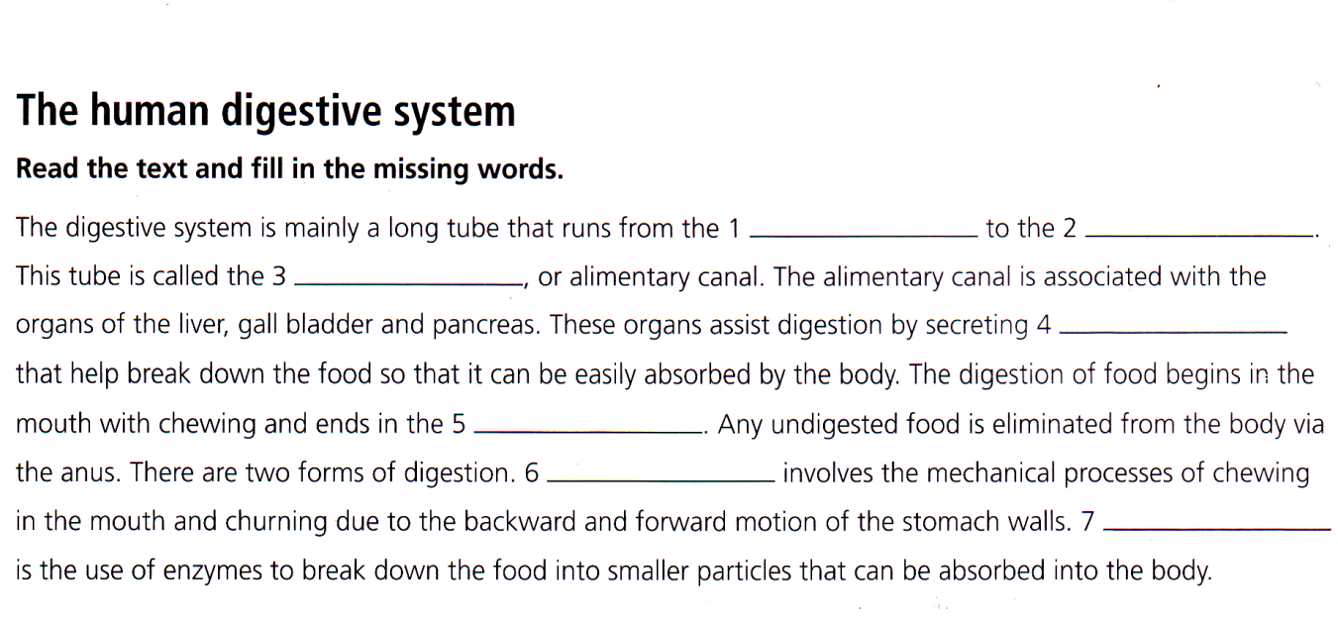

Keys

1.Matching
1 | 2 | 3 | 4 | 5 | 6 | 7 | 8 | 9 | 10 | 11
K | E | D | I | B | J | C | G | H | A | F

2.Open close
1 | 2 | 3 | 4 | 5 | 6 | 7
mouth | anus | gut | enzymes | small intestine | physical | chemical

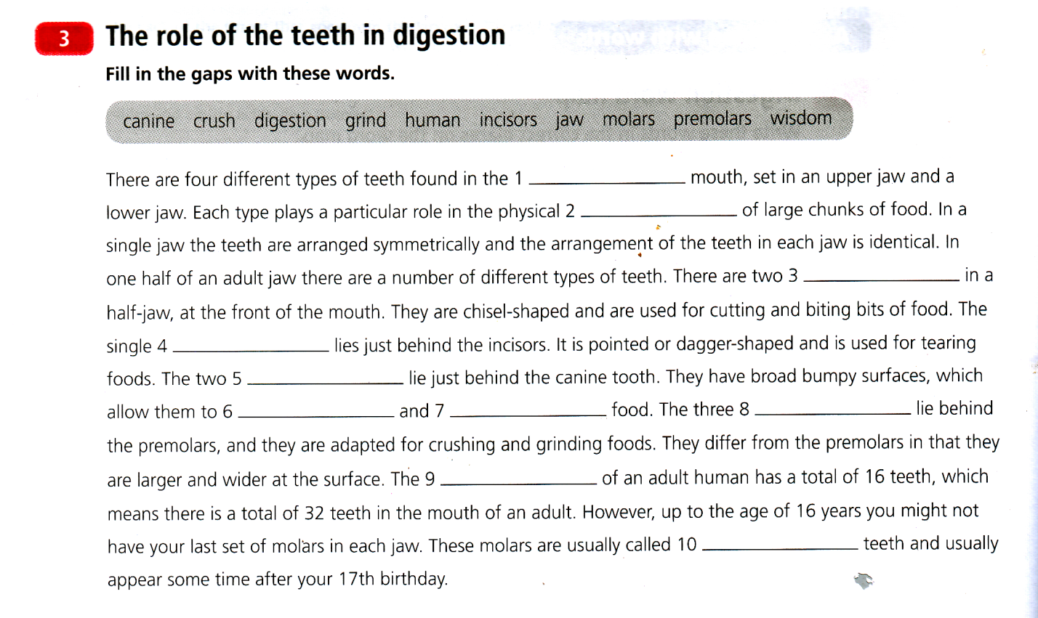

Keys for Working with words A
1.
a | b | c | d | e | f | g
gastric juices | teeth | Premolar  (priekšdzeroklis) | enzymes | Inhibitors(enzīmi,kaspalēninabioloģiskosprocesus) | digested food | anus

2. a teeth cut and grind food b tongue mixes food with saliva(siekalas) c epiglottis closes entrance to trachea when food is being swallowed d salivary glands produce saliva e trachea(breathing tube into lungs) f oesophagus(barībasvads) g diaphragm h stomach mixes food with gastric juice I liver produces bile(žults) j gall bladder(žultspūslis) stores bile k pancreas(aizkuņģadziedzeris) l duodenum(divpadsmitpirkstuzarna) m ileum(tievāzarnutraktanobeigums) n small intestine(tievās zarnas) digests and absorbs food o large intestine(resnāszarnas) removes water from undigested food p caecum(aklāzarna) q rectum(taisnāzarna) r appendix anus.

Key

3.Insertion
1 | 2 | 3 | 4 | 5 | 6 | 7 | 8 | 9 | 10
human | digestion | incisors | canine | premolars | crush | grind | molars | jaw | wisdom

Lesson 3.The digestive system.(Cont.)

Content aims
After completing the lesson, the student will be able to:
List internal organs that take part in digestion.
Explain functions of internal organs that take part in digestion.

Language aims
After completing the lesson, the student will be able to:
Use new vocabulary within the topics.
Describe the processes of digestion using new terms.
Analyze the main ideas and details in texts related to the topic ‘Digestion’.

Vocabulary: abdomen,absorb, absorption, alimentary canal, digest, digestion, digestive, ingestion, egestion, saliva, mouth cavity, crush, grind, break down, chew, chyme, bolus, gullet(oesophagus), stomach, acid(ic), bile, peristalsis, intestine, mucus, villus/villi, colon, anus, faeces, water-soluble, fat-soluble, swallow.
Procedure:
1.The teacher offers a text with gaps.(Handout 1, task 2) Students do the task, after read out loudly.

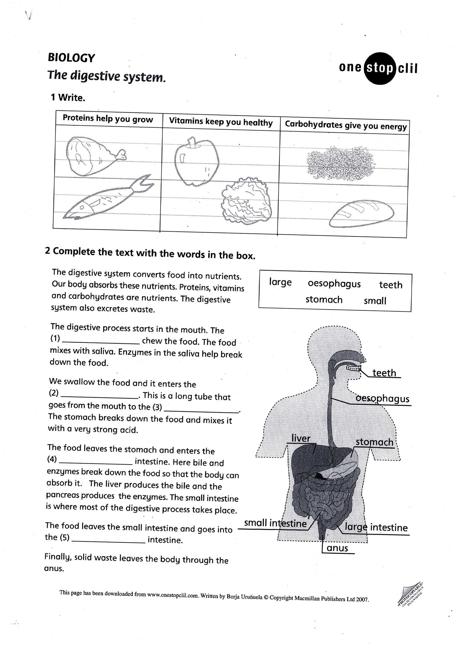Handout 1.↑
2.Listening activity. Teacher hands out the sets of cut cards with vocabulary to pairs of deskmates(Handout 2).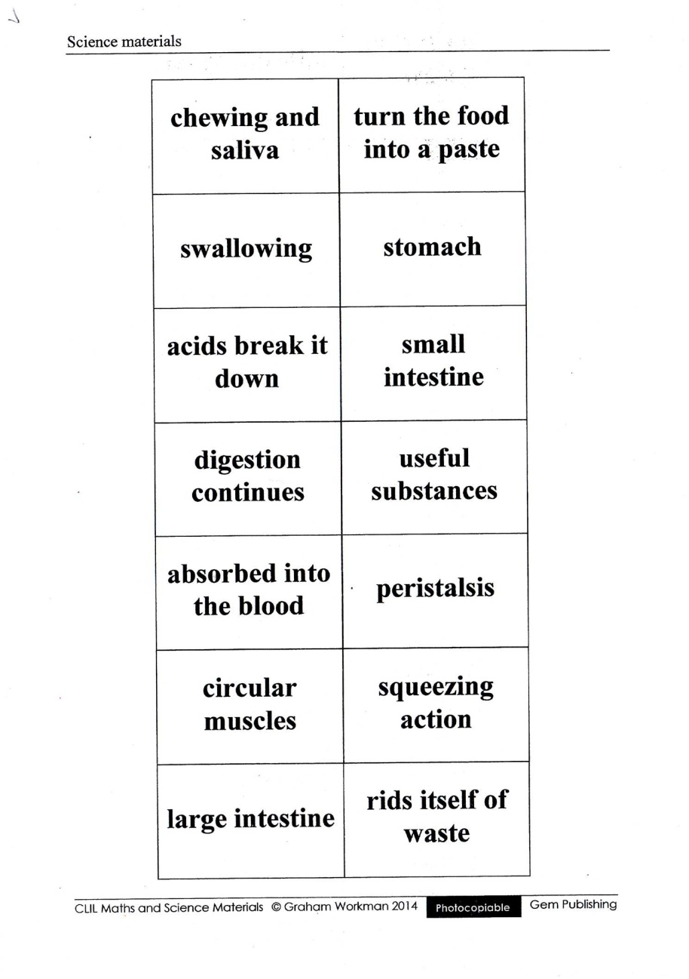Handout 2 ↑
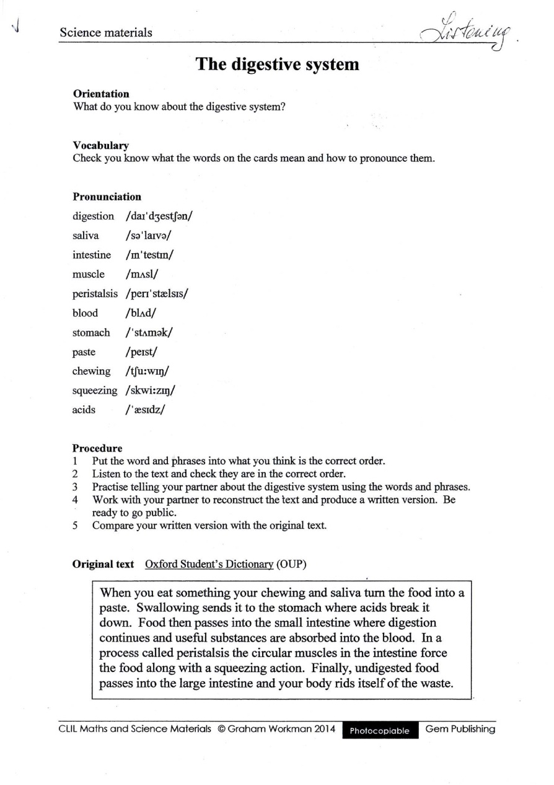

Students read what is written on cards.Teacher reads the „story” and students have to put the cards in the correct order while listening.(Handout 3)
Handout 3.↑

3. Revision quiz. The teacher offers 10 questions to answer . (Handout 4- or to write on interactive whiteboard).
DIGESTION QUESTIONS:
1) What is alimentary canal?
2)Which is its longest section?
3)How long does food travel through alimentary canal?
4)What does it depend on?
5)What is absorption?
6)What modes of digestion do you know?
7)What is ingestion/egestion?
8)What are the functions of mucus?
9)What is the role of bile?
10)What is villi? Why do we need them?

To find answers to the questions they still cannot, students have to read the text. (Handout 5).(Clean variant-for students, underlined-for teachers).(Text on pages 62-63 about teeth has been omitted).
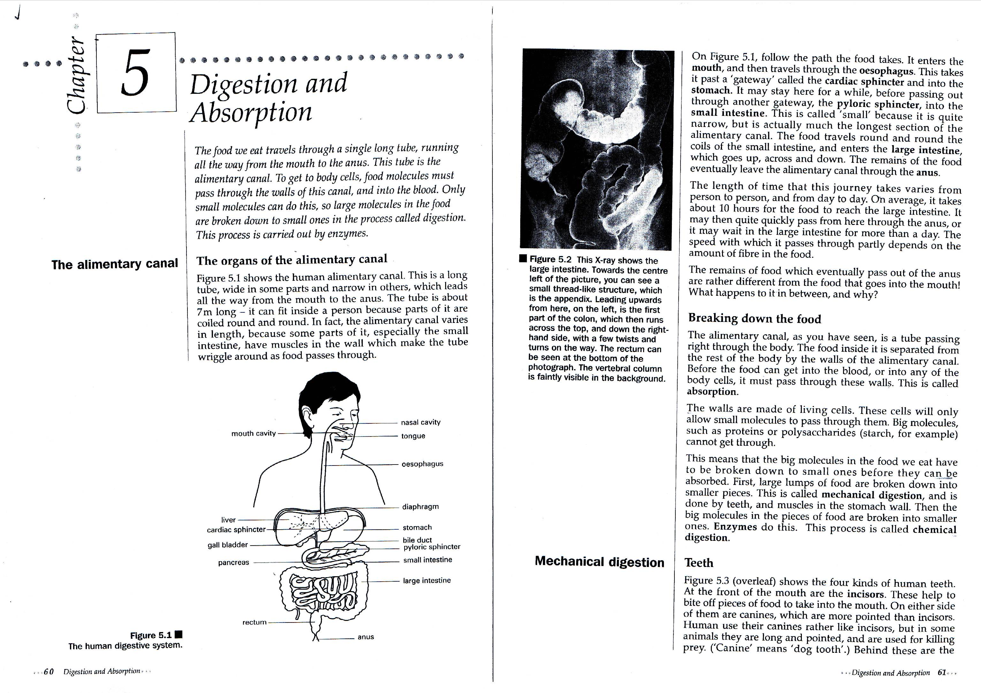
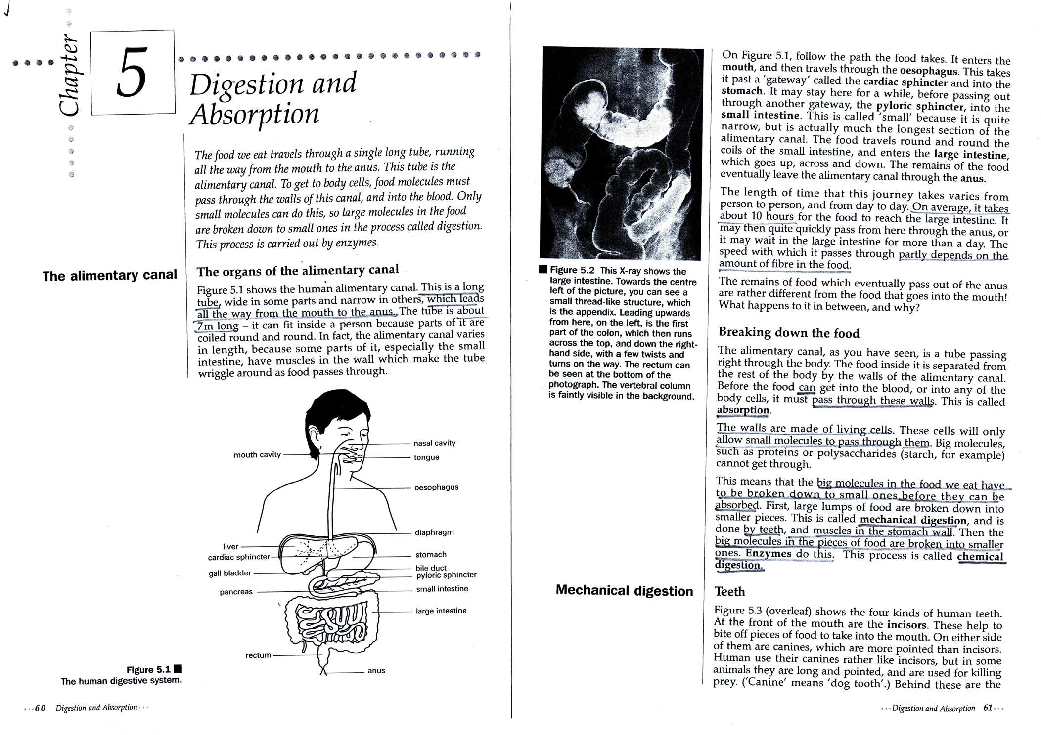

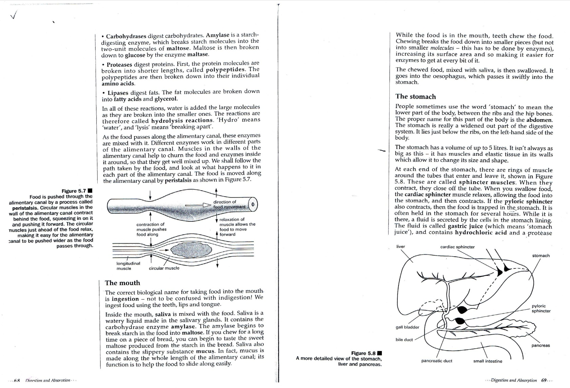
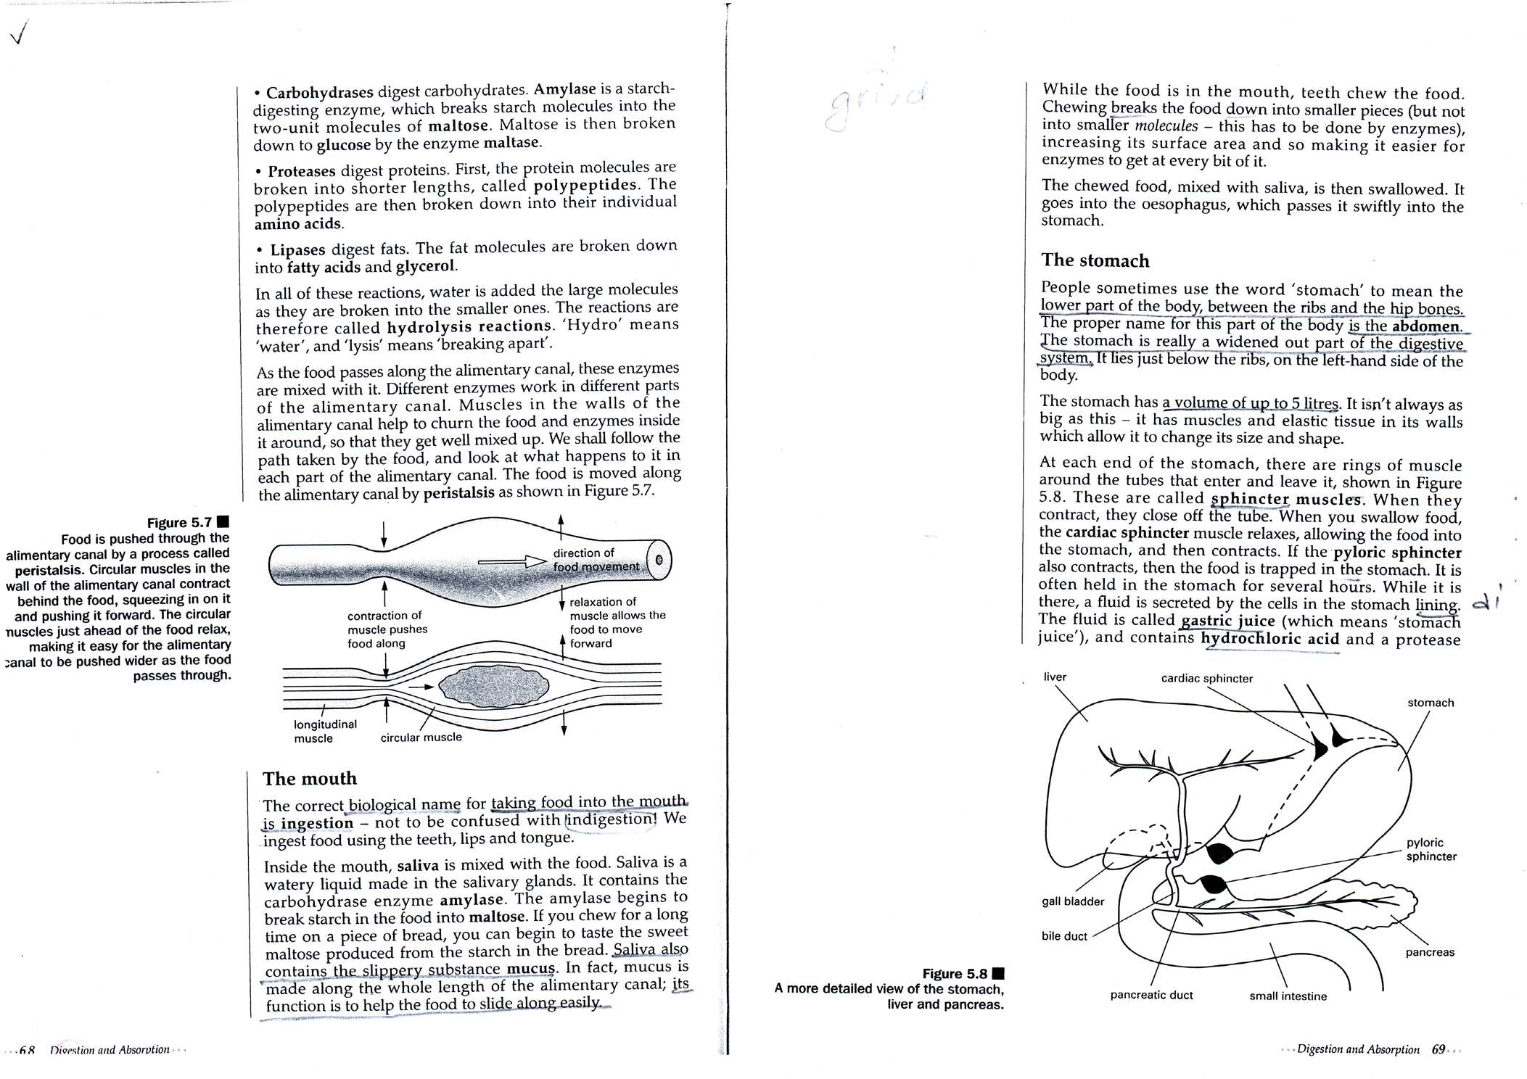
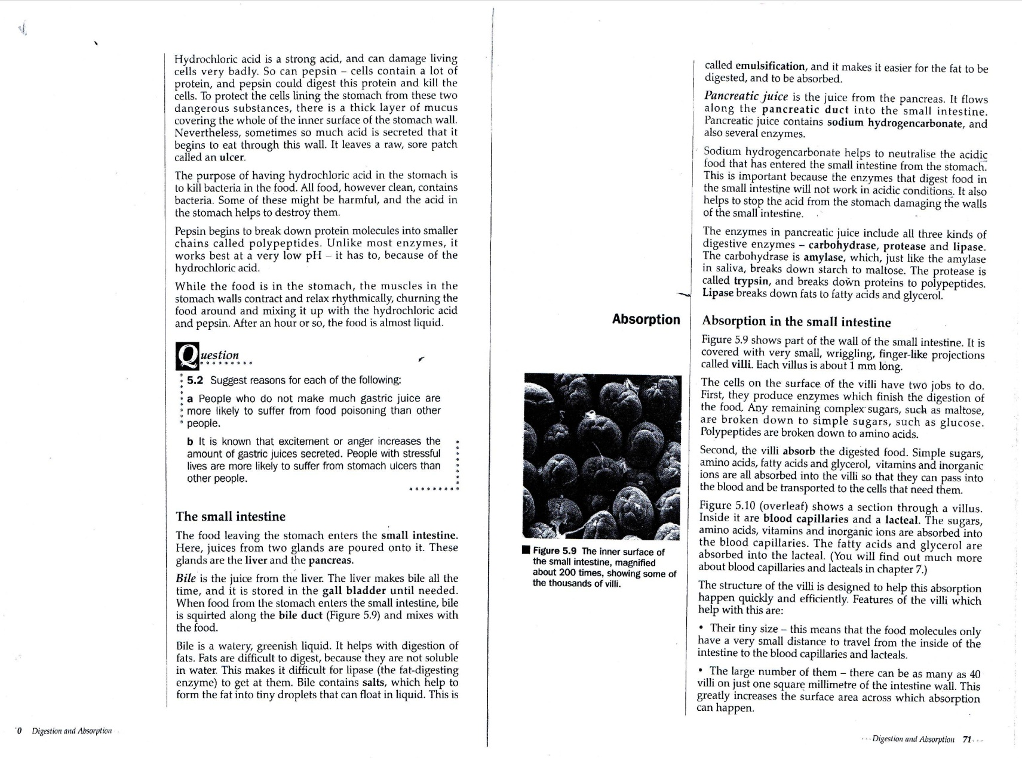
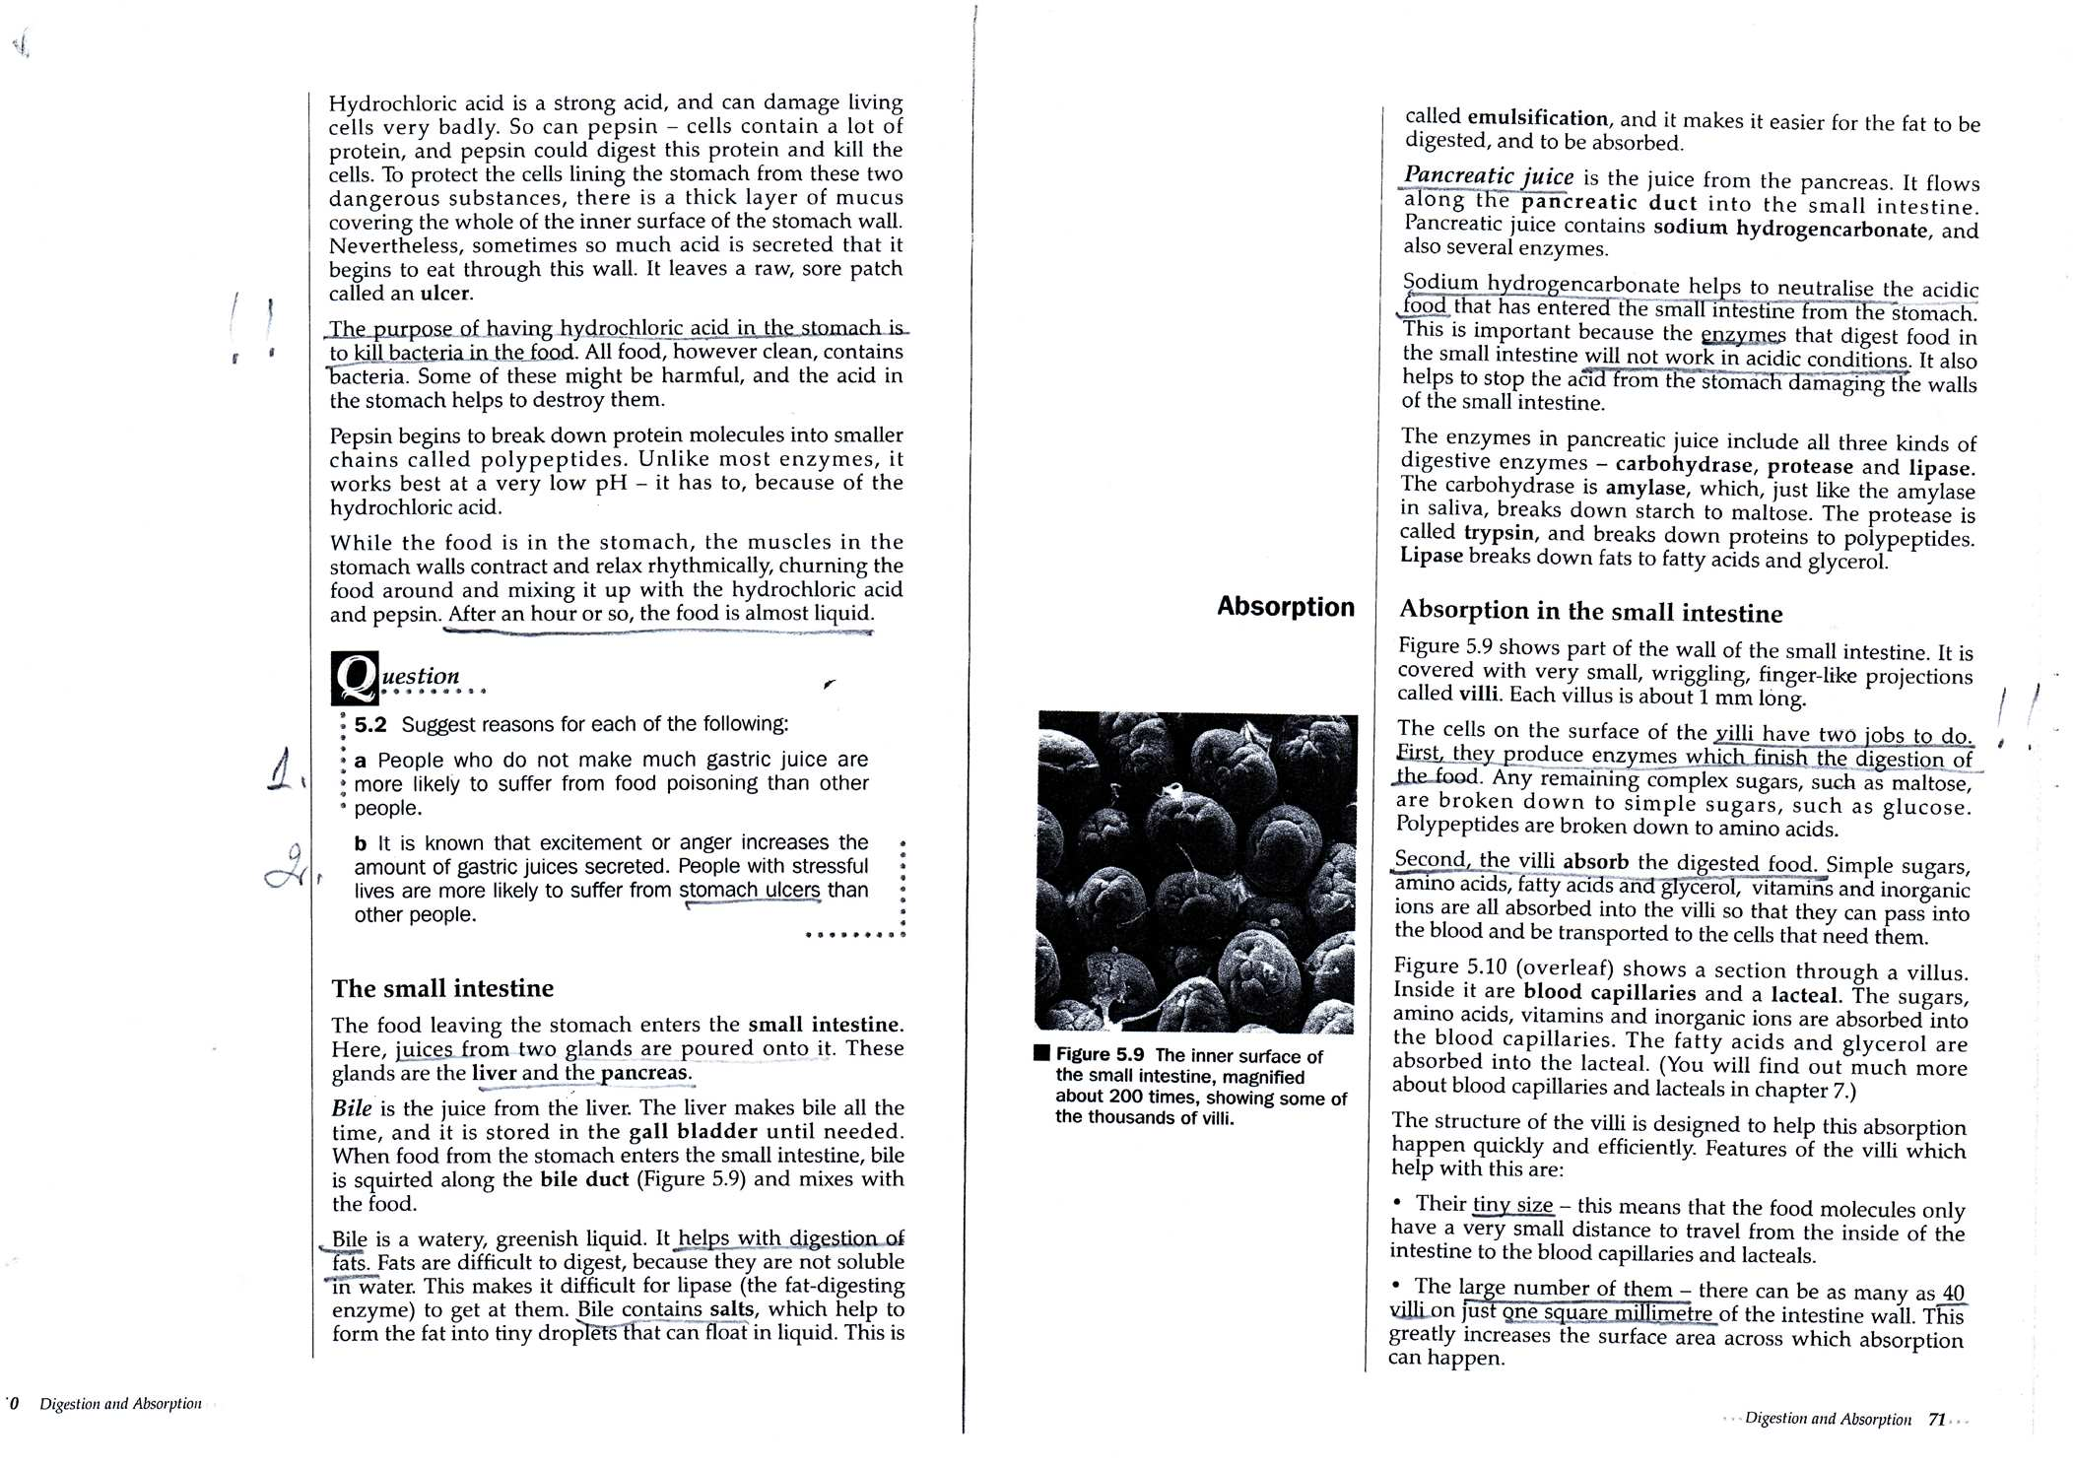

Key:
1.A long tube which leads from the mouth to the anus.
2.The small intestine.
3.On average -10 hours.
4.On the amount of fibre. Other factors: Health problems, amount of food, water consumed.
5.The passage of food through the walls of the alimentary canal.
6. Mechanical and chemical.
7.Taking food into mouth. The removal of faeces from the body.
8. To help the food to slide along easily.
9.It helps to digest fats.
10.Small finger-like projections covering the walls of intestine.
They increase the surface area of absorption.

*Optional activity-digestion song. Watch online-
https://www.youtube.com/watch?v=OKWPlM_qIuo

