LESSON PLAN

Subject: Maths

Topic: Direct and indirect variation

Age of students: 15-16

Language level: B1

Time: 45-60 minutes

Contents aims:
After completing the lesson, the student will be able to:
Identify direct variation equations.
Solve problems involving direct variation.
Identify inverse (indirect) variation equations.
Solve problems involving inverse (indirect) variation.
Distinguish direct and indirect variation.

Language aims:
After completing the lesson, the student will be able to:
Use new vocabulary within the topic.
Interpret and communicate mathematics.

Pre-requisites:
Pupils have to know :

Linear and nonlinear
Materials: Handouts

Procedure steps:
1. Make copies of the handouts for each learner in the class.

Procedure:

1. WARM UP: Give pupils a problem:

If 5 cats can catch 5 mice in 5 days, how many days does it take 3 cats to catch 3 mice?

Talk to students about the task. Can they solve it alone? Tell them to try and solve it in pairs. Observe and give pupils 3 minutes to try to solve the problem.
2. Linear vs.nonlinear (10 minutes)
Teacher distributes handout 2.
- Instruct students to observe numerical, graphical and verbal representations from the Linear vs. Nonlinear Activity Sheet.
- Instruct students to sort the representations as linear or nonlinear relationships and to write which ones are linear and which ones are nonlinear. Students should complete this activity independently. Monitor student progress.

When they are finished teacher explains the difference between linear and directly proportional using a graph (directly proportional has to go through the origin)

Teacher explains:
A simple illustration of a proportional relationship would be the amount of money you earn at a fixed hourly wage of 10 pounds an hour. At zero hours, you will have earned zero pounds, at two hours, you will have earned 20 and at five hours you will have earned £50. The relationship is linear because you will get a straight line if you graph it, and proportional because zero hours equals zero dollars. (GRAPH A)
Compare this with a linear but non-proportional relationship. For example, the amount of money you earn at £10 an hour in addition to a 50 signing bonus. Before you start working (that is, at zero hours) you have 50 pounds. After one hour, you will have £60, at two hours £70, and at five hours £100. The relationship still graphs as a straight line (making it linear) but is not proportional because doubling the time you work does not double your money. (GRAPH B)

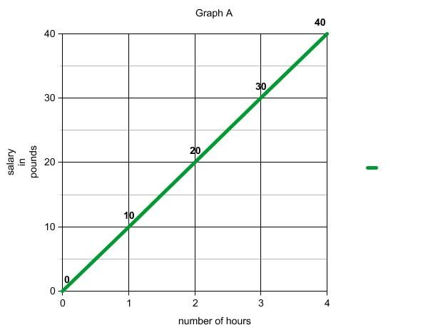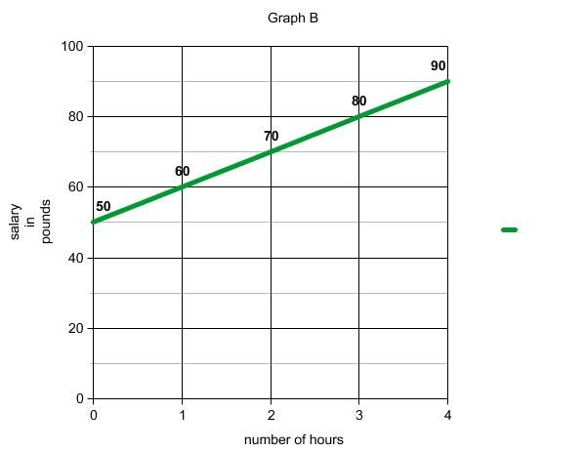
Teacher plots both graphs on the whiteboard and challenge students to determine which linear representations in handout A are direct variations. Instruct students to indicate these on their worksheet.

Linear vs. Nonlinear Answer Key:
- Linear: Items 1, 5, 8
- Linear and Directly proportional Items 2, 4, 9, 10, 14, 15
- Non-Linear: Items: 3, 6, 7, 11, 12, 13

2. Introduction to variations: (15 min)
Teacher explains: In this lesson, you'll learn how to approach questions about direct and inverse variation with a simple explanation of what the terms mean and how to apply them to problems. Equations with direct and inverse variation sound a little intimidating, but really, they're just two different ways of talking about how one number changes relative to another number.
Two quantities are said to vary directly if they change in the same direction. As the first increases, the second does also. As the first decreases, the second does also.
For example, the distance you travel at a constant rate varies directly as the time spent traveling. The number of pounds of apples you buy varies directly as the amount of money you spend. The number of pounds of butter you use in a cookie recipe varies directly as the number of cups of sugar you use.
Whenever two quantities vary directly, a problem can be solved using a proportion. We must be very careful to compare quantities in the same order and in terms of the same units in both fractions. If we compare miles with hours in the first fraction, we must compare miles with hours in the second fraction.
You must always be sure that as one quantity increases or decreases, the other changes in the same direction before you try to solve using a proportion.
Example: If 10 boys can deliver 100 newspapers in one hour, how many newspapers can 15 boys deliver in the same time?
10/100=15/x
X=150

In inverse variation, it's exactly the opposite: as one number increases, the other decreases. This is also called inverse proportion. An example would be
4 people can paint a fence in 3 hours.
How long will it take 6 people to paint it?
(Assume everyone works at the same rate)
If we wanted to give this one an equation, we would say:
y = k/x, where x is number of people and y is the number of hours, and k is still the constant of proportionality, telling how much one varies when the other changes.
Two quantities are said to vary inversely if they change in opposite directions. As the first increases (in this case the number of people), the second decreases (number of hours needed). As the first decreases, the second increases.
Whenever two quantities vary inversely, their product remains constant. Instead of dividing one quantity by the other and setting their quotients equal as we did in direct variation, we multiply one quantity by the other and set the products equal.
3×2=2×X; X (the number of days)=3
3, Teacher distributes handouts 1 and 2 to students and asks them to observe them briefly. Which one is direct and which one is indirect variation exercise?
Discussion about the first exercise: is cost of book directly proportionate to the cost?
Sscussion about problem 7. How does the diameter of a gear affect the number of revolutions? Draw gears on whiteboard and ask which one has to have more revolutions, big one or small one?
Teacher gives pupils 15 minutes to solve both handouts. Teacher has to insist that pupils solve all exercises as explained by the teacher. The difficult part for the pupils will be to understand which ones are direct variotions and which problems are indirect variations:

SOLUTIONS:
direct: 1 D 3C 5A 7D 9B
inverse: 2C 4A 6 B 8B 10B

Attachment *:
Classroom handout 1 & 2
Assessment grid
Class observations, questions
Teachers will also be collecting information through informal assessment activities. By observing students as they work in groups, asking questions, setting specific activities, and marking students’ work

1. Find the cost, in pennies, of 8 books if 2 books of the same kind cost P pounds .
(A) 4P
(B) $\frac{1}{400P}$
(C) $\frac{1}{4P}$
(D) $400P$
(E) $\frac{108P}{2}$

2. A restaurant has enough food to serve 100 people for 4 days. If only 80 people come each day how many days can they be in business without the need to restock their supplies?
(A) 3
(B) 6
(C) 5
(D) 4 $\frac{1}{8}$
(E) 5 $\frac{1}{3}$

3. The toll on a new highway is 8 eurocents for every 5 kilometres traveled. What is the toll for a trip of 115 km on this road?
(A) 9.20 €
(B) 1.70 €
(C) 1.84 €
(D) 1.64 €
(E) 1.76 €

4. A gear with 20 teeth revolving at 200
revolutions per minute is meshed with a second gear turning at 250 revolutions per minute. How many teeth does this gear have?
(A) 16
(B) 25
(C) 15
(D) 10
(E) 24

5. If b boats can carry p passengers, how many boats are needed to carry m passengers?
(A)rm/b
(B) rb/m
(C) b/rm
(D) bm/r
(E)m/rb

6. Two boys weighing 30 kilos and 40 kilos balance a seesaw. How many meters from the fulcrum must the heavier boy sit if the lighter boy is 1.5.m from the fulcrum?
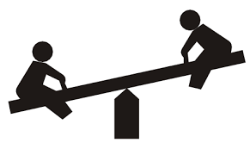
(A) 1
(B) $\frac{2}{3}$
(C) 1$\frac{1}{3}$
(D) $3$
(E) 0.5
7. John’s car uses 20 litres of gas to drive 425 kilometres. At this rate,approximately how many litres of gas will he need for a trip of 1000 kilometres?
(A) 44
(B) 45
(C) 46
(D) 47
(E) 49
8. 8 people can paint a wall in 6 hours. If 3 people don't come to work, how many hours will it take to paint the wall?
(A) 12
(B) 9$\frac{3}{5}$
(C) 3 $\frac{3}{4}$
(D) 4
(E) 16
9. On a map $\frac{1}{2}$ cm = 10 kilometres. How many km apart are two towns that are 2 $\frac{1}{4}$ cm apart on the map?
(A) 11 $\frac{1}{4}$
(B) 45
(C) 22 $\frac{1}{2}$
(D) 40$\frac{1}{2}$
(E) 42
10. A pulley revolving at 200 revolutions per minute has a diameter of 15 inches. It is belted to a second pulley which revolves at 150 revolutions per minute. Find the diameter, in inches, of the second pulley.
(A) 11.2
(B) 20
(C) 18
(D) 16.4
(E) 2

HANDOUT 2

Linear vs. Nonlinear Pre-Assessment
- Determine whether each relationship represented by the tables, equations, graphs and written descriptions is linear or nonlinear.
- Place each item in the appropriate column on your “Linear vs. Nonlinear Worksheet”

x | 0 | 1 | 2 | 3
y | 0 | 2 | 4 | 6
1. 2.
x | 0 | 3 | 6 | 9
y | 2 | 6 | 10 | 14

3.
x | 1 | 2 | 4 | 5 | 10 | 20
y | 20 | 10 | 5 | 4 | 2 | 1

4. y= 4x 5. y = 3x + 3 6. xy = 20 7. y = x ²
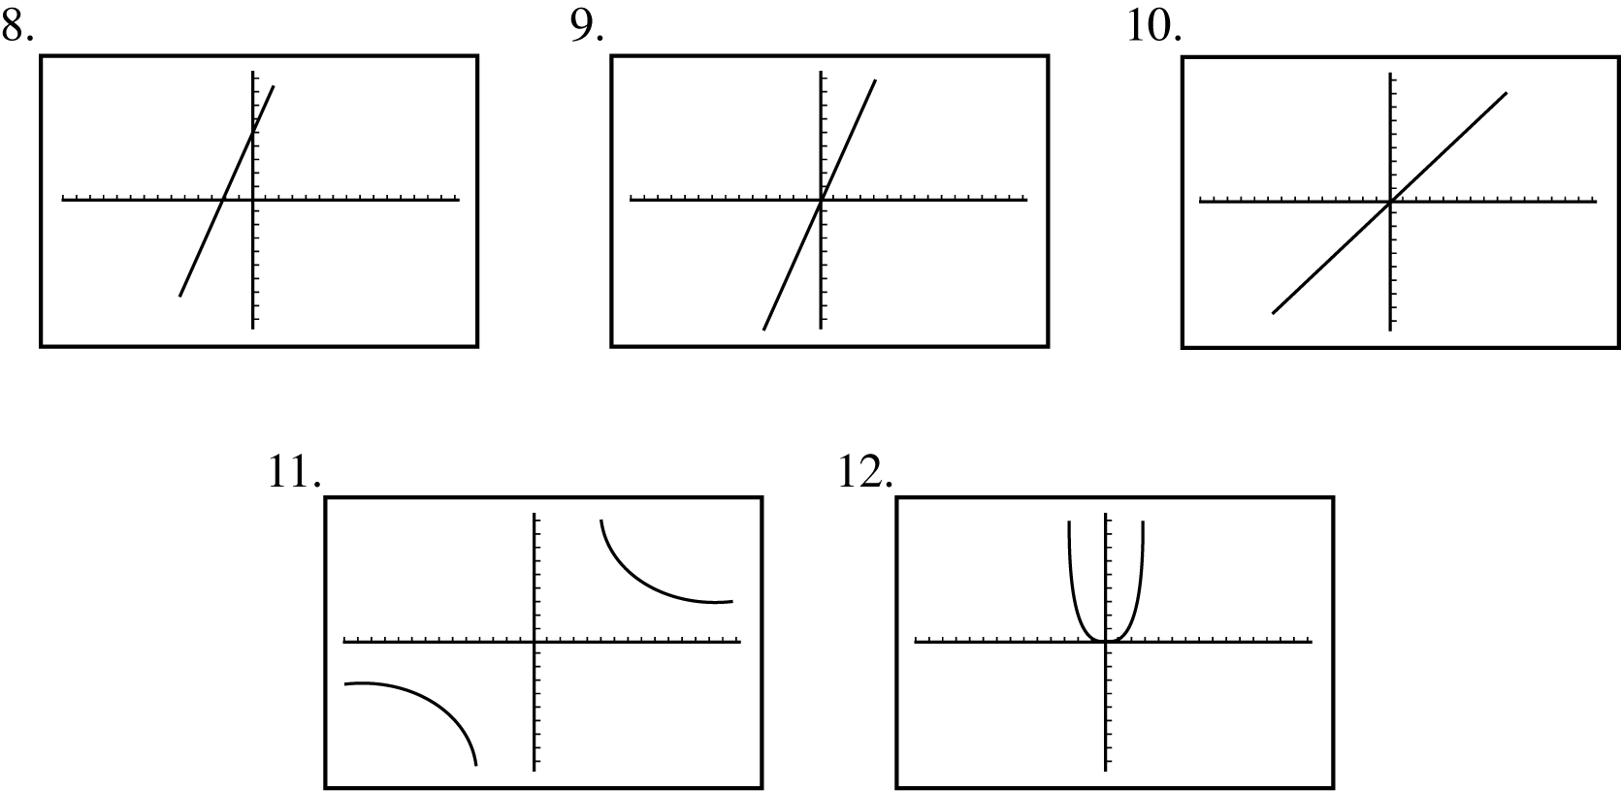
- The length and width of rectangles with areas of 20 square units
- The number of hours and the distance traveled when driving in a car at a constant rate of 60 mph
- The number of touchdowns scored in a football game and the points scored (from touchdowns)

Linear:
Nonlinear:

