Subject:​ ART HISTORY

Topic: ​PROPAGANDA POSTERS: WORLD WAR I

Age of students:​ 17 ­18

Language level: ​B1/B2

Time:​ 90/ 120 MINUTES

Contents aims:
After completing the lesson, the student will be able to:
Describe elements of propaganda poster.
Analyze the visual contents of propaganda poster.
Recognize and list the aims of a proaganda poster.
Discuss the differences between common language and the language used in propaganda posters.
Create a propaganda poster.

Language aims:
After completing the lesson, the student will be able to:
Use the vocabulary to describe features of a poster.
State an opinion about the poster, using examples from the lesson to support the opinion.

Prerequisites:
To be able to describe a picture. Use of present/past tense. Passive. Modals. Expressing suppositions

Materials: ​Photos, the Net, a projector

Procedure steps:

step 1 ( 15minutes)​:WARM UP ACTIVITIES ­ the teacher introduces the topic and asks the students to define the three key­words in the title, with the help of a dictionary if necessary:

PROPAGANDA:

POSTER:

WORLD WAR:

Since WORLD WAR I is mainly involved, a possible question including History can be asked to give students a general idea of the historical context which produced that tragic event. Students can fill in the following table:

COUNTRIES | When did the | WHY ? | When did | Consequences
INVOLVED | war start? | causes | the war
 |  |  | finish?

To help students describe war and propaganda, teachers can introduce new words and concepts explaining their meaning
Glossary
Figure, stroke, caption, atmosphere, army, patriottism, to appoint, to join, chivalry, hero, battle field, trenches, attack, annexion, freedom, conquest, to conquer, political, political power, comrades.

step 2 (30minutes) : ​the teacher divides the class into 5 groups. Each group must cooperate and analyze the poster given, filling in the table which covers the 2 aspects stated:

- visual features

- language used

ANALYSIS OF VISUAL FEATURES | ANALYSIS OF LANGUAGE
main figures: | Is there a ​caption​?Yes......... No.........
space organization: | If YES, what are t​he key­words​?
 | ­
colours: | ­
 | ­
stroke: | ­
atmosphere created: | verbs:
 | ­ what verb tense is predominant?
 | ­ what feeling do they convey?

All together the posters analyzed will be 5

ANALYSIS OF VISUAL FEATURES | ANALYSIS OF LANGUAGE
main figures: | Is there a ​caption​?Yes......... No.........
space organization: | If YES, what are t​he key­words​?
 | ­
colours: | ­
 | ­
stroke: | ­
atmosphere created: | verbs:
 | ­ what verb tense is predominant?
 | ­ what feeling do they convey?

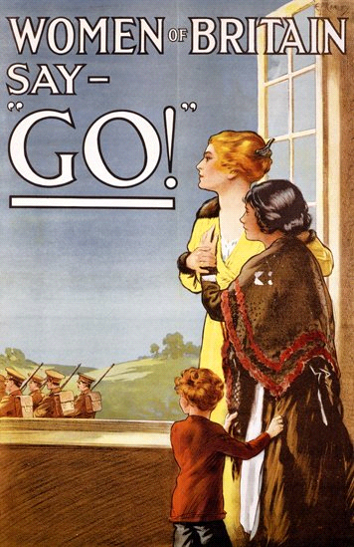

ANALYSIS OF VISUAL FEATURES | ANALYSIS OF LANGUAGE
main figures: | Is there a ​caption​?Yes......... No.........
space organization: | If YES, what are t​he key­words​?
 | ­
colours: | ­
 | ­
stroke: | ­
atmosphere created: | verbs:
 | ­ what verb tense is predominant?
 | ­ what feeling do they convey?

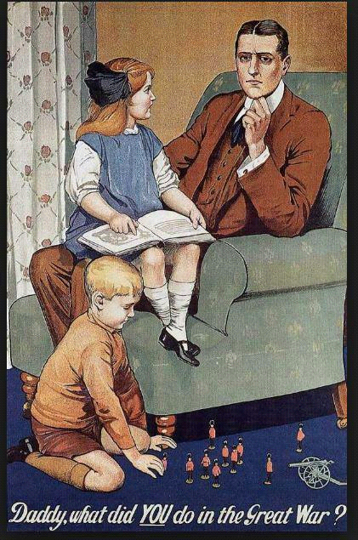

ANALYSIS OF VISUAL FEATURES | ANALYSIS OF LANGUAGE
main figures: | Is there a ​caption​?Yes......... No.........
space organization: | If YES, what are t​he key­words​?
 | ­
colours: | ­
 | ­
stroke: | ­
atmosphere created: | verbs:
 | ­ what verb tense is predominant?
 | ­ what feeling do they convey?

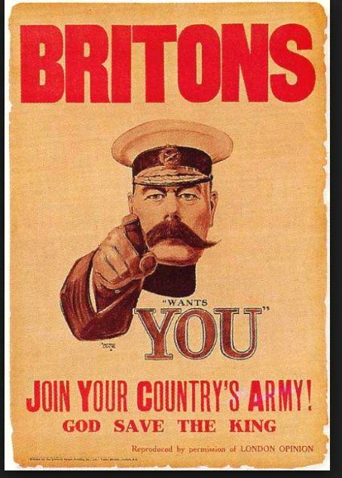

ANALYSIS OF VISUAL FEATURES | ANALYSIS OF LANGUAGE
main figures: | Is there a ​caption​?Yes......... No.........
space organization: | If YES, what are t​he key­words​?
 | ­
colours: | ­
 | ­
stroke: | ­
atmosphere created: | verbs:
 | ­ what verb tense is predominant?
 | ­ what feeling do they convey?

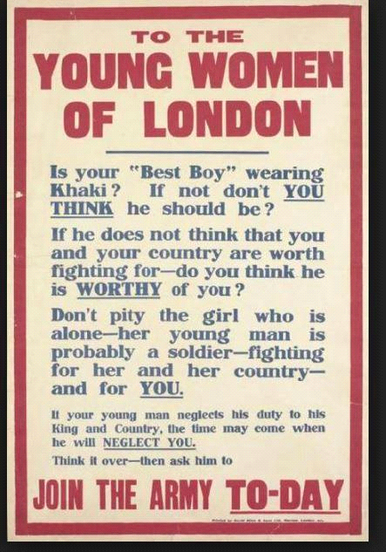

ANALYSIS OF VISUAL FEATURES | ANALYSIS OF LANGUAGE
main figures: | Is there a ​caption​?Yes......... No.........
space organization: | If YES, what are t​he key­words​?
 | ­
colours: | ­
 | ­
stroke: | ­
atmosphere created: | verbs:
 | ­ what verb tense is predominant?
 | ­ what feeling do they convey?

step 3 (30minutes) ​:each group shares its results with the class, asking/answering possible questions

step 4 (15minutes): ​the class fills in a table which summarizes the features all the posters have in common

ANALYSIS OF VISUAL FEATURES | ANALYSIS OF LANGUAGE

step 5 (15minutes)​: ​the class is asked to create a poster supporting PEACE

Expansion. For a further and more complete knowledge of ​WORLD WAR I ​a literary approach can be suggested.

Some war poems can be read and analyzed with the whole group, focusing on the language used by poets to convey the sense of horror they experienced in war or to support patriotism and heroism.:

Isaac Rosenberg

Break of Day in the Trenches

The darkness crumbles away.
It is the same old druid Time as ever,
Only a live thing leaps my hand,
A queer sardonic rat,
As I pull the parapet’s poppy
To stick behind my ear.

Droll rat, they would shoot you if they knew
Your cosmopolitan sympathies.
Now you have touched this English hand
You will do the same to a German
Soon, no doubt, if it be your pleasure
To cross the sleeping green between.

It seems you inwardly grin as you pass
Strong eyes, fine limbs, haughty athletes,
Less chanced than you for life,
Bonds to the whims of murder,
Sprawled in the bowels of the earth,
The torn fields of France.

What do you see in our eyes
At the shrieking iron and flame
Hurled through still heavens?
What quaver—what heart aghast?
Poppies whose roots are in man’s veins
Drop, and are ever dropping;
But mine in my ear is safe—
Just a little white with the dust.

Isaac Rosenberg

‘August 1914′

What in our lives is burnt In the fire of this?

The heart’s dear granary? The much we shall miss?

Three lives hath one life – Iron, honey, gold.

The gold, the honey gone – Left is the hard and cold.

Iron are our lives

Molten right through our youth. A burnt space through ripe fields A fair mouth’s broken tooth.

Wilfred Owen

Dulce Et Decorum Est

Bent double, like old beggars under sacks,
Knock­kneed, coughing like hags, we cursed through sludge, Till on the haunting flares we turned our backs
And towards our distant rest began to trudge. Men marched asleep. Many had lost their boots
But limped on, blood­shod. All went lame; all blind; Drunk with fatigue; deaf even to the hoots
Of disappointed shells that dropped behind.

GAS! Gas! Quick, boys!­­ An ecstasy of fumbling, Fitting the clumsy helmets just in time;
But someone still was yelling out and stumbling And floundering like a man in fire or lime.­­
Dim, through the misty panes and thick green light As under a green sea, I saw him drowning.

In all my dreams, before my helpless sight,
He plunges at me, guttering, choking, drowning.
If in some smothering dreams you too could pace Behind the wagon that we flung him in,
And watch the white eyes writhing in his face, His hanging face, like a devil's sick of sin;
If you could hear, at every jolt, the blood Come gargling from the froth­corrupted lungs, Obscene as cancer, bitter as the cud
Of vile, incurable sores on innocent tongues,­­ My friend, you would not tell with such high zest To children ardent for some desperate glory, The old Lie: Dulce et decorum est
Pro patria mori.

Rupert Brooke

The Soldier

If I should die, think only this of me: That there's some corner of a foreign field That is for ever England. There shall be In that rich earth a richer dust concealed;
A dust whom England bore, shaped, made aware, Gave, once, her flowers to love, her ways to roam, A body of England's, breathing English air, Washed by the rivers, blest by suns of home.
And think, this heart, all evil shed away,
A pulse in the eternal mind, no less
Gives somewhere back the thoughts by England given; Her sights and sounds; dreams happy as her day;
And laughter, learnt of friends; and gentleness, In hearts at peace, under an English heaven.

