LESSON PLAN

Subject: Art History

Topic: The Athenian acropolis

Students' age: 14-15

Language level: B1

Time: 2 hours

Content aims: Art History (and a bit of History) on ancient Greece and the poleis.
To describe an artistic element of an ancient city
To understand the political role of Art and Religion in Ancient Greece

Language aims:
- Listening activity
- Learn and use new vocabulary
- Knowledge of technical art and history vocabulary

Pre-requisites:
- Geographical and cartographical skill
- Knowledge of Greek history from the Persian wars to Pericles;
- The role of the city in the world

Materials:
- Personal computer
- handouts
Procedure steps:
Teacher starts explaining the geographical asset: where is Greece in Europe, where is Athens, arriving to the map that shows the metropolis in the details. Then after a short brainstorming activity about the poleis, (birth and main characters) arrives to the substantial continuity of the word polis in English.
Which are the words deriving from polis?
acropolis, necropolis, metropolis, metropolitan; megalopolis,
cosmopolitan;
Politics
Policy
Police
T. shows map and asks:
Where are the acropolis and the necropolis of Athens?
Then t. shows a video, inviting students to understanding the following items:
- Which was the Athenian political role?
- Which politicians are quoted? Why? When do they live?
- Which are the most relevant urban changes for Athens?

Finally teacher invites students to complete the handout

HANDOUT
a) Sites references:
Image coins: http://www.ancientresource.com/lots/greek/coins_athens.html
http://blogs-images.forbes.com/stephenpope/files/2011/05/300px-1_euro_coin_Gr_serie_1.png
Athena's birth: http://galeri7.uludagsozluk.com/282/zeus_454246.png

b) vvideos's transcripts
1) https://www.khanacademy.org/humanities/ancient-art-civilizations/greek-art/classical/v/parthenon

Transcript
Voiceover: We're looking at the Parthenon.
This is a huge marble temple to the goddess Athena.
Voiceover: We're on the top of a rocky outcropping in the city of Athens very high up overlooking the city, overlooking the Aegean Sea.
Voiceover: Athens was just one of many Greek city states and almost everyone had an acropolis.
That is had a fortified hill within its city because these were warring states.
Voiceover: In the 5th CenturyAthens was the most powerful city state and that's the period that the Parthenon dates to.
Voiceover: This precinct became a sacred one rather than a defensive one.
This building has had tremendous influence not only because it becomes the symbol of the birth of democracy, but also because of its extraordinary architectural refinement. The period when this was built in the 5th cent ury is considered the high classical moment and for so much of western history we have measured our later achievements against this perfection.
Voiceover: It's hard not to recognize so many buildings in the west. There's certainly an association especially to buildings in Washington D.C. and that's not a coincidence.
Voiceover: Because this is the birthplace of democracy it was a limited democracy but democracy nevertheless.
Voiceover: There was a series of reforms in the 5th century in Athens that allowed more and more people to participate in the government.
Voiceover: We think that the city of Athens had between 300 and 400,000 inhabitants and only about 50,000 were actually considered citizens. If you were a woman, obviously if you were a slave you were not participating in this democratic experiment.
Voiceover: This is a very limited idea of democracy.
Voiceover: This building is dedicated to Athena and in fact the city itself is named after her and of course there's a myth. Two gods vying for the honor of being the patron of this city.
Voiceover: Those two gods are Poseidon and Athena. Poseidon is the god of the sea and Athena has many aspects. She's the goddess of wisdom, she is associated with war. A kind of intelligence about creating and making things.
Voiceover: Both of these gods gave the people of this city a gift and then they had to choose. Poseidon strikes a rock and from it springs forth the saltwater of the sea. This had to do with the gift of naval superiority. Voiceover: Athena offered in contrast an olive tree. The idea of the land of prosperity, of peace. The Atheneans chose Athena's gift. There actually is site here on the acropolis where the Atheneans believed you could see the mark of the trident from Poseidon where he struck the ground and also the tree that Athena offered.
Voiceover: Actually the modern Greeks have replanted an olive tree in that space. Let's talk about the building. It is really what we think of when we think of a Greek temple but the style is specific. This is a Doric temple.
Voiceover: Although it has Ionic elements which we'll get to.
Voiceover: The Doric features are really easy to identify. You have massive columns with shallow broad flutes the vertical lines. Those columns go down directly into the floor of the temple which is called the stylobate and at the top the capitals are very simple. There's a little flare that rises up to a simple rectangular block called an abacus. Just above that are triglyphs and metopes.
Voiceover: It's important to say that this building was covered with sculpture. There were sculpture in the metopes, there were sculpture in the pediments and in an unprecedented way a frieze that ran all the way around four sides of the building just inside this outer row of columns that we see. Now this is an Ionic feature. Art historians talk about how this building combines Doric elements with Ionic elements.
Voiceover: In fact there were four Ionic columns inside the west end of the temple.
Voiceover: When the citizens of Athens walked up the sacred way perhaps for religious procession or festival. They encountered the west end and they walked around it either on the north or south sides to the east and the entrance. Right above the entrance in the sculptures of the pediment they could see the story of Athena and Poseidon vying to be the patron of the city of Athens. On the frieze just inside they saw themselves perhaps at least in one interpretation involved in the Panathenaic Procession, the religious procession in honor of the goddess Athena. This was a building that you walked up to, you walked around and inside was this gigantic sculpture of Athena.
Voiceover: These were all sculptures that we believe were overseen by the great sculptor Phidias and one of my favorite parts are the metopes. Carved with scenes that showed the Greeks battling various enemies either directly or metaphorically. The Greeks battling the Amazons, the Greeks against the Trojans, the Lapiths against the Centaurs, and the Gigantomachy. The Greek gods against the titans.
Voiceover: All of these battles signified the ascendancy of Greece and of the Atheneans of their triumphs.
Civilization over barbarism, rational thought over chaos.
Voiceover: You've just hit on the very meaning of this building. This is not the first temple to Athena on this site. Just a little bit to the right as we look at the east end there was an older temple to Athena that was destroyed when the Persians invaded. This was a devastating blow to the Atheneans.
Voiceover: One really can't overstate the importance of the Persian War for the Athenean mindset that created the Parthenon. Athens was invaded and beyond that the Persians sacked the acropolis, sacked the sacred site, the temples. Destroyed the buildings.
Voiceover: They burned them down. In fact, the Atheneans took a vow that they would never remove the ruins of the old temple to Athena.
Voiceover: So they would remember it forever.
Voiceover: But a generation later they did.
Voiceover: They did, well there was a piece that was established with the Persians and some historians think that that allowed them to reneg on that vow and Pericles, the leader of Athens embarked on this enormous, very expensive building campaign.
Voiceover: Historians believe that he was able to fund that because the Atheneans had become the leaders of what is called the Delian League. An association of Greek city states that paid a kind of tax to help protect Greece against Persia but Pericles dipped into that treasury and built this building.
Voiceover: This alliance of Greek city states, their treasure, their tax money, their tribute was originally located in Delos hence the Delian League, but Pericles managed to have that treasure moved here to Athens and actually housed in the acropolis. The sculpture of Athena herself which was made of gold and ivory Phidias said if we need money we can melt down the enormous amount of gold that decorates this sculpture of Athena.
Voiceover: Since that sculpture doesn't exist any longer we know somebody did that. (chuckles) We need to imagine this building not pristine and white but rather brightly colored and also a building that was used. This was a storehouse. It was the treasury and so we have to imagine that it was absolutely full of valuable stuff.
Voiceover: In fact we have records that give us some idea of what was stored here. We think about temples or churches or mosques as places where you go in to worship. That's not how Greek religion work. There usually was an altar on the outside where sacrifices were made and the temple was the house of the god or goddess, but with the Parthenon art historians and archeologists have not been able to locate an altar outside so we've wondered what was this building? One answer is it was a treasury.
Voiceover: It also functions symbolically.It is up on this hill. It commands this extraordinary view from all parts of the city, and so it was a symbol of both the city's wealth and power.
Voiceover: It's a gift to Athena. When you make a gift to your patron goddess you want visitors to be awed by the image of the goddess that was inside and of her home.
Voiceover: This isn't any goddess. This is the goddess of wisdom so the ability of man to understand our world and its rules mathematically, and then to express them in a structure like this is absolutely appropriate.
Voiceover: Iktinos is a supreme mathematician. I mean we know that the Greeks even in the archaic period before this were concerned with ideal proportions.
Voiceover: Pythagoras.
Voiceover: Or the sculptor Polykleitos and his sculpture of the Doryphoros searching for perfect proportions and harmony and using mathematics as the basis for thinking that through.
Voiceover: We have that here.
Voiceover: To an unbelievable degree.
Voiceover: What's extraordinary is that it's perfection is an illusion based on a series of subtle distortions that actually correct for the imperfections of our sight. That is the Greeks recognize that human perception was itself flawed and that they needed to adjust for it in order to give the visual impression of perfection. Their mathematics and their building skills were precise enough to be able to pull this off.
Voiceover: Every stone was cut to fit precisely.
Voiceover: When we look a this building we assume it's rectilinear, it's full of right angles, and in fact there's hardly a right angle in this building.
Voiceover: There's another interpretation of these tiny deviations that these deviations give the building a sense of dynamism. The sense of the organic that otherwise it would seem static and lifeless. The Greeks had used this idea that art historians call entasis before in other buildings. Slight adjustments. For example, columns bulge toward the center. This is not new but the degree to which it's used here and the subtlety in the way it's used is unprecedented.
Voiceover: For instance in those Doric columns you can see that there's a taper and you assume that it's a straight line but the Greeks wanted ever so slight a sense of the organic. That the weight of the building was being expressed in the bulge, the entasis of the column about a third of the way from the bottom. In this case every single column bulges only 11/16th of an inch the entire length of that column. The way that the Greeks pulled this off is they would bring column drums up to the site. They would carefully carve the base and the top and then they would carve in between.
Voiceover: We see this slight deviation in the columns but we also see it not only vertically but also horizontally in the building.
Voiceover: That's right. You assume that the stylobate, the floor of the temple is flat but it's not. Rain water would run off it because the edges are lower than the center.
Voiceover: But only very, very slightly lower.
Voiceover: Across the long side of the temple the center rises only 4 3/8 of an inch and on the short side of the temple on the east and the west side the center rises only by 2 3/8 inches. What happens is it cracks. Our eye would naturally see a straight line seem as if it rises up at the corners a little bit so it seems to us to be perfectly flat. The columns are all leaning in a little bit.
Voiceover: You would expect the columns to be equidistant from one another but in fact the columns on the edges are slightly closer to one another than the columns in the center of each side.
Voiceover: Architectural historians have hypothesized that the reason for this is because the column at the edge is in the sense an orphan.It doesn't have anything past it. Therefore, it would seem to be less substantial. If we could make that column a little bit closer to the one next to it it might compensate and it would have an even sense of density across the building.
Voiceover: Placing of the columns closer together on the edges create a problem in the levels above. One of the rules of the Doric Order is that there had to be a triglyph right above the center of a column or in between each column.
Voiceover: They also wanted the triglyphs to be at the very edge so one triglyph would abut against another triglyph at the corner of the building. If in fact you're placing your columns closer together you can actually solve for that problem. You can avoid the stretch of the metope in between those triglyphs that would result, but because the columns are placed so close together they had the opposite problem which is to say that the metopes at the ends of the building would be too slender. What Phidias has done in concert with Iktinos and Kallikrates the architects is to create sculptural metopes that are widest in the center just like the spaces between the columns and actually the metopes themselves gradually become thinner as you move to the edges so that you can't really even perceive the change without measuring.
Voiceover: The general proportions of the building can be expressed mathematically as X equals Y times two plus one. Across the front we see eight columns and along the sides 17 columns. That ratio also governs the spacing between the columns and its relationship to the diameter of a column. Math is everywhere
Voiceover: If we look at the plan of the structure we see the exterior colonnade on all four sides. On the east and west end it's actually a double colonnade and on the long sides, inside the columns a solid masonry wall. You can enter rooms on the east west only. The west has a smaller room with the four Ionic columns within it but the east room was larger and held the monumental sculpture of Athena. It's interesting. The system that was used to create a volt that was high enough to enclose a sculpture that was almost 40 feet high was unique. There was a U shape of interior columns at two storeys. They were Doric and they surrounded the goddess.
The sculpture is now lost but the building is almost lost as well. Here we come to one of the great tragedies
of western architecture. This building survived into the 17th century and was in pretty good shape for 2000 years and it's only in the modern era that it became a ruin.
Voiceover: First it was as we know an ancient Greek temple for Athena then it became a Greek orthodox church then a Roman catholic church and then a mosque. In a war between the Ottomans who were in control of Greece at this moment in history in the 17th century and the Venetians. The Venetians attacked the Parthenon, the Ottomans used the Parthenon to hold ammunitions, gunpowder. Gunpowder exploded from the inside basically ripping the guts out of the Parthenon.
Voiceover: Then to add insult to injury in the 18th century, Lord Elgin received permission from the Turkish government to take sculptures that had already fallen off the temple and bring them back to England. The [lie] and share of the great sculptures by Phidias are now in London. Greece recently has built a museum just down the hill from the acropolis specifically intended to house these sculptures should the British ever release them.
Voiceover: Some have argued that Elgin saved the sculptures that would have been further damaged had he not removed them, but what to do about the future is uncertain.
Voiceover: At least one theory states that this building was paid for by plundered treasury from the Delian League so there's a long history of contested ownership.
Voiceover: As we stand here very high up on the acropolis overlooking the Aegean Sea, islands beyond and mountains on this glorious day, I can't help but imagine standing inside the Parthenon between those columns which we can't do today.
Voiceover: The site is undergoing tremendous restoration. There are cranes, the scaffolding to maintain the ruin and not let it fall into worst disrepair.
Voiceover: But if we could stand there what would it feel like?
Voiceover: There is this beautiful balance between the theoretical and the physical. The Greeks thought about mathematics as the way that we could understand the divine and here it is in our world.
Voiceover: There's something about the Parthenon that is both an offering to Athena, the protector of Athens, but also something that's a monument to human beings, to the Atheneans, to their brilliance, and by extension I suppose in the modern era human spirit generally.

Parthenon final quiz: https://www.khanacademy.org/humanities/ancient-art-civilizations/greek-art/classical/e/parthenon-quiz

http://www.ancientgreece.co.uk/acropolis/home_set.html with the possibility of exploring the model clicking on the image.

c) Students sheet
Let's find the keywords
polis/poleis (plur) , state-city; acropolis; Parthenon

After the video on acropolis and Parthenon (n1 e 2): answer to the questions:
- There was another Temple of Athena?
- When the Parthenon was built?
- Who was the leader of Athens?
- How many citizens had the ancient city of Athens? And who were excluded by the citizenship?
- Which were the material used for the construction?
________________________________________________________________________________________________________________________________________________________________________________________________________________________________________________________________________________________________________________________________________________________________________________________________________________________________________________________________________________________________________________________________________________________________________________________________________________________________________________________________________________________________________________________________________________________________________________________________________________________________________________________________________________________________________________________________________________________________________________________________________________________________________________________________________________________________________________________________________________________________________________________________________________________________________________________________________________________________

Put on the map the following words (be careful, there are some extra)
Eretteo, Pericle, Parthenon, first temple of Athena, Propilea, Acropolis, Pireo, walls, Fidia, Academia; Museon; stadyum; lower city (astu); Saronic gulf; Phaleron; Long Walls

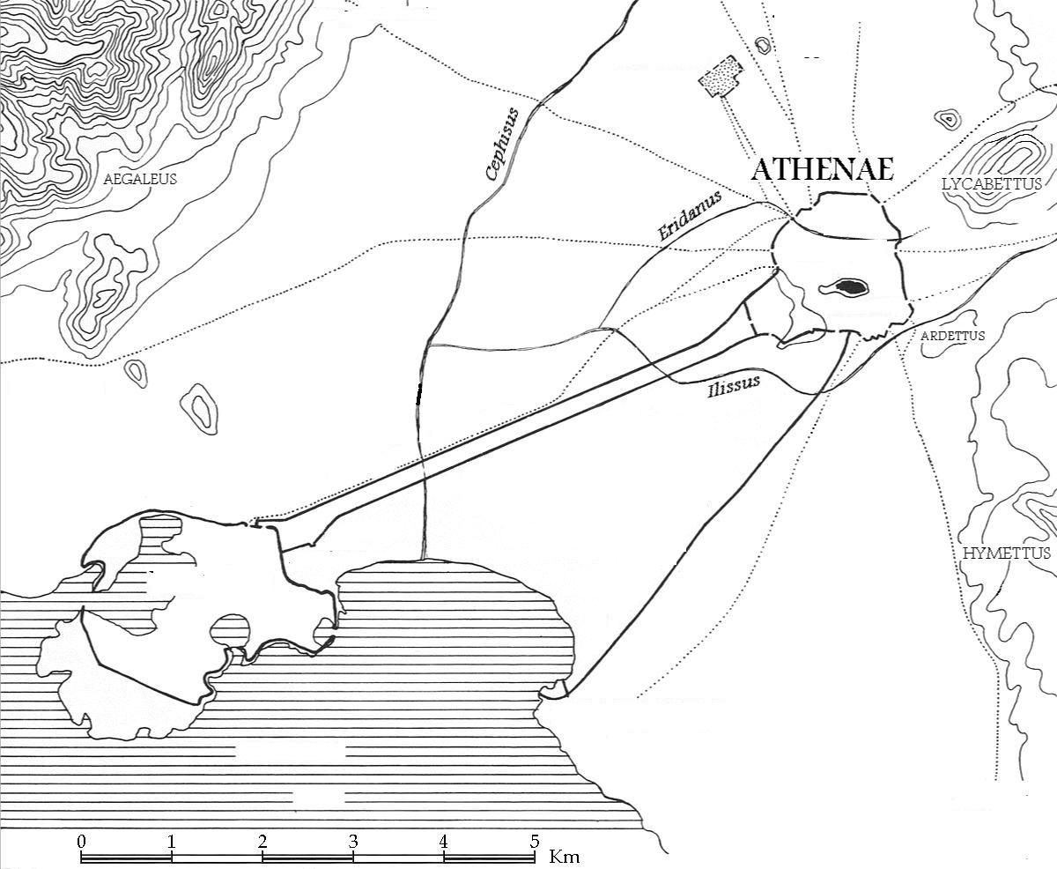

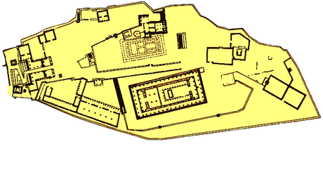
1 _______________________________; 2_________________________________;
3 _______________________________; 4_________________________________;
5 _______________________________; 6 _________________________________.

Identify the parts of an Ancient Greek temple, putting the number or the names on the image:
Cella; Pronaos; Opisthodomos; colonnade; Frieze; Triglyph; Cornice; Metope; crepidoma, columns, entablature, pediment, roof; tympanum; abacus; architrave; column
