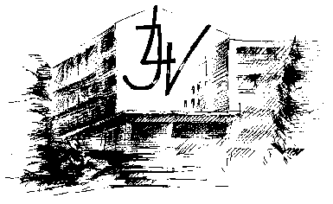

Meeting plan in Latvia
16.10.2016.-23.10.2016.
Day | Time | Activity type - short-term joint staff training events
Sunday  October 16th |  | Arrival
Monday  October 17th | 9.00 – 10.30 | Welcome from the headmaster, project coordinators, musical moment.
 | 10.45-12.15 | Teachers evaluate presentations
 |  | lunch
 | 13-16 | Visit in Jelgava city
Tuesday  October 18th | 9.00-9.45 | Teachers attend open lessons
 | 10-12 | Project team meeting. Discussion on project activities.
 | 12-13 | Discussion on evaluation’s grid
 |  | lunch
 | 16.00-19.00 | Exploration of web tool for infographic
Wednesday  October 19th | 8-18 | Visit Sigulda, Turaidas castle  White sand dune in Saulkrasti
Thursday  October 20th | 8-9 | Open lessons in Jelgava State Gymnasium
 | 9 - 10 | Teachers evaluate the lessons and discuss on improvements
 | 10 - 12 | Geogebra courses at Jelgava State Gymnasium
 | 12-12.45 | lunch
 | 12.45-16.45 | Geogebra courses at Jelgava State Gymnasium
 | 19.30 | Dinner in a restaurant in Jelgava
Friday  October 21th | 8 - 9 | Discussion on Geogebra usage in classess
 | 10-13 | Visit the University of Latvia
 | 13.30-15.30 | Visit in Riga Old town.
Saturday/Sunday  October 22nd/23rd |  | Departure

Jelgava, 21st October, 2016 Headmaster A. Celms

