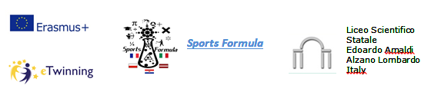
05/06 | ora | Students’ Activities | Where
 |  | Arrivals
 | 12:45 | Latvia | Orio
 | 17:00 | Croatia | Alzano - Piscine
 | 18:00 | France | Bergamo Train Station
 | 20:45 | Poland | Orio
06/02 | 9.30-10 | Headmistress welcome | Auditorium
 | 10-10:50 | Students present their works | Auditorium
 | 11:05-11:30 | Musical entertainment | Auditorium
 | 11:30-12.40 | Students present their works | Auditorium
 | Lunch
 | 14:15-16.30 | Treasure hunt | Bergamo Alta
7/02 | 8 - 9 | Students visit lessons | Classroom
 | 9 - 11 | Chemistry – Physics lab | Chemistry – Physics lab
 | 11 – 13 | Chemistry – Physics lab | Chemistry – Physics lab
 | Lunch
 | 14-15.30 | Sport
8/02 | 8 - 10 | Muscle strengthening | Gym room
 | 10 - 12 | Students make presentation | Lab ICT
9/02 | 7-19 | Mantua | Alzano – Piscine
10/02 | 9-12 | Conference: “skate and maths” | Auditorium Nassiriya
 | Lunch
 | 13.30-15.30 | Discussion about students’ ebook | Auditorium, lab ICT
11/02 |  | Departures
 | 7:05 (9:05) | Poland | Orio
 | 8:45 (10:45) | Latvia | Orio
 | 8:45 | France | Bergamo Train Station
 | 9 | Croatia | Alzano piscine

