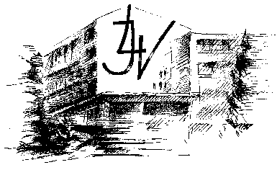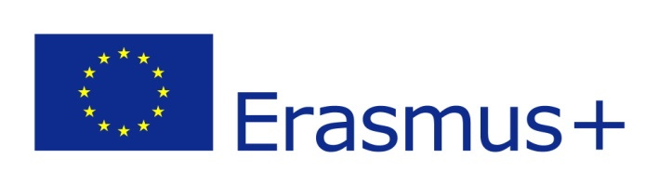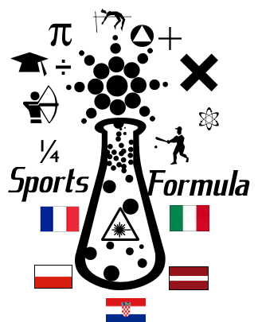

**Sports formula**

**DIARY OF THE 1ST PROJECT MEETING**

Jelgavas 4. vidusskola, Latvia, 17th to 21st October 2016

Partners:

|  |  |
| --- | --- |
| http://www.indobaltic.lv/img/flag_of_Latvia.gif | Jelgavas 4. Vidusskola, Latvia |
| http://upload.wikimedia.org/wikipedia/commons/thumb/1/1b/Flag_of_Croatia.svg/2000px-Flag_of_Croatia.svg.png | Druga gimnazija Varaždin, Croatia |
| Attēlu rezultāti vaicājumam “poland flag” | Zespol Szkol Elektronicznych I Licealnych, Poland |
| Attēlu rezultāti vaicājumam “france flag” | LEGTA Xavier Bernard, France |
| http://www.33ff.com/flags/XL_flags/Italy_flag.gif | LICEO SCIENTIFICO STATALE EDOARDO AMALDI, Italy |

The project is funded by the Erasmus+ Programme of the European Commission.

**Participants:**

|  |  |  |  |  |
| --- | --- | --- | --- | --- |
|  | **TEACHERS** | **STUDENTS** | | |
| **LICEO SCIENTIFICO STATALE EDOARDO AMALDI, Italy** | Antonietta Teresa Nani  Raffaella Marinoni | Ester Riccardi  Vannesa Madaschi  Francesco Cartisano  Luca Torri | | Marco Mangili  Michele Colombelli  Daniele Gagni |
| **DRUGA GIMNAZIJA VARAŽDIN, Croatia** | Vlatka Drvarić  Marijana Horvat | Patric Mežnarić  Martina Klepač  Ivana Labaš | | |
| **ZESPOL SZKOL ELEKTRONICZNYCH I LICEALNYCH, Poland** | Anna Sulek  Dariusz Rudzki | Maciej Dabrowski  Maciej Kulak  Dominik Kunaniec  Jakub Uchman - Lach | | |
| **LEGTA XAVIER BERNARD, France** | Pierre Lefebre  Olivier Noc | Matteo Clochard  Maxime Bouhier  Juliette Audurier  Clara Courrege | | |
| **Jelgavas 4. Vidusskola, Latvia** | Aina Pitrane  Liga Nevlana  Sanita Baltina  Renate Bogdanova  Vita Paula | Marta Klavkalne Sallija Klavkalne Daniela Gelvere Artis Ozols Martins Tomsons Erika Smirnova Rainers Laksa Emils Karpjuks Liva Lagzdina Laura Karkle | Diana Rijkure Lauma Laurinovica Niks Klavins Karlis Zurins Marta Kozlenoka Nikita Puke Elizabete Kovtuna Adrija Grinfelde Alina Zaharevska Davids Klavins | |

**Summary of participants:**

|  |  |  |  |
| --- | --- | --- | --- |
| **Country** | **Teachers** | **Students** | **Total** |
| **Croatia** | **2** | **3** | **5** |
| **Italy** | **2** | **7** | **9** |
| **Poland** | **2** | **4** | **6** |
| **France** | **2** | **4** | **6** |
| **Latvia** | **5** | **20** | **25** |
| **Total** | **13** | **38** | **51** |

**Meeting plan in Latvia**

**16.10.2016.-23.10.2016.**

|  |  |  |
| --- | --- | --- |
| **Day** | **Time** | **Activity type -  short-term joint staff training events** |
| **Sunday**  **October 16th** |  | Arrival |
| **Monday**  **October 17th** | 9.00 – 10.30 | Welcome from the headmaster and project coordinators, musical moment. |
| 10.45-12.15 | Teachers evaluate the student’s presentations |
| lunch | |
| 13-16 | Visit in Jelgava city |
| **Tuesday**  **October 18th** | 9.00-9.45 | Teachers attend the open lessons |
| 10-12 | Project team meeting. Discussion on the project activities. |
| 12-13 | Discussion on the evaluation grid |
| lunch | |
| 16.00-19.00 | Exploration of the web tool  for infographic |
| **Wednesday**  **October 19th** | 8-18 | Visit to Sigulda, Turaidas castle and  White sand dune in Saulkrasti |
| **Thursday**  **October 20th** | 8-9 | Open lessons in Jelgava State Gymnasium |
| 9 - 10 | Teachers evaluate the lessons and discuss on improvements |
| 10 - 12 | Geogebra courses at Jelgava State Gymnasium |
| lunch | |
| 12.45-16.45 | Geogebra courses at Jelgava State Gymnasium |
| 19.30 | Dinner in a restaurant in Jelgava |
| **Friday**  **October 21th** | 8 - 9 | Discussion on Geogebra usage in the classes |
| 10-13 | Visit the University of Latvia |
| 13.30-15.30 | Visit in Riga Old town. |
| **Saturday/Sunday**  **October 22nd/23rd** |  | Departure |
|  |  | |

**Short-term joint staff training events**

**DIARY OF THE 1ST PROJECT MEETING**

**1st day**

**17th October 2016**

On the first day of the meeting all participants came to school, Jelgavas 4. Vidusskola, Participants from Latvia prepared a short concert for the teachers and students from Croatia, Poland, Italy and France. Students performed a few Latvian national folk songs and teachers made some short speeches.

At 10.45 a.m., in the lecture hall, students from every country presented their works. Students prepared the presentations about their country and school, and teachers evaluated them.

After the presentations and lunch, at 1 p.m. teachers went to the guided tour of Jelgava city.

[Questionnaire for the evaluation of students](https://docs.google.com/forms/d/e/1FAIpQLSfZ0pWz8JAF0dqkdVoscxWBo9l98v1o3HQv1aK3q5r_W0wf5w/viewform?c=0&w=1&usp=mail_form_link)

|  | Bad | Satisfying | Good | Very good | Excellent |
| --- | --- | --- | --- | --- | --- |
| Use of ICT |  |  |  |  |  |
| Language skills |  |  |  |  |  |
| Presentation skills |  |  |  |  |  |
| Performance of given task |  |  |  |  |  |
| Overall impression |  |  |  |  |  |

**2nd day**

**18th October 2016**

At 9 a.m. teachers attended the open maths lessons. 4 teacher attended Renate Bogdanova’s lesson and 4 teachers attended Vita Paula’s lesson.

After the open lessons, at 10 a.m., there was a discussion on the further project activities. Teacher came to an agreement on different project activities and visits to other countries. Project participant set the roles of every country (eTwinning, project homepage, e-book, project diary and activities for students). At 12 o’clock, teachers had a discussion on evaluation grid. After lunch, teachers continued the discussion on the web tool for info graphic.

**3rd day**

**19th October 2016**

Teachers together with students went on excursion to Sigulda and Saulkrasti.

At 10 a.m. we went to „Sigulda wheel” and rodel track. Sigulda wheel was very scary, but there was a beautiful view. Then we went down from the hill and up. Ferris wheel, which is located in Celebration of the goal, its visitors can get up to 30 meters high, revealing breathtaking views of the Gauja valley landscape, the Livonian Order Sigulda Castle Turaida Castle Gauja opposite bank.

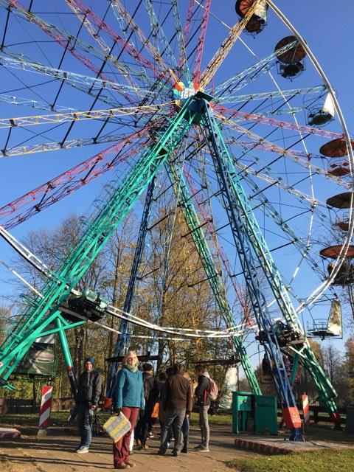

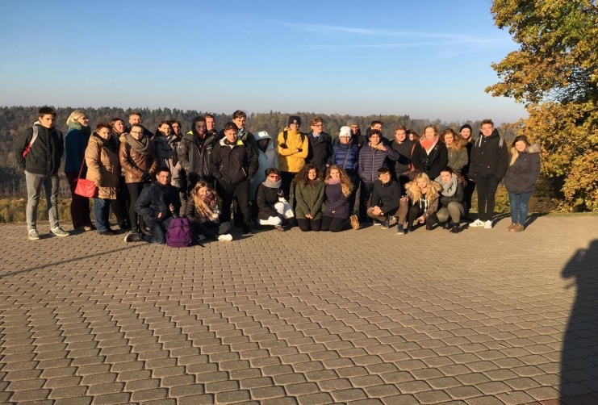

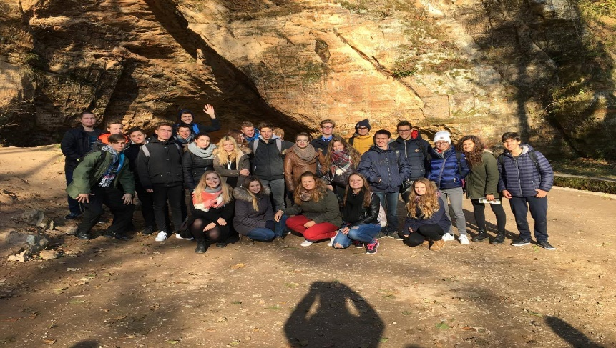At 12 o’clock we went to Gūtmaņu cave. There were two guides; Alina and Elisabeth. There we got up the cave and looked down.

Gutman's Cave is the widest and highest cave in the [Baltics](https://en.wikipedia.org/wiki/Baltics). It is 18.8 meters deep, 12 meters wide and 10 meters high. The cave was formed from the yellow-brown sandstone rock of the [Gauja](https://en.wikipedia.org/wiki/Gauja) river bank; its formation is due to a millennium long interaction between the river and an underground spring.

The cave is considered the oldest tourist attraction in Latvia because visitors, from even the earliest days, have left “decorations” such as names, initials and the dates of their visits engraved on the walls of the cave. Inside the cave are coats-of-arms and the names of various barons and estate owners. These were made to order for a fee by local craftsmen who would wait for wealthy visitors near the cave armed with tools, stepladders and templates. Writing on the cave walls is no longer permitted as the site is a protected archaeological and geological monument. Then we went to Turaidas castle. We saw the museums and territory.

Turaida castle dominates the Museum Reserve and is visually, the most impressive element. When seen from the air or the opposite bank of the river Gauja in Sigulda, Turaida castle rises above the trees like mighty ship built of red brick. The forepart of this imaginative ship is formed by the northern forecastle's gate tower. The main tower, which is the highest, is like a spar in the middle of the ship, and the rear of the ship is the southern forecastle with its tower shaped southern section.

Last place was Saulkrasti where we had a staggering view. Our guide told us some most important facts about the beach. Saulkrasti is a [town](https://en.wikipedia.org/wiki/Town) in [Latvia](https://en.wikipedia.org/wiki/Latvia), which lies on the east coast of [Gulf of Riga](https://en.wikipedia.org/wiki/Riga_Gulf). It stretches across 17 km from [Lilaste](https://en.wikipedia.org/w/index.php?title=Lilaste&action=edit&redlink=1) river to [Zvejniekciems](https://en.wikipedia.org/w/index.php?title=Zvejniekciems&action=edit&redlink=1) village including. The town itself spans across 48 square kilometres and includes 42 square kilometres of field and forest territory. The town’s motto is "The town closer to the Sun. Town which carries the name of the Sun". The coat of arms of Saulkrasti represents the four rivers [Inčupe](https://en.wikipedia.org/w/index.php?title=In%C4%8Dupe&action=edit&redlink=1), [Pēterupe](https://en.wikipedia.org/w/index.php?title=P%C4%93terupe&action=edit&redlink=1), [Ķīšupe](https://en.wikipedia.org/w/index.php?title=%C4%B6%C4%AB%C5%A1upe&action=edit&redlink=1), [Aģe](https://en.wikipedia.org/w/index.php?title=A%C4%A3e&action=edit&redlink=1), and five villages– [Bādciems](https://en.wikipedia.org/w/index.php?title=B%C4%81dciems&action=edit&redlink=1), Katrīnbāde ([Pabaži](https://en.wikipedia.org/w/index.php?title=Paba%C5%BEi&action=edit&redlink=1)), [Pēterupe](https://en.wikipedia.org/w/index.php?title=P%C4%93terupe&action=edit&redlink=1), [Neibāde](https://en.wikipedia.org/w/index.php?title=Neib%C4%81de&action=edit&redlink=1), Zvejniekciems. The top parts represent the sea and the sun.

**4th day**

**20th October 2016**

At 8 a.m. teachers attended an open lesson in Jelgava State Gymnasium, where teachers showed the usage of GeoGebra in Math lesson. After the lesson teachers had an evaluation of the lesson and discussed on improvements.

After that, teachers had a GeoGebra course. The course was led by teacher Līva Ozola where project participants were taught the basis of GeoGebra and given different tasks, so that they are able to create the exercises for the students themselves. Teachers were shown the examples, that using GeoGebra it is possible to create a life related tasks, using sports through sciences.

**5th day**

**21st October 2016**

At 8 a.m. teachers had a discussion on Geogebra usage in the classes. After discussion teachers with students went to Riga. Teachers had a guided tour around Riga. At 2 p.m. teachers and students went to the Academic Centre for Natural Sciences.

Student Zane Šmite led the presentation on topic “How humans muscles absorb the necessary nutrients, oxygen”. After the lecture teacher had a guided tour around the faculty.

**Meeting plan in Latvia**

**16.10.2016.-23.10.2016.**

|  |  |  |
| --- | --- | --- |
| **Day** | **Time** | **Activity type -  short-term Exchange of groups of pupils** |
| **Sunday**  **October 16th** |  | Arrival |
| **Monday**  **October 17th** | 9.00 – 10.30 | Welcome from the headmaster and project coordinators, musical moment. |
| 10.45-12.15 | Presentation of the week plan. Students present their works |
| lunch | |
| 13-16 | Visit in Jelgava city. Orienteering in Jelgava |
| **Tuesday**  **October 18th** | 9.00-9.45 | Students attend the open lessons |
| 10-12 | Students, divided into smaller groups, analyze the survey and discuss (guided scheme) the motivation to study math and science subjects. |
| 12-13 | Exploration of the web tool  for infographic |
| lunch | |
| 16.00-19.00 | Sport activities |
| **Wednesday**  **October 19th** | 8-18 | Visit to Sigulda, Turaidas castle and White sand dune in Saulkrasti |
| **Thursday**  **October 20th** | 9-11.35 | Students attend the open lessons |
| lunch | |
| 12.00-13.45 | Students, divided into smaller groups, carry out an infographic about motivation to study math and science |
| 13.45-15.00 | Students present their presentation |
| **Friday**  **October 21th** | 10.00-13.00 | Visit the University of Latvia. Students have lecture and group work |
| 13.30-15.30 | Visit in Riga Old town. Orienteering in Riga Old town |
| **Saturday/Sunday**  **October 22nd/23rd** |  | Departure |
|  |  | |

**Short-term Exchange of groups of peoples**

**DIARY OF THE 1ST PROJECT MEETING**

**1st day**

**17th October 2016**

The first day of the project started with the meeting in the lecture hall where we wrote the greetings for the teacher Aina who had birthday that day. Then we went to the concert hall, where was a little concert. In the concert hall preformed Marta Kozļenoka and sisters Marta and Sallija Klavkalnes. After that, teachers from every country gave a little speech. Then we went back to the lecture hall where students from each country introduced all project participants with their country, city, and school and education system.

Presentation of Italy was carried out by Ester Riccardi, Vanessa Madaschi, Francesko Cartisano, Luca Torri, Marco Mangili, Michele Colombelli and Daniele Gagni

Presentation of Croatia was carried out by Patrik Mežnarič, Martina Klepač and Ivana Labaš.

Presentation of Poland was carried out by Maciej Dabrovski, Maciej Kulak, Dominik Kunaniec, Jakub Uzchmanlach.

Presentation of France was carried out by Matteo Clochard, Maxime Bouhier, Juliette Audurier and Clara Courrege.

About Latvia, Jelgava and school presentations introduced Adrija Grīnfelde, Laura Kārkle, Rūta Reinsone, Diāna Rijkure, Marta Kļavkalne, Rainers Ļaksa, Marta Kozļenoka, Daniela Gelvere, Ērika Smirnova, Sallija Kļavkalne, Elizabete Kovtuna and Mārtiņš Tomsons created the presentations about Latvia, Jelgava and our school. Artis Ozols, Dāvids Kļaviņš and Ņikita Puķe created the presentation on Latvia education system. After lunch all students went to the city centre where they had to do an orientation game. They had to do different exercises. The most interesting exercise for the students was to make a slogan in Latvian language.

**2nd day**

**18th October 2016**

At 9 a.m. foreign students were attending a lesson of Latvian language with one Latvian teacher and one Latvian student as an assistant while all other Latvian students were attending their own lessons.

After this lesson at 10 a.m. all students, divided into four groups, from five to seven people with at least one person from each participating country and with Latvian students (one per group) as the leaders, analyzed the survey, which Italian students had summarized in a table, and discussed the two questions given to each group about motivation to study math and science subjects based on the survey mentioned before. Each group also had to think of an additional question, that they could answer, using the data of the survey. Each group had to choose one Latvian word for its group name. During the analysis and discussion groups had to organize the data they needed as a preparation for the next task.

12:00-13:00 – each group of students (that were divided before) had to explore the different wed tools and choose the one they consider the most useful and practical to use in making informative graphics on each group’s organized data of the survey.

After group work, in the afternoon, students participated in the school sports games. All countries participated in this event and we played floorball, volleyball and basketball. The teams we divided friendly, equally and the same with each other. We had a lot of fun and interesting time.

**3rd day**

**19th October 2016**

Teachers together with students went on excursion to Sigulda and Saulkrasti.

At 10 a.m. we went to „Sigulda wheel” and rodel track. Sigulda wheel was very scary, but there was a beautiful view. Then we went down from the hill and up. Ferris wheel, which is located in Celebration of the goal, its visitors can get up to 30 meters high, revealing breathtaking views of the Gauja valley landscape, the Livonian Order Sigulda Castle Turaida Castle Gauja opposite bank.





At 12 o’clock we went to Gūtmaņa cave. There were two guides; Alina and Elisabeth. There we got up the cave and looked down.

Gutman's Cave is the widest and highest cave in the [Baltics](https://en.wikipedia.org/wiki/Baltics). It is 18.8 meters deep, 12 meters wide and 10 meters high. The cave was formed from the yellow-brown sandstone rock of the [Gauja](https://en.wikipedia.org/wiki/Gauja) river bank; its formation is due to a millennium long interaction between the river and an underground spring.

The cave is considered the oldest tourist attraction in Latvia because visitors, from even the earliest days, have left “decorations” such as names, initials and the dates of their visits engraved on the walls of the cave. Inside the cave are coats-of-arms and the names of various barons and estate owners. These were made to order for a fee by local craftsmen who would wait for wealthy visitors near the cave armed with tools, stepladders and templates. Writing on the cave walls is no longer permitted as the site is a protected archaeological and geological monument. Then we went to Turaidas castle. We saw the museums and territory.

Turaida castle dominates the Museum Reserve and is visually, the most impressive element. When seen from the air or the opposite bank of the river Gauja in Sigulda, Turaida castle rises above the trees like mighty ship built of red brick. The forepart of this imaginative ship is formed by the northern forecastle's gate tower. The main tower, which is the highest, is like a spar in the middle of the ship, and the rear of the ship is the southern forecastle with its tower shaped southern section.

Last place was Saulkrasti where we had a staggering view. Our guide told us some most important facts about the beach. Saulkrasti is a [town](https://en.wikipedia.org/wiki/Town) in [Latvia](https://en.wikipedia.org/wiki/Latvia), which lies on the east coast of [Gulf of Riga](https://en.wikipedia.org/wiki/Riga_Gulf). It stretches across 17 km from [Lilaste](https://en.wikipedia.org/w/index.php?title=Lilaste&action=edit&redlink=1) river to [Zvejniekciems](https://en.wikipedia.org/w/index.php?title=Zvejniekciems&action=edit&redlink=1) village including. The town itself spans across 48 square kilometres and includes 42 square kilometres of field and forest territory. The town’s motto is "The town closer to the Sun. Town which carries the name of the Sun". The coat of arms of Saulkrasti represents the four rivers [Inčupe](https://en.wikipedia.org/w/index.php?title=In%C4%8Dupe&action=edit&redlink=1), [Pēterupe](https://en.wikipedia.org/w/index.php?title=P%C4%93terupe&action=edit&redlink=1), [Ķīšupe](https://en.wikipedia.org/w/index.php?title=%C4%B6%C4%AB%C5%A1upe&action=edit&redlink=1), [Aģe](https://en.wikipedia.org/w/index.php?title=A%C4%A3e&action=edit&redlink=1), and five villages– [Bādciems](https://en.wikipedia.org/w/index.php?title=B%C4%81dciems&action=edit&redlink=1), Katrīnbāde ([Pabaži](https://en.wikipedia.org/w/index.php?title=Paba%C5%BEi&action=edit&redlink=1)), [Pēterupe](https://en.wikipedia.org/w/index.php?title=P%C4%93terupe&action=edit&redlink=1), [Neibāde](https://en.wikipedia.org/w/index.php?title=Neib%C4%81de&action=edit&redlink=1), Zvejniekciems. The top parts represent the sea and the sun.

**4th day**

**20th October 2016**

At 9 a.m. students attend the open lesson of their hosts. During this time students had a chance to attend Girls Choir ‘’ Spīgo ’’ concert at the school concert hall. Student also saw lessons like math, geography, literature, Latvian, English and arts.

After the lessons students were divided into the same 4 groups they were on Tuesday. Using the data they have gathered, each group had to make a presentation according to the task and questions they were given. All the groups had a total of 9 internet info graphic programmes they can use for the presentations.

Then students presented their presentations and the teachers evaluated them. Each group had to come up with a Latvian name for the group, each presentation was strictly judged by the teachers and all students could compare their work to other group work.

After the group work, students completed a survey about their group work and harmony in the group.

**5th day**

**21st October 2016**

Our trip started at school. From school to train station. Most of the students haven't been on a train in Latvia.

When we arrived to our gorgeous capital city Riga, students were divided into smaller group. Each group had to find every point in the map, created by Latvian students and do several tasks while orienteering.

After that we splitted and each group went to their starting point (every group had it different). For example, first stop was Latvian National opera and ballet. While going to the opera house, we thought that maybe there were some tasks that we could do while walking. There was. We had to choose a park and make a composition that shows our teams level of activity. We weren't very energetic or sporty, so while drinking our marvellous hot coffee that kept us warm, we took a very funny photo that perfectly described our team’s level of activity. We were sitting on a bench with coffees in our hands, heads on each other’s shoulders pretending to sleep and then, there was a guy laying on the ground, reaching for that cup of coffee like it was the last cup on the Earth.

The walk to the opera house was filled with some awkward silence and car noises. When we got there, the students were fascinated with the beauty of Latvian National opera and ballet. Every group had to take a picture where they make a human pyramid and where Latvian national opera was in the background. The process of taking picture was very funny and we all had a good laugh.

Our next stop was Laima Clock. The clock was built in 1924 for practical reasons – in order to let Riga people to be at work in time. In 1936 the clock was painted over with logo of that time biggest sweets manufacturer "Laima". After the Second World War the clock, during the long period of time, was used as political information stand. In 1999 the clock has gone through the total reconstruction, bringing back the look it had in 1930s. Nowadays Laima clock is the main place for meeting of Riga people and guests. We took a photo there and filmed a video.

After we took photos in front of Laima clock and went to Laima chocolate shop we went to look at the Monument of freedom. The group took a photo with the guard which was guarding the monument.

While visiting all sights students did some tasks like sold someone on the street Latvian sweet cheese "Kārums", interviewed 5 different people, learned a sentence "Mēs visi esam aktīvi, tāpēc mīlam sportot" etc.

After orienteering we went to the lecture at Academic Center for Natural Sciences of the University of Latvia. We listened to the presentation of Zane Šmite on topic “How human’s muscles absorb the necessary nutrients, oxygen.” After 50 minutes of theoretical part we had small break. We were divided in two groups of 15 people in each so that we can go into two different laboratories for the practical part. The first group were researching how does muscle work depending on carried load, according to O2  inhale and N2  exhale, monitoring, sending information to the computer and analyzing the data we got after the research.

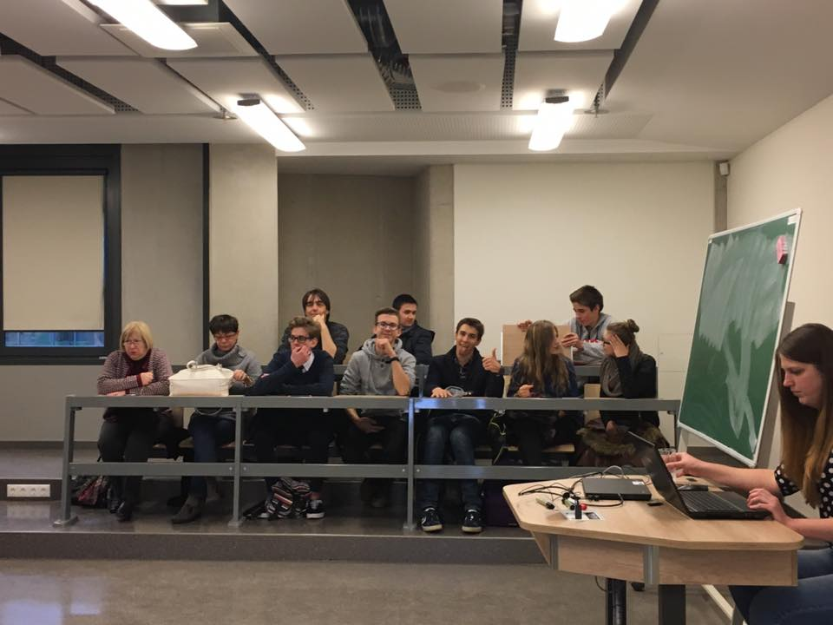Second group were researching muscle work, having active activity, fatigue, what we can compare to “Steps”, heartbeats, and pulse rate before and after sport activities.

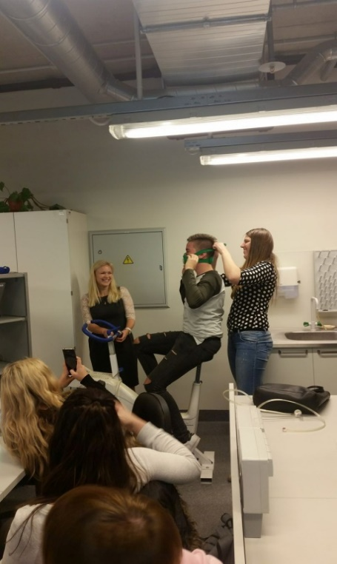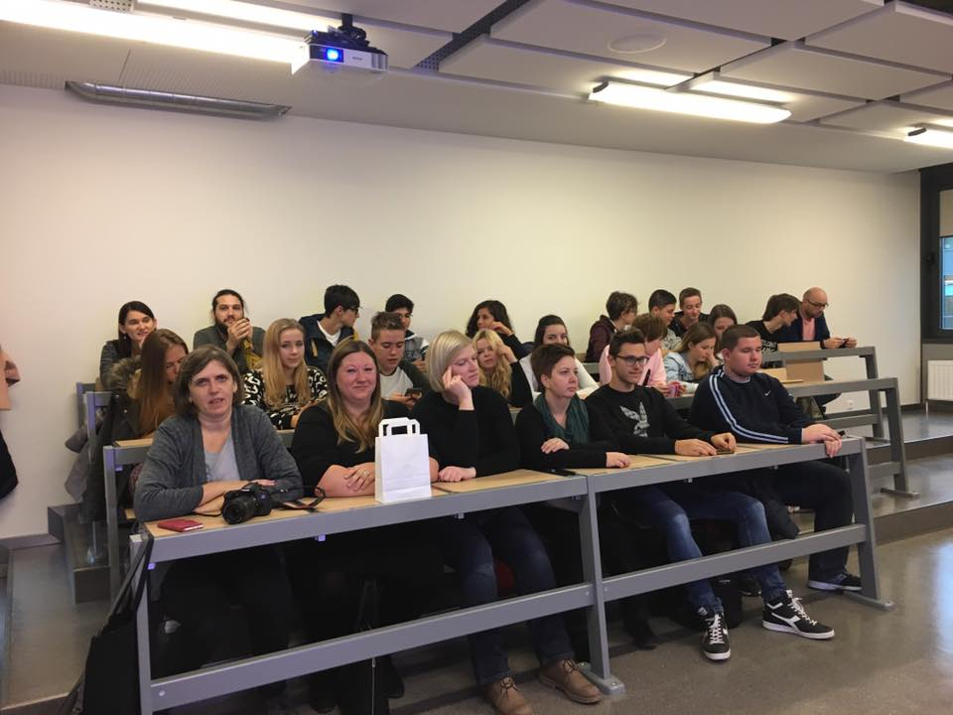

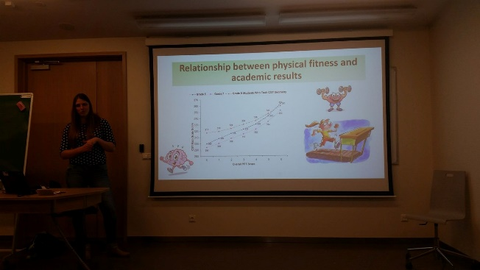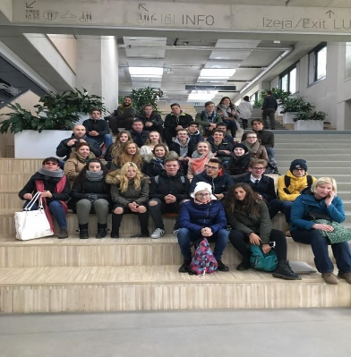

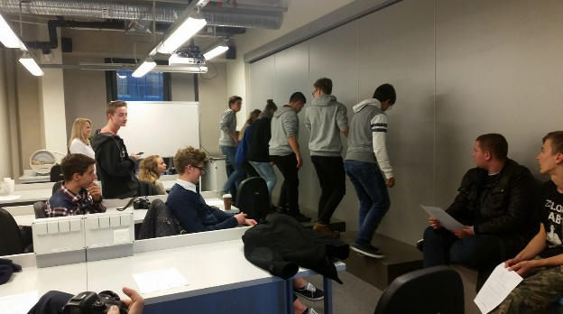

**Diary from Croatia team**

Monday

After coming to Latvia on Sunday, we met our hosts and took a long afternoon rest. Next morning we went to our hosts’ school, Jelgavas 4. vidusskola (4th High School Jelgava) where the hosts prepared a short concert for the students from Croatia, Poland, Italy and France to mark the beginning of a successful partnership. Students performed a few Latvian national songs and teachers made some short speeches. Afterwards we all went to a classroom where every country was presented by their students. The students had presentations about their country and their school and the teachers evaluated them. After that we had lunch in the school canteen and later there was orientation in the city of Jelgava. The students were divided into four groups consisting of students from different countries. We received our assignments and went to do them. We needed to do some interesting tasks like singing, taking photos, meeting strangers, reading... After long 13 km of walking, we finally finished our tasks and had free time until the end of the day. We spent that time on a choir rehearsal and a basketball game.

Tuesday

At 8.40 we arrived to school. All of the students gathered in one classroom where a Latvian teacher had a presentation on the Latvian alphabet. We had to repeat every letter and a word starting with that letter. This was very entertaining because the Latvian alphabet consists of 33 letters. Particularly interesting were similar letters pronounced differently (e.g. a and ā). Then our hosts joined us and we all played games and learned a traditional Latvian dance. Around 10 o'clock the teachers divided us into groups. We analysed data obtained from different countries and created diagrams and charts. We finished at 12.30, had lunch in the school canteen, presented our charts and diagrams and had some free time until 4 p.m. when we all came to the school gym to play different sports among which were hockey, basketball and volleyball.

Wednesday

This day particularly stands out. We went on an excursion to region Vidzeme where we visited a national park and the Baltic Sea. Our first stop was a park where we went for a ride on a ferris wheel and we had some free time in the valley which we reached by cable car. The next place we visited was Gutman’s Cave. We also went to Turaida castle where the beautiful landscape and forests we saw from the highest tower left us breathless, but the highlight of the excursion was the white dune at Saulkrasti, which is in our opinion the most beautiful place in the world.

Thursday

In the morning, instead of usual project activities, we attended a few school lessons. The first lesson we went to was a concert in the school auditorium. The second and the third lesson were the Latvian and the English language and after that we finished the group work which we had started on Tuesday. We analyzed the data, created graphs in online tools for infographic and finally presented our work, which the teachers evaluated. That was the last activity we did at the school. The afternoon was free, so we went to the students’ parliament. This is a council of schools’ representatives which deals with cooperation and creating new projects. After that we went to the church tower which is now a museum that offers a view of the entire Jelgava.

Friday

Today at 8.30 we gathered in front of the school and went to the train station to board a train to Riga. After 40 minutes we arrived to the capital of Latvia. Students, divided into smaller groups, started their orienteering tasks. We visited Latvian National Opera, one Russian orthodox and one catholic church (from the tower we could see the whole city), and the square with the Freedom Monument. In the Old Town we saw some impressive buildings. Although it was freezing, nothing could stop us from having a good time. We had a lunch break, and then we went to University of Latvia to attend a lecture on physiology of sport. There was also a workshop. Patrik was riding a bike and we observed his heart rate. Around 5 p.m. we returned to Jelgava to our hosts' houses and in the early morning hours we headed home to Croatia.

**Assessment of the visit based on the survey results**

The questionnaire was completed by 42 people involved in the first project meeting. The questions were adjusted to different roles in the project: participants (Croatia / other countries), hosts, hosts’ parents, teachers and the headmaster.

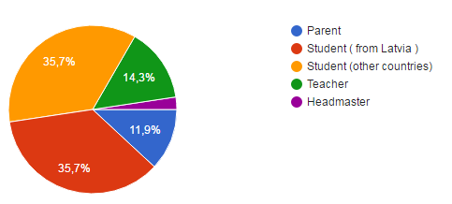**Pie - Roles**

|  |
| --- |
| 5 |
| 15 |
| 15 |
| 6 |
| 1 |

**Parents**

All the parents who hosted foreign participants evaluated the experience of hosting a foreigner in their family with the highest grade (5 – 20%) or the second highest grade (4 – 40%) and third grade (3 – 40%). If they could, they would host a student in another project 40% - yes and 20% - other.

The majority agree that language communications was quite. 2 parents answered that Organization skills were little and 2 that very much. 2 parents answered that interest and involvement in the new project was very much and the same number as quite. The same number of parents answered about the understanding a culture and tolerance.

All the parents evaluated the organisation of the first project meeting with the second highest grade (4), one parent evaluated third grade (3) or the fourth grade (4).

*Comments: What did you like about the 1st project meeting?*

It was a new experience

I liked that all the students were friendly. And they visited our house.

*What did you dislike about the 1st project meeting?*

I think that they should visit more sightseeing objects. For example Italians were interested in Italian architecture in Jelgava.

**Students (Croatia, Poland, Italy, France)**

|  |
| --- |
| 7 |
| 2 |
| 2 |
| 4 |

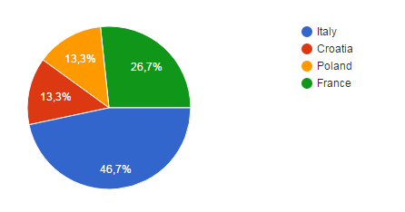

The students were asked whether their mathematical, physics, biology and chemistry capacities were improved thanks to the participation in the project. Most of them believe they were improved up to a certain point, but it is important to note that this is only the first meeting of the project and by the end of the project they should be significantly improved.

All of them but one thinks that the project has enriched their cultural awareness.

60 percent evaluated their experience in the foreign family with the highest grade (5) and 93,3 percent of them would like to participate in another project.

*Comments: What did you like about the 1st project meeting?*

The possibility of getting know persons from other countries the part of their course of reasoning.

I liked the activities and the opportunity given to us

I liked that we have met a lot of guys from other States and we became friends with them

Visiting every place we visited

I liked in particular sharing ideas, uses and customs, opinions with people from other countries and it was also a good way to test my English skills.

The orienting in the city of Jelgava

I like the interaction between students from different countries

Sport activities

*What did you dislike about the 1st project meeting?*

Sometimes our hosts were unorganised

I disliked that sometimes not every Latvian guy was with us during the school project, because they had to stay at school

The unorganized usage of some technological platforms.

**Teachers**

|  |
| --- |
| 1 |
| 0 |
| 3 |
| 1 |
| 1 |

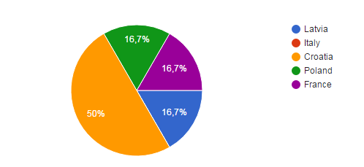

The teachers were asked to give their opinion (1=disagree 5=fully agree) about different statements concerning students presentations (school systems, students survey results, raising awareness of the teaching and learning process problems), usage of English, participants’ attitude towards the ICT technology, and the field trips.

They were also asked to grade different aspects of the first meeting on a scale from one (not good at all) to five (excellent).

Most of them believe that the knowledge of other school systems will influence their teaching process. 5 of them believe it was an opportunity to improve their language skills and all of them believe the participants’ attitude towards the ICT technology has improved with this project. They all believe that the field trips were appropriate and that the level of cooperation between the teachers was good, very good or excellent. However, when asked about the quality of language interaction, not everybody evaluates it with such high grades.

The other part of the questionnaire for teachers dealt with the benefits for students. They all believe that students have improved their skills concerning different areas: language, culture, ICT, presentation skills and teamwork.

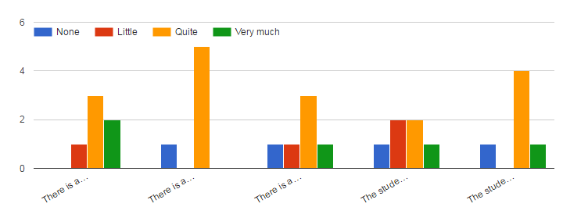language skills teamwork special softwares ICT tools improving

presentation skills

Finally, they were asked on ideas how to improve the future meetings. All of them are listed below:

*Comments:*

*Everything was great, there's no need to improve anything.*

*Students need more ice-breaking activities.*

*Perhaps more math and science activities with other students.*

**Headmaster**

The 1st meeting was successful. Students and teachers have shown the fantastic communication and group work skills. All activities went according to the plan.

**Links to publications**

[**http://m.zz.diena.lv/lietotaju-raksti/rudens-ciemini-no-eiropas-jeb-erasmus-plus-projekta-sports-formula-vizite-4-vidusskola-224036?from-full**](http://m.zz.diena.lv/lietotaju-raksti/rudens-ciemini-no-eiropas-jeb-erasmus-plus-projekta-sports-formula-vizite-4-vidusskola-224036?from-full)

[**http://www.jelgavasvestnesis.lv/izglitiba/4-vidusskola-viesojas-arvalstu-skoleni-un-skolotaji**](http://www.jelgavasvestnesis.lv/izglitiba/4-vidusskola-viesojas-arvalstu-skoleni-un-skolotaji)

[**http://www.varazdinske-vijesti.hr/obrazovanje/tim-druge-gimnazije-varazdin-vratio-se-iz-latvije-gdje-su-zapoceli-novi-erasmus-projekt-11644/**](http://www.varazdinske-vijesti.hr/obrazovanje/tim-druge-gimnazije-varazdin-vratio-se-iz-latvije-gdje-su-zapoceli-novi-erasmus-projekt-11644/)