3 highlights – Latvia:
- Teachers together with students went on excursion to Sigulda and Saulkrasti.
We went to „Sigulda wheel”, rodel track, Gūtmaņa cave and Saulkrasti.
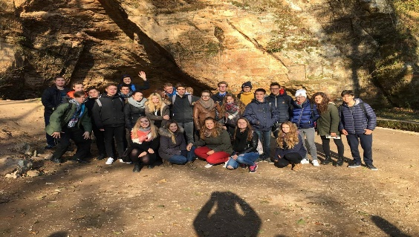
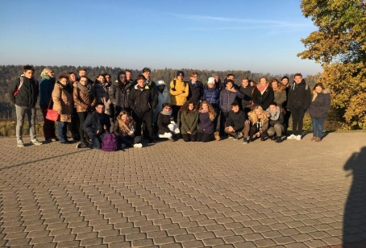
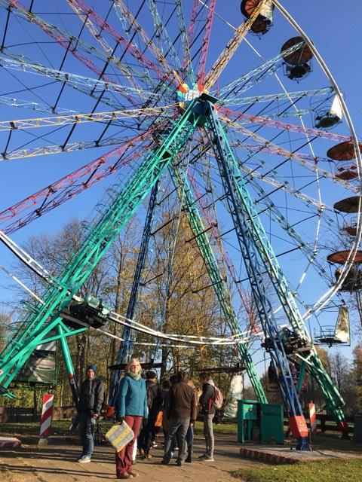

- “How humans muscles absorb the necessary nutrients, oxygen”.
We went to the lecture at Academic Center for Natural Sciences of the University of Latvia. We listened to the presentation of Zane Šmite on topic “How human’s muscles absorb the necessary nutrients, oxygen.” Then we divided in two The first group were researching how does muscle work depending on carried load, according to O2 inhale and N2 exhale, monitoring, sending information to the computer and analyzing the data we got after the research.
Second group were researching muscle work, having active activity, fatigue, what we can compare to “Steps”, heartbeats, and pulse rate before and after sport activities.
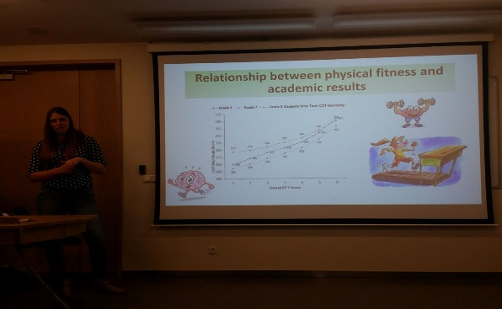
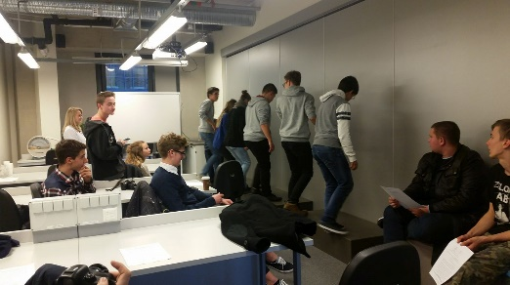

- Teachers had a GeoGebra course.
The course was led by teacher Līva Ozola where project participants were taught the basis of GeoGebra and given different tasks, so that they are able to create the exercises for the students themselves. Teachers were shown the examples, that using GeoGebra it is possible to create a life related tasks, using sports through sciences.
