1. One of the highlights of the Croatian meeting was workshop “Who did it?” prepared by teacher Danka Jelenčić. The aim of the workshop was to become a detective and use mathematical knowledge in order to solve a murder mystery and find the murderer.
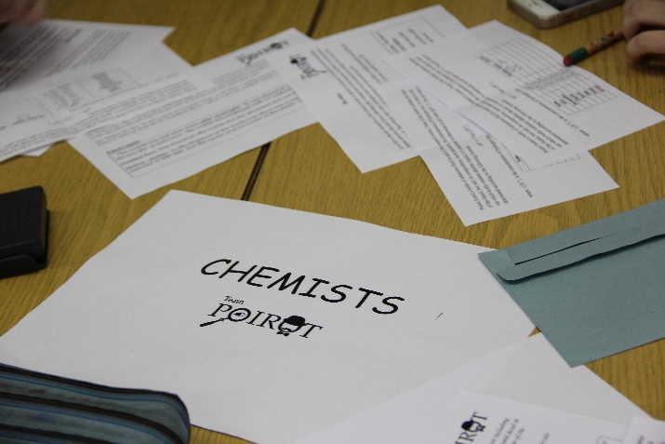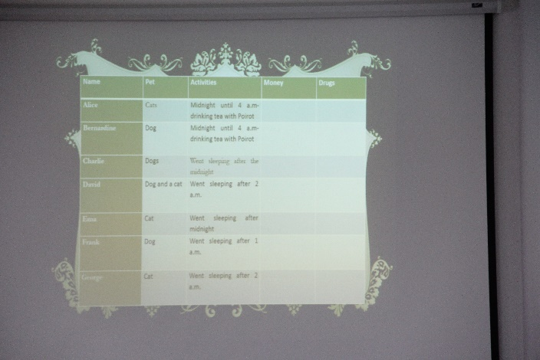

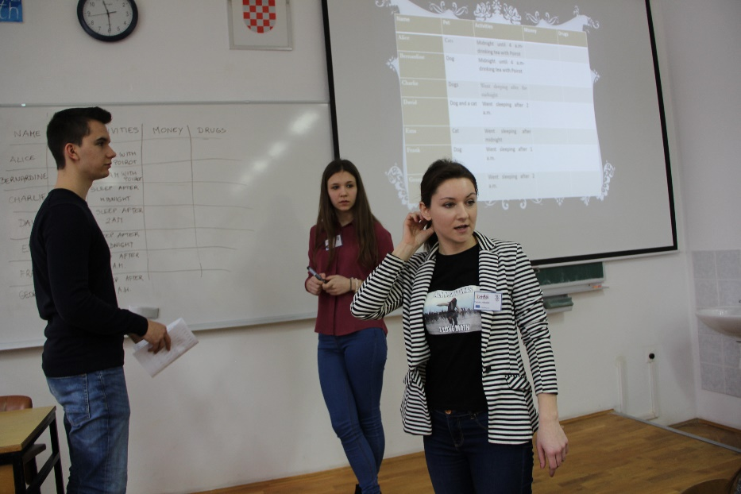

2. Another highlight was a trip to the capital city of Croatia, Zagreb. Here, despite heavy snow and low temperatures, our guests had an opportunity to explore our capital, learn more about its history on a guided tour and take some stunning winter photos.
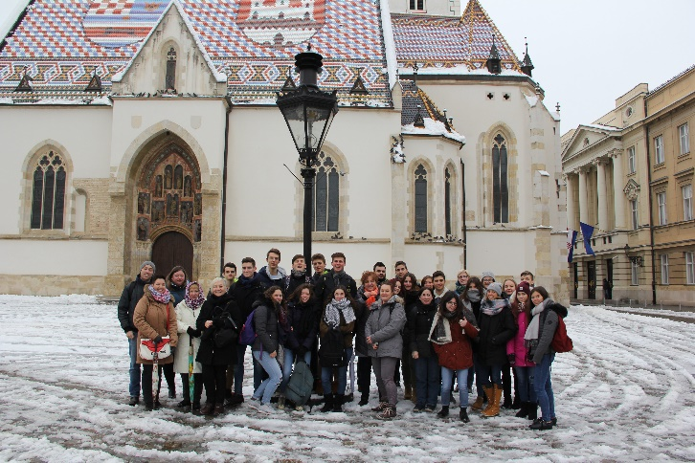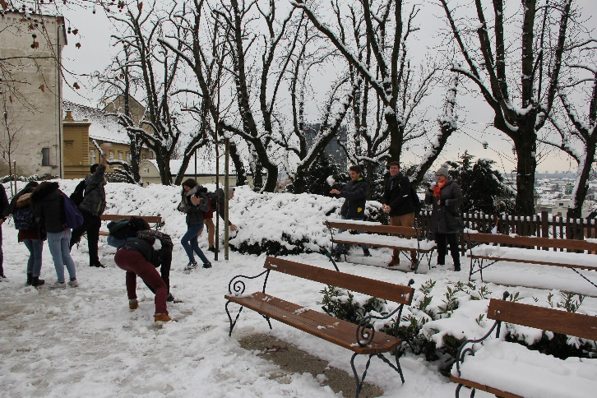

3. The third highlight was a quiz held by physics teacher Mihaela Habunek. The quiz resembled the form of a typical pub quiz where students in groups of five answered general knowledge questions. Those that were best even won some prizes which will remind them of Sports Formula project and Croatia.
