LESSON PLAN

Subject: Chemistry
Topic: Matter matters!
Age of students: 17
Language level: B1/B2
Time: 45 - 60 minutes
Content aims:
After completing the lesson, the student will be able to:
Understand the basic structure of an atom, subatomic particles, isotopes and ions.
Differentiate atoms, ions and molecules.
Recognise the atomic models.
Compare differences and similarities of the atomic models.
Explain nuclear processes and their uses.

Language aims:
After completing the lesson, the student will be able to:
Use new vocabulary within the topics.
Explain personal opinion about risks of nuclear bombing.

Content-obligatory language | Content-compatible language
Atom, subatomic, orbital  Nucleus, nuclei  Proton, Neutron, Electron  Electrically balanced, Coulomb  Ions, Anions, Cations  Hydrogen, Helium, Uranium  Deuterium, Tritium, Isotopes  Nuclear fusion, Nuclear fission  Fusion/ Fission bomb | Model, Scientist  Solid, liquid, gas  Particle, Element, matter, mass  Electrical charge, Positive/Negative charge, Neutral atom  temperature, pressure  to split into, to fuse, to release, to hit, to collide  Nuclear process, Chain reaction  Nuclear power station, Energy

Materials:
- The presentation ‘Matter matters’
- Student’s worksheets 0 to 3.

Procedure:
- Teacher has introduced in a previous lesson the atomic models (Thomson, Rutherford, Bohr and Schrodinger).
- Before starting the lesson, students review the main contents and the distribution of the activities individually using Worksheet 0.

1. ‘Matter matters’: Atomic models: work in pairs, Worksheet 1.
- Students, working in pairs, review the atomic models learned in the previous lesson through the activities 1.1 and 1.2. of their Worksheet 1.
- Task 1.1. A. Match each scientist with the atomic model he has created. B. Identify each atomic model with its name and fill in the gaps.
- Task 1.2. Compare the different atomic models and find the differences and similarities between themselves. Justify your answers. In this task, students can use the phrase bank to help them do the comparisons.
- Students compare their answers checking the tasks all together.

Answer keys
Task 1.1.
A. Match each scientist with the atomic model he has created. 1. c; 2. a, 3. d, 4. b
B. Identify each atomic model with its name and fill in the gaps. 1. Thomson, 1.a) positive charge; 1.b) negative charge / 2. Rutherford, 2.a) electrons; 2. b) nucleus / 3. Bohr; 3. a) electrons; 3. b) nucleus / 4. Schrodinger; 4.a) 1s orbital; 4.b) 2s orbital; 4.c) 2px orbital; 4.d) 2py orbital; 4.e) 2pz orbital

Task 1.2.
Compare the different atomic models and find the differences and similarities between themselves. Justify your answers.
A.1. There is no nucleus. The atom must have been a great mass of positive charge and inserted into this mass there must have been electrons. A.2. Positive and negative charge. B.1. At the nucleus there are concentrated all the positive charge of the atom and almost all the mass. At the crust there are electrons spinning around the nucleus. B.2. Positive and negative charge. C.1. Bark electrons orbit the nucleus describing only certain circular orbits. C.2. Positive and negative charge.

2. ‘Matter matters’: Structure of matter: work in pairs, Worksheet 2
- Students, working in pairs, learn the main ideas about the structure of matter completing tasks 2.1 , 2.2. and 2.3. of their Worksheet 2.
- Task 2.1. A. Read the text provided and underline in red the sentences, which state what makes the atoms of two different elements different from each other. B. Underline in blue the sentences, which state why all atoms of an element do not have the same number of neutrons
- Task 2.2. Complete the boxes in blank on the right column with the provided words of the left side.
- Task 2.3. Complete the next matrix with the information you have previously read in the text.
- Students compare their answers checking the tasks all together.

Answer keys
Task 2.1.
A. Read the text provided and underline in red the sentences, which state what makes the atoms of two different elements different from each other.
‘[…] The atoms of different elements are different from each other because they have different numbers of protons. […] what makes the atoms of two different elements different from each other? […] The number of protons and neutrons in the nucleus give the atoms their specific characteristics. […]’
B. Underline in blue the sentences, which state why all atoms of an element do not have the same number of neutrons
‘[…] Atoms of the same element can have a different number of neutrons. […] These atoms are called isotopes, which are atoms of the same element that have a different number of neutrons. […]’

Task 2.2. Complete the boxes in blank on the right column with the provided words of the left side.
1. Hydrogen element; 1. a) 1 electron; 1. b) 1 neutron; 1. c) 1 proton / 2. Isotope of Hydrogen or Deuterium; 2. a) 1 electron; 2. b) 2 neutrons; 2. c) 1 proton; 3. Neutral atom; 3.a ) 5 electrons; 4. Ion; 4.1. anion; 4.1.a) 6 electrons; 4.2. a) 4 electrons

Task 2.3. Complete the next matrix with the information you have previously read in the text.
1. a) +1,6·10⁻¹⁹ C ; 1. b) 1,673·10⁻²⁷kg ; 1. c) nucleus / 2. Neutrons ; 2. b) 1,675·10⁻²⁷ kg ; 2. d) isotopes / 3. Electrons; 3. a) -1,6·10⁻¹⁹ C ; 3. c) energy levels around the nucleus; 3. d) ion.

3. ‘Matter matters’: Nuclear energy: work in pairs, Worksheet 3
- Students work in pairs to do the task 3.1. of Worksheet 3., in order to identify and understand nuclear processes.
- Task 3.1. Write the name of the processes and places where they happen in the correct place of this page. a) NUCLEAR FISSION ; b) NUCLEAR POWER STATION ; c) NUCLEAR BOMB ; d) CHAIN REACTION ; e) NUCLEAR FUSION ; f) STARS ; g) FUSION BOMB
- Students compare their answers checking the tasks all together.

Answer keys
Task 3.1. Write the name of the processes and places where they happen in the correct place of this page.
1. a) NUCLEAR FISSION ; 2. e) NUCLEAR FUSION ; 3. b) NUCLEAR POWER STATION ; 4. f) STARS ; 5. c) NUCLEAR BOMB ; 6. g) FUSION BOMB ; 7. d) CHAIN REACTION

4. ‘Matter matters’: Worksheets
Teachers will provide students with the following worksheets 0 to 3

Worksheet 0 | 0. Review of the content
Contents
- Atomic models: differences and similarities.
- Structure of matter.
- Nuclear fusion and fission processes, Chain reaction.

Distribution of activities
- Worksheet 1: Atomic Models
- Tasks 1.1. , 1.2.

- Worksheet 2: Structure of matter
- Tasks 2.1. , 2.2. , 2.3.

- Worksheet 3: Nuclear Energy
- Task 3.1.

Worksheet 1 | - Atomic models |  | Task 1.1.
A. Match each scientist with the atomic model he has created.
B. Identify each atomic model with its name and fill in the gaps.
- 1. Bohr  2. Schrödinger  3. Rutherford  4. Thomson |  | 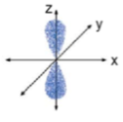  (a)  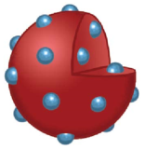  (b)  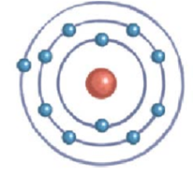  (c)  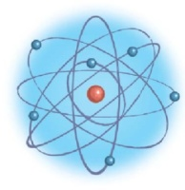  (d)
e)
d)
c)
b)
a)
4

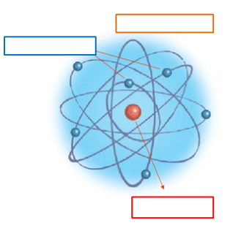
b)
b)
a)
a)
b)
a)
3
2
1

Worksheet 1 |  | Atomic models |  |  | Task 1.2.
Compare the different atomic models and find the differences and similarities between themselves. Justify your answers.
Atomic model created by | Differences with the others  (what is unique of this atom model) |  |  | Similarities with the others  (what is shared with other atom models)
A. Thomson 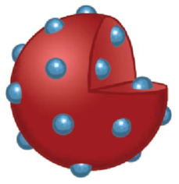 | A.1.  … example: No nucleus |  |  | A.2.  … example: positive charge
B. Rutherford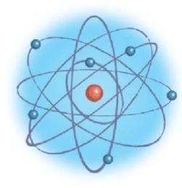 | B.1. |  |  | B.1.
C. Bohr  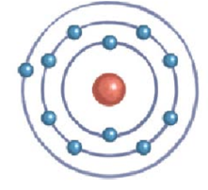 | C.1. |  |  | C.2.
Phrase bank
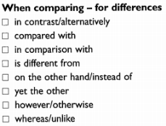 |  |  | 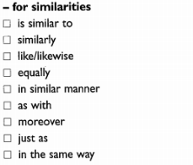
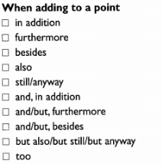 |  |  | 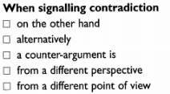

Worksheet 2 | Structure of matter |  | Task 2.1.
A. Read the text provided and underline in red the sentences, which state what makes the atoms of two different elements different from each other.
B. Underline in blue the sentences, which state why all atoms of an element do not have the same number of neutrons
All matter, such as solids, liquids and gases, is composed of atoms. Any material that is composed of only one type of atom is called a chemical element, a basic element, or just an element. An atom is the smallest particle of any element that still retains the characteristics of that element. A piece of an element that we are able to see or handle is made of many, many atoms and all atoms are the same...they all have the same number of protons. The atoms of different elements are different from each other because they have different numbers of protons.  Particles that are smaller than the atom are called subatomic particles. The three main subatomic particles that form an atom are protons, neutrons, and electrons. The centre of the atom is called the nucleus.  Protons and neutrons make up the nucleus of an atom. All protons are identical to each other, and all neutrons are identical to each other. Protons have a positive electrical charge, so they are often represented with the mark of a "+" sign. Particularly, their electrical charge is +1,6·10⁻¹⁹ Coulomb. Its mass is 1,673·10⁻²⁷kg. Neutrons have no electrical charge (0 Coulomb) and is said to be neutral. Its mass is 1,675·10⁻²⁷ kg. Like protons, all neutrons are identical. Neutrons help hold the protons together (protons are positively charged particles and should repel each other).  If all protons are identical and all neutrons are identical, then what makes the atoms of two different elements different from each other? For example, what makes a hydrogen atom different from a helium atom? The number of protons and neutrons in the nucleus give the atoms their specific characteristics. In the graphic below you will notice that each of the three elements have different numbers of protons and neutrons. They would also like to have the same number of electrons as they have protons in order to stay electrically balanced.  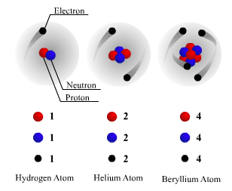 |  | Do all atoms of an element have the same number of neutrons? The answer to this question is no. The number of protons in the nucleus of every atom of an element is always the same, but this is not the case with the number of neutrons. Atoms of the same element can have a different number of neutrons. Atoms want to have the same number of neutrons and protons but the number of neutrons can change.  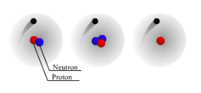  Notice that the three hydrogen atoms have the same number of protons, but a different number of neutrons. These atoms are called isotopes, which are atoms of the same element that have a different number of neutrons.  Circling around outside the nucleus are tiny little particles called electrons. Electrons have a negative electrical charge, is -1,6·10⁻¹⁹ Coulomb. Its mass is 9,11·10⁻³¹kg.  Electrons spin as they circle the nucleus billions of times every second. They are moving so fast and the path that they travel is not the same each time, so that if we could see these electrons, they might appear to look like a cloud around the nucleus.  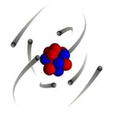  According to current theory, electrons are arranged in energy levels around the nucleus. When atoms gain or lose electrons, they are called ions. Anions are atoms which have gained electrons, so they aren’t electrically balanced but they have negative electrical charge. On the other hand, cations are atoms which have lost electrons, so they aren’t electrically balanced but they have positive electrical charge.  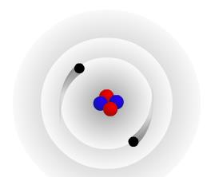

Worksheet 2 | Structure of matter |  | Task 2.2.
Complete the boxes in blank on the right column with the words provided on the left side.

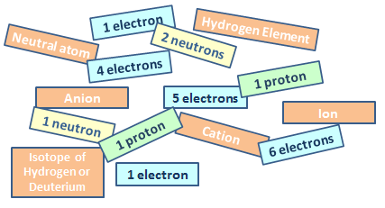 |  | 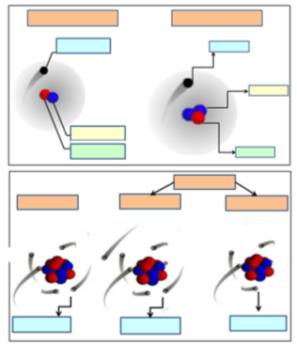  4.2.  4.1.1.a)  a)  a)  a)  c)  b)  a)  a)  c)  b)  4  3  2  1

Worksheet 2 |  | Structure of matter |  |  | Task 2.3.
Complete the next matrix with the information you have previously read in the text.

Name of subatomic particle | Electrical charge |  | Mass | Location in the atom |  | A variation in number gives …
1. Protons | a) |  | b) | c) |  | d) A different element
2. | a) 0 C; No electrical charge |  | b) | c) nucleus |  | d)
3. | a) |  | b) 9,11·10⁻³¹kg | c) |  | d)

Worksheet 3 | 3. Nuclear energy | Task 3.1.
IDENTIFYING NUCLEAR PROCESSES AND USES:
Write the name of the processes and places where they happen in the correct place of this page.

a) NUCLEAR FISSION e) NUCLEAR FUSION
b) NUCLEAR POWER STATION f) STARS
c) NUCLEAR BOMB g) FUSION BOMB
d) CHAIN REACTION

...
...
...
...
...
...
...

B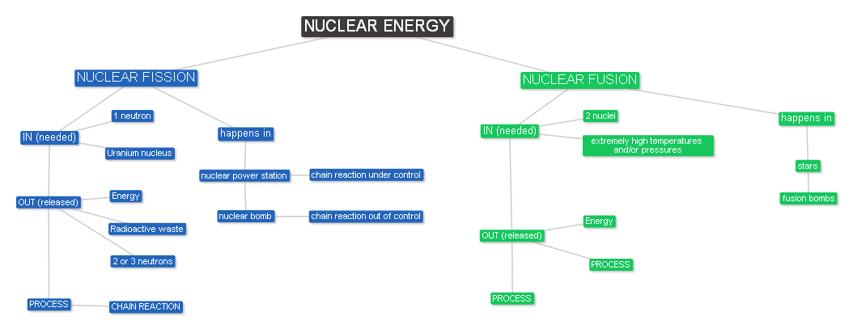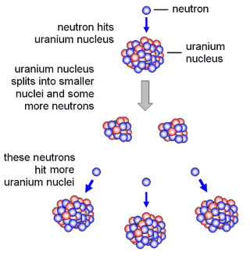 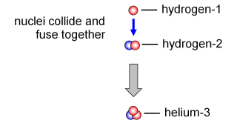
7
6
5
4
3
2
1

5. ‘Matter matters’: Self-assessment grid
Students assess themselves using the provided self -assessment grid.

CATEGORY | Beginning  1 | Developing  2 | Accomplished  3 | Excellent  4 | Score
Task 1.1. | Only 25% correctly answered | Between 25 and 50% correctly answered | Between 50 and 75% correctly answered | All questions correctly answered | … / 6
Task 1.2. | Only 25% correctly answered | Between 25 and 50% correctly answered | Between 50 and 75% correctly answered | All questions correctly answered | … / 6
Task 2.1. | Only 25% correctly answered | Between 25 and 50% correctly answered | Between 50 and 75% correctly answered | All questions correctly answered | … / 6
Task 2.2. | Only answers correctly the yellow boxes | Answers correctly the yellow and green boxes | Answers correctly the yellow, green and blue boxes | Answers correctly all boxes | … / 6
Task 2.3. | Only answers correctly the first column | Answers correctly first three columns | Answers correctly first four columns | Answers correctly all columns | … / 6
Task 3.1. | Not answered | Less than three correct answers | Up to three correct answers, but less than seven | All answers correct | … / 6

