LESSON PLAN 3

Subject: SCIENCE - Biology

Topic: THE HISTORY OF LIVE ORGANISM BEGAN IN WATER:
Let’s take a look to the MICROSCOPIC WORLD
of a drop of water

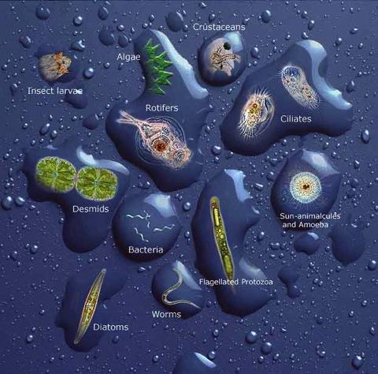

Age of students: 16

Language level: Intermediate

Time: two hours

Content aims:
After completing the lesson, the student will be able to:
Describe the begining of life billions of years ago.
Illustrate the change of life through evolution.
Summarize the history of the Universe form Big Bang to the birth of first live organism in water.
Explain the conditions of developing of life in water.
Compare the characteristics of living cells.
Observe single-cell and pluri-cell organisms using a microscope.
Analyze the differences between the organism.
Classify these microorganisms.

Language aims:
After completing the lesson, the student will be able to:
Apply the correct scientific language.
Use scientific inquiry through questioning, predicting, observing, recording and interpreting data

Pre-requisites:
- Knowledge of atomic structures and elements
- Biology of unicellular and pluricellular organisms,
- Biology of prokaryotic and eukaryotic organism.
- Difference between autotrophic and heterotrophic organism
- Kingdoms of organism
- Operating with a simple light microscope

Materials:
- Computers
- Aquarium in classroom, a little ecosystem like a pond (with rocks, aquatic plants, little aquatic snails, insects)
- Light Microscope for students
- Light Microscope connected with computer for teacher

Procedure steps:

TEACHER activity:
- Frontal lesson with short film :
- The history of the universe in 10 minutes www.dailymotion.com/video/x2p8tdj
- Rise of the Bacteria (animation) https://www.youtube.com/watch?v=OQQ_U3rpWIU
- Evolution from Bacteria to Humans
https://www.youtube.com/watch?v=Ew-6WuTo1Is
- Finding Nemo, Mr. Ray song (animation)
https://www.youtube.com/watch?v=ufxGw8EqY5Q

- Supporting observations using microscope of the living organism in the drop of water from the aquarium
- Supporting discussion with student

STUDENT ACTIVITY:
- Collecting water, rocks and plants in a pond
- Preparation of a simple pond aquarium
- Observations using microscope of the living organism in the drop of water from the aquarium
- Trying to classify the observed microorganisms comparing their characteristics with image on a computer
- Discussion

The Lesson will take place in computer laboratory equipped with microscopes

