LESSON PLAN

Subject: Mathematics

Topic: Triangle

Age of students: 16

Language level: B1, B2

Time: 45 - 60 min

Contents aims:
After completing the lesson, the student will be able to:
Classify and compare different triangles.
Interpret properties of triangles.
Distinguish and explain properties of right triangle.
Recognize the use of triangles in everyday life.

Language aims:
After completing the lesson, the student will be able to:
Apply new vocabulary in the frames of the topic.
Interpret and communicate mathematics.

Pre-requisites:
- Types of triangles;
- Properties of triangles;
- Right triangle.

Key words: right triangle, acute triangle, obtuse triangle, isosceles triangle, scalene triangle, side, angle, leg (opposite, adjacent), hypotenuse.

Materials: Worksheet “Triangle”, game “Domino”, crosswords “Triangle”.

Procedure steps:
- Teacher invites students to name any type of triangles they know.
- Students match the triangles in the exercise 1 in pairs.
- Students communicate and explain their point of view.
- Students complete the sentences in the exercise 2 in pairs.
- Students communicate and explain their point of view.
- Students define the notions in the exercise 3 in pairs.
- Students discuss their definitions.
- Students correct the mistakes in the exercise 4 in pairs.
- Students communicate and explain their point of view.
- Students play the game “Domino”.
- Teacher sets the hometask - crosswords “Triangle”.

Attachment:
Triangle

d

b

c

e

a

Exercise 1
Which of the given triangles are
Equilateral (regular) triangles_________ Acute triangles _________________
Isosceles triangles _________________ Obtuse triangles ________________
Scalene triangles __________________ Right triangles _________________

Exercise 2
Complete the sentences
- Triangle is a plane figure consisting of three sides and three _________________ .
- Triangles with 2 equal sides are called _________________________ .
- Triangles with 3 equal sides are called ___________________ or ___________________ .
- Triangles with all different sides are called _________________________ .
- The sum of all internal angles equals __________________________ .
- Depending on the internal angles triangles can be distinguished as _________________, ___________________ or _____________________.

Exercise 3
Give the definitions of the following notions: acute triangle, obtuse triangle, right triangle, hypotenuse, legs, tangent of an acute angle, cosine of an acute angle.

Exercise 4
Correct the mistakes in the following sentences
- The angle which is larger than half of the right angle is called obtuse angle.
- In right triangles the largest side is called a leg.
- The heights of right triangle are bisectors of that triangle as well.
- All sides of isosceles triangle are equal.
- The base angle in isosceles triangle can be 90°.
- Equilateral triangle can be right triangle as well.
- To find the projections of a leg to hypotenuse you have to draw the bisector of the right angle.

Game “Domino”
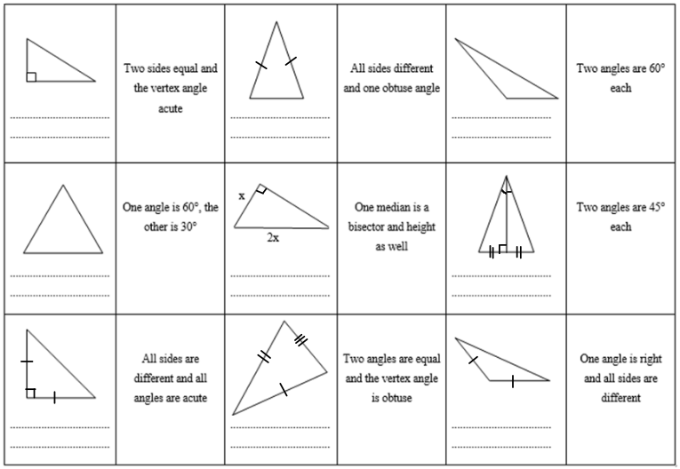

Hometask:
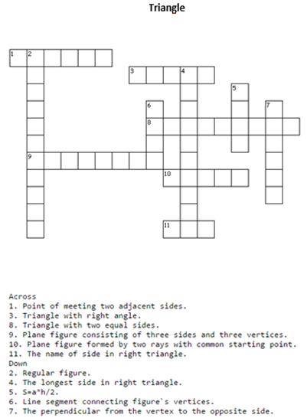
Triangle (answers)

d

b

e

c

a

Exercise 1
Which of the given triangles are
Equilateral (regular) triangles e Acute triangles a, e
Isosceles triangles a, c, e Obtuse triangles d
Scalene triangles b, d Right triangles b, c

Exercise 2
Complete the sentences
  - Triangle is a plane figure consisting of three sides and three angles.
  - Triangles with 2 equal sides are called isosceles.
  - Triangles with 3 equal sides are called equilateral or regular.
  - Triangles with all different sides are called scalene .
  - The sum of all internal angles equals 180⁰ .
  - Depending on the internal angles triangles can be distinguished as right, acute or obtuse.

Exercise 3
Give the definitions of the following notions: acute triangle, obtuse triangle, right triangle, hypotenuse, legs, tangent of an acute angle, cosine of an acute angle.
Acute triangle is a triangle with three acute angles.
Obtuse triangle is a triangle with one obtuse and two acute angles.
Right triangle is a triangle with one right angle and two acute angles.
Hypotenuse is the longest side in right triangle.
Legs are the shortest sides in right triangle.
Tangent of an acute angle is ratio of its opposite leg over its adjacent leg.
Cosine of an acute angle is ratio of its adjacent leg over hypotenuse.

Exercise 4
Correct the mistakes in the following sentences
  - The angle which is larger than half of the right angle is called obtuse angle.
  - In right triangles the largest shortest side is called a leg.
  - The heights of right equilateral triangle are bisectors of that triangle as well.
  - All sides of isosceles regular triangle are equal.
  - The base angle in isosceles triangle can be is smaller than 90°.
  - Equilateral triangle cannot be right triangle as well.
  - To find the projections of a leg to hypotenuse you have to draw the bisector height of the right angle.

Game “Domino”
