**LESSON PLAN**

**Subject:**Mathematics

**Topic:**Right triangle

**Age of students:**16

**Language level:**B1, B2

**Time:**45 min

**Contents aims:**

After completing the lesson, the student will be able to:

Classify and compare different triangles.

Interpret properties of triangles.

Describe properties of right triangle.

Explain what is hypotenuse.

Recognize the use of right triangles in everyday life.

**Language aims:**

After completing the lesson, the student will be able to:

Use new vocabulary within the topics.

Interpret and communicate mathematics.

**Pre-requisites:**

* Types of triangles;
* Right triangle.

**Key words:** right triangle, right angle, leg (opposite, adjacent), hypotenuse, projection to hypotenuse, height, similar triangles.

**Materials:**Worksheet “Right triangle”.

**Procedure steps:**

1. Students do the exercise 1 in pairs.
2. Students read, compare and explain their point of view.
3. Students complete the sentences in the exercise 2 in pairs.
4. Students read, compare and explain their point of view.
5. Students match in the exercises 3 and 4 in pairs.
6. Students discuss their results.
7. Students do the exercise 5 in pairs.
8. Students compare and explain their point of view. Mathematical relations are: ; ; ; ; 

**Attachment:**

**Right triangle**

1. What types of triangles can you find in the figures?
   * 1. 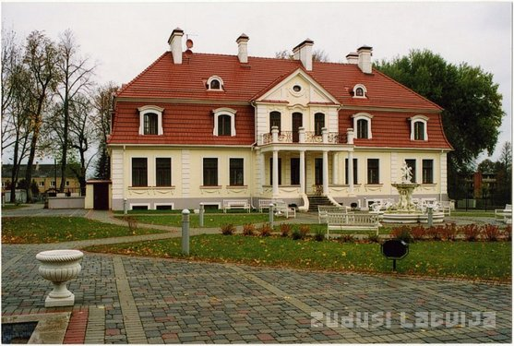........................... b) .....................................



c) .......................................... d) .......................................

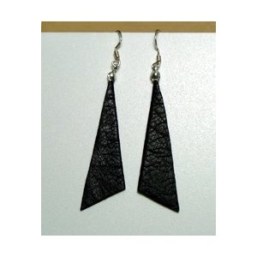

e) ............................................ f) .........................................

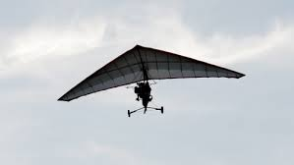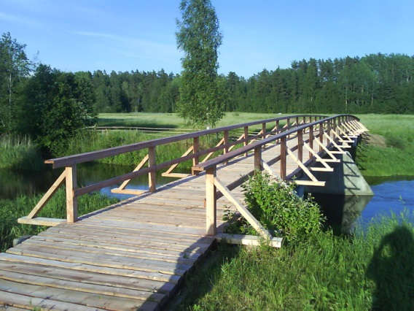

1. Fill in the gaps!
   1. A triangle where one of its interior angles is a ........................ angle (90 degrees) is called a right triangle.
   2. The side opposite the right angle is called a .................................. .
   3. Hypotenuse will always be the ............................ side of a right triangle.
   4. The two sides that are not the hypotenuse are called ............................ .
   5. They are the two sides making up the .......................................... angle.
   6. A right triangle can also be ................................. if the two legs are equal in length.
   7. The leg opposite to 30 degrees angle is a ............................ of the hypotenuse in length.
   8. The sum of the squares of the lengths of the legs ............................... the square of the length of the ............................. .
2. Match the notion and its description or definition!

|  |  |
| --- | --- |
| 1. Pythagorean triangle.   * 1. Projections of the legs to the hypotenuse.   2. The sine of an acute angle.   3. The tangent of an acute angle. | **A** Drawing the height to the hypotenuse you get two line segments of the hypotenuse.  **B** Ratio of lengths of an acute angle’s opposite leg over the adjacent leg.  **C** The name of a right triangleif the length of all three sides of it are integers. Its side lengths are collectively known as a [Pythagorean triple](https://en.wikipedia.org/wiki/Pythagorean_triple). (3, 4, 5 or 5, 12, 13 etc.)  **D** Ratio of lengths of an acute angle’s opposite leg over the hypotenuse. |

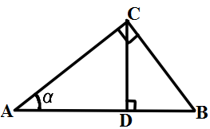

1. Match the following terms and elements from the given figure:

|  |  |
| --- | --- |
| hypotenuse | CD |
| opposite leg to angle α | AB |
| adjacent leg to angle α | AD |
| height | AC |
| projection of the opposite leg to the hypotenuse | BC |
| projection of the adjacent leg to the hypotenuse | BD |

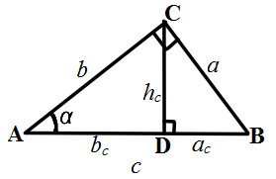

1. How many right triangles can you find in the figure?

Can you find similar triangles there? How many pairs? Why are they similar?

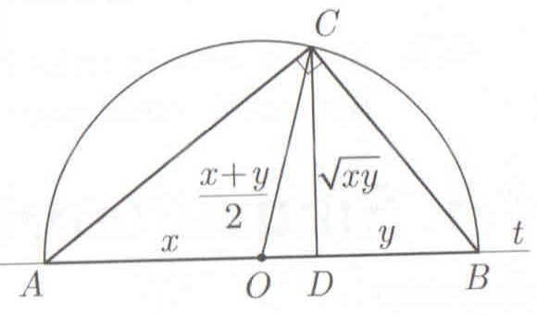What conclusions about mathematical relations among *a, b, c, ac, bc, hc* can be drawn?

**Hometask:**Using right triangle prove the inequality .

**Right triangle (answers)**

* + - 1. What types of triangles can you find in the figures?
    1. isosceles obtuse triangle b) regular (equilateral) tr.



c) isosceles right triangles d) scalene obtuse triangles



e) isosceles right triangle f) isosceles obtuse triangle



* + - 1. Fill in the gaps!

1. A triangle where one of its interior angles is a right angle (90 degrees) is called a right triangle.
2. The side opposite the right angle is called a hypotenuse .
3. Hypotenuse will always be the longest side of a right triangle.
4. The two sides that are not the hypotenuse are called legs.
5. They are the two sides making up the right angle.
6. A right triangle can also be isosceles if the two legs are equal in length.
7. The leg opposite to 30 degrees angle is a half of the hypotenuse in length.
8. The sum of the squares of the lengths of the legs equals the square of the length of the hypotenuse .
   * + 1. Match the notion and its description or definition!

1. – C

2. – A

3. – D

4. – B

**4**. Match the following terms and elements from the given figure:

|  |  |
| --- | --- |
| hypotenuseAB | CD |
| opposite leg to angle α BC | AB |
| adjacent leg to angle αAC | AD |
| heightCD | AC |
| projection of the opposite leg to the hypotenuseBD | BC |
| projection of the adjacent leg to the hypotenuseAD | BD |

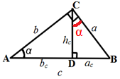

* + - 1. How many right triangles can you find in the figure?3

Can you find similar triangles there? How many pairs? Why are they similar?

3 pairs: ∆ACD ~ ∆CBD

∆ACD ~ ∆ABC

∆BCD ~ ∆BAC according to similarity test AA

What conclusions about mathematical relations among *a, b, c, ac, bc, hc* can be drawn?

 or 

 or  or 



