LESSON PLAN

Subject: Mathematics

Topic: Circle

Age of students: 16

Language level: B1, B2

Time: 60 min

Contents aims:
After completing the lesson, the student will be able to:
Define circle, angles and line segments in circle.
Formulate mathematical relations about circle.
Calculate the area of an circle.
Solve practical tasks concerning circle.

Language aims:
After completing the lesson, the student will be able to:
Use new vocabulary within the topic.
Interpret and communicate mathematics.

Pre-requisites:
- Properties of angles in circle;
- Properties of line segments in circle.

Materials: Worksheet “Circle”.

Procedure steps:
- Students do the exercise 1 in pairs.
- Students read, listen and compare.
- Students do the exercise 2 in pairs.
- Students read, listen and compare.
- Students do the exercise 3 individually.
- Students read, listen and compare.
- Students do exercises from 4 to 7 in pairs.
- Students read, compare and explain their point of view.

Attachment:
Circle
- What are the following elements in the figure:
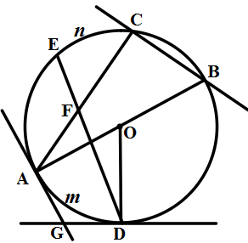
CB –
AC –
AB –
OD –
GD, GA –
ᴗAD –

- Fill in the table:
The property | The name/explanation of the property
AB =
GD =
< ACB =
< ODG =
< AOD =
< GDE =
< AGD =
< DFA =

- What can be worked out using formulae S = πR² and C = 2πR?
Write down the formulae for radius if
- the area of a circle is given;
- the circumference is given!

- To make a cloak for masquerade, there were drawn two concentric circles on a rectangular piece of cloth, sized 1,20×1,20m. The shortest circumference should coincide with the size of the head circumference -45 cm. Solve how long red ribbon should we buy to sheathe (apšūt) the bottom part. What is the radius of the shortest circumference?

- The tablecloth is a circle with the radius 1,60 m. Can we cover a round table with the diameter 2,6 m, so that it covered the whole surface and not more than 20 cm wide side round the table edge?

- We have to put on a round table a quadratic crocheted doily. How long should the coil side be so that the edge reached the edge of the table?

- Confectionery factory is baking a round cake the radius of which is 15 cm. The base of the cake box is a square. What is the size of the square, if the cake should be 5 cm from the edge of the box?

