**LESSON PLAN**

**Subject:** Mathematics

**Topic:** The area of triangle

**Age of students:**16

**Language level:** B1, B2

**Time:** 45 min

**Contents aims:**

After completing the lesson, the student will be able to:

Describe what the area of the triangle is.

Determine different formulas of triangle area.

Work out the area of a triangle.

**Language aims:**

After completing the lesson, the student will be able to:

Use new vocabulary within the topic.

Interpret and communicate mathematics.

**Pre-requisites:**

* Types and properties of triangles;
* Formulae for the area of triangle.

; ; ; ; 

**Key words:** triangle, area of triangle, side of triangle, height.

**Materials:** Worksheet “Area of the triangle”.

**Procedure steps:**

1. Students do the exercise 1 in pairs.
2. Students read and compare.
3. Students do the exercise 2 in pairs.
4. Students read and compare the results.
5. Teacher reads the tasks of game „Bingo”, students solve them and search the answers in the table.

**Attachment:**

**Area of the triangle**

* + 1. Write down all the possible formulae for calculating the area of a triangle!
    2. Work out the area of the given triangles! Choose the correct answer!

Complete the table!

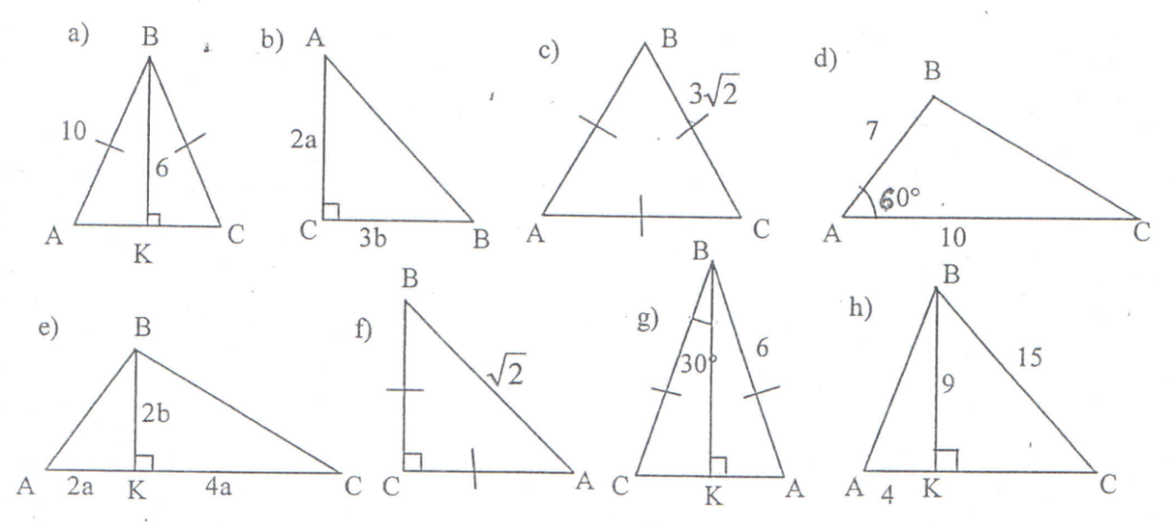

|  |  |  |  |
| --- | --- | --- | --- |
|  | 5) 6ab | 9) 72 | 13) 3ab |
|  | 6) | 10) 2a + 3b | 14) |
|  | 7) | 11) 1 | 15) |
| 1. 128 | 8) 12ab | 12) 48 | 16) |

|  |  |  |  |  |  |  |  |  |
| --- | --- | --- | --- | --- | --- | --- | --- | --- |
| Number of the task | a | b | c | d | e | f | g | h |
| Number of the answer |  |  |  |  |  |  |  |  |

**BINGO**

1. If the longest side of the right isosceles triangle is , its area is … 18
2. If each side of the triangle is 4, its area is … 
3. If the sides of the triangle are 5cm, 12cm and 13 cm, its area is … 30cm2
4. If the area of the triangle is 12 and its longest side is 6, its shortest height is … 4
5. If sides of the triangle are 5m, 6m and 7m, its area is … m2
6. If two sides of the triangle are 4cm and 5cm and angle between them is 30°, its area is … 5 cm2
7. If an angle of the triangle is 45° and its adjacent sides are 8 cm and 1,5 dm, its area is …  cm2
8. If the area of the equilateral triangle is , its side is … 6
9. If the legs of the right triangle are 2 cm and  cm long, the height to the hypotenuse is … cm
10. If a leg in the right triangle is 12 cm and its area is cm2, the other leg is … cm

|  |  |  |  |  |
| --- | --- | --- | --- | --- |
| m2 | 3 dm | 7 | cm2 | 13 |
| 6 | 30cm2 | 12 cm |  | 5 cm2 |
| 45m2 | 14 dm2 | cm |  | 3m |
| 8 cm | 18 | 10cm2 | 4 | 14 |
| 2 | cm | 1 m | 20 cm | cm2 |

**Hometask:** Draw three different triangles (of different types) and solve their area.

**Area of the triangle (answers)**

* + 1. Write down all the possible formulae for calculating the area of a triangle!

; ; ; ; 

1. Work out the area of the given triangles! Choose the correct answer! Complete the table!



|  |  |  |  |
| --- | --- | --- | --- |
|  | 5) 6ab | 9) 72 | 13) 3ab |
|  | 6) | 10) 2a + 3b | 14) |
|  | 7) | 11) 1 | 15) |
| 1. 128 | 8) 12ab | 12) 48 | 16) |

|  |  |  |  |  |  |  |  |  |
| --- | --- | --- | --- | --- | --- | --- | --- | --- |
| Number of the task | a | b | c | d | e | f | g | h |
| Number of the answer | 12 | 13 | 1 | 2 | 5 | 7 | 3 | 9 |

**BINGO**

|  |  |  |  |  |
| --- | --- | --- | --- | --- |
| m2 |  |  |  |  |
| 6 | 30cm2 |  |  | 5 cm2 |
|  |  | cm |  |  |
|  | 18 |  | 4 |  |
|  | cm |  |  | cm2 |