LESSON PLAN

Subject: ICT

Topic: How to set up Wordpress blog PART 1

Age of students: 15/16

Language level: B1

Time: 45 minutes

Content aims:
After completing the lesson, the student will be able to:
Describe the Wordpress blogs.
Define Wordpress themes and Wordpress plugging.
Explain the use of blogs.
Access Wordpress quick installation and go through it step by step.
Demonstrate practical experience in setting up Wordpress blog.
Finalize Wordpress blog setup.

Language aims:
After completing the lesson, the student will be able to:
Explain the process of Wordpress installation.
Discuss with pupils what he or she would like to blog about and why.

Pre-requisites:

Pupils have learned about using browsers.

Also previously we set up basic Wordpress installation for each pupil.

Materials: Materials needed:
Computer or tablet computer for each pupil.

Wi-fi network for pupils to use during practical part of this lesson.

Assessment:
The pupils are to be assessed based on their participation in activities. The writing task in handout 2 is to be assessed as a writing skill task. Assessing writing task:
1 Little organization is apparent; the task has little structure and the argument is poorly developed.
2 Some organization is apparent; the task has some structure, although it is not sustained. The argument has some development.
3 The task is organized, and the structure is generally coherent. There is some development of the argument.
4 The task is well organized; the structure is mostly coherent and the argument is clearly developed.
5 The task is effectively organized; the structure is coherent and the argument is effectively developed.

Procedure steps:

1. Make copies of the handouts for each learner in the class

2. Ask pupils if they know what a Blog is. Explain what blog and blogging are all about. Ask them if they read any kind of blogs and if they do what are their favorites.

3. Discuss with pupils what they would like to blog about and why.

4. Exercise 1

Teacher distributes handout 1 to pupils. On handout 1 pupils have a short step by step tutorial on how to install and set up Wordpress blog by themselves. Teacher first demonstrates how to do it alone.

5. Teacher tells pupils to open previously created folders for each pupil in browser. Teacher then guides pupils through the process of Wordpress installation.

At the end of this exercise pupils should all be able to replicate this process and will have their own Wordpress set up.

6. After each pupil has set up his/her own Wordpress teacher explains what are Wordpress themes and Wordpress plugins.

7. Teacher shares handout 2 to pupils. On handout 2 pupils write a short text explaining what they would like to blog about and why.

8. After pupils finish writing what they want to blog about, teacher asks pupils to go to https://Wordpress.org/themes/ and browse for next 10 minutes and look for a free theme that they want to use for their blog.

9. When each pupil has selected their favorite theme teacher demonstrates how to install Wordpress themes on. After that he guides pupils while they repeat the process of installing their selected Wordpress theme.

Handout 1:

1 | 2
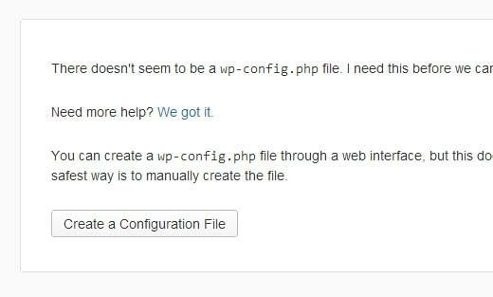  Click on the button to create the configuration page. The next screen will show you the information you need to have (database name, database username and password, database host, and table prefix). Simply click on the Let’s go button. Next you will see the form to enter all the information. | 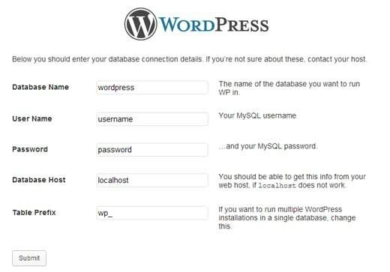  Once you enter the information, click on the submit button. It will take you the page that has the button to Run the Install. Click on it.
3

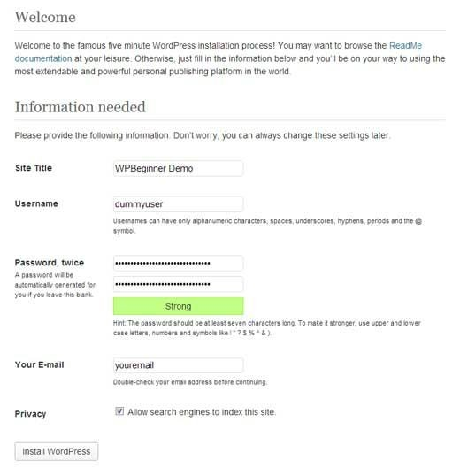

On the this screen, you will see the form to enter your website’s information. This information

would be your site’s title, your username, password, and email.

HANDOUT 2

Read the text and use all resources available on the net to write a small review:

TASK:

What would you like to blog about and why?

