LESSON PLAN

Subject: ICT
Topic: QR CODES
Age of students: 15/16
Language level: B1
Time: 45-60 minutes

Content aims:
After completing the lesson, the student will be able to:
Describe features of OR Codes.
Explain the use of QR Codes.
Download and install QR software to mobile device (laptop and mobile phone)
Scan and recognize an example of QR Code.
Analyze how QR Codes can be used.
Evaluate his or her practical experience using QR codes.
Create a QR Code.

Language aims:
After completing the lesson, the student will be able to:
Use correctly new vocabulary about QR codes.
Write a summary.
Express a personal opinion about the possible future of QR CODES.

Pre-requisites:
Pupils have learned about using browsers although we do not advise using mobile phones in classroom usually, this time let's make an exception, ask pupils to bring a smartphone to classroom and have one ready yourself.
Materials:
Materials needed:
Enough mobile phones with QR code reader
Optional: wi-fi network for pupils to use in order to download a QR code reader (if not enough are available create groups of pupils)
Assessment:
The pupils are to be assessed based on their participation in activities.
The writing task in handout 2 is to be assessed as a writing skill task;
Assessing writing task:
1 Little organization is apparent; the task has little structure and the argument is poorly developed.
2 Some organization is apparent; the task has some structure, although it is not sustained. The argument has some development.
3 The task is organized, and the structure is generally coherent. There is some development of the argument.
4 The task is well organized; the structure is mostly coherent and the argument is clearly developed.
5 The task is effectively organized; the structure is coherent and the argument is effectively developed.

Procedure steps:
1. Make copies of the handouts for each learner in the class.
2. Show the QR Code (display it for all to see) - Discuss Anyone seen/used this? What do you think it is? How can QR be used? What applications can be used for?
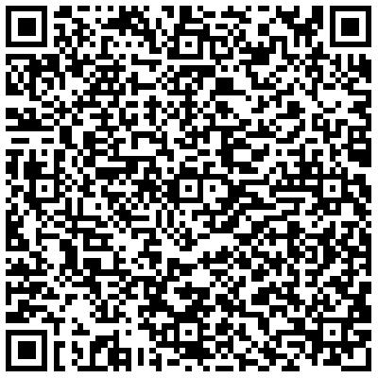
3. Exercise 1
Teacher distributes handout 1 to pupils. They have to scan the QR code and write down some facts about QR codes:
QR codes let you share messages quickly. QR means Quick Response.
You can scan them with a phone or tablet. They contain hidden links or messages.

4. Teacher tells pupils to open www.goqr.me in their browsers and create a QR code with a geolocation of several important locations in their town. Teacher brainstorms with pupils what would be some interesting places they would show their friends from abroad.
Also, teacher writes on the blackboard the terms- longitude and latitude- and ask pupils to define them.
A web quest game is to create the QR code (pupils can organize themselves in groups)- the winner is the group which manages to find the longitude and latitude of their places and manages to create a QR code that works. (it can be done easily in google maps, longitude and latitude appear in the browser and then it can be entered in QR code generator)
5. Teacher shares handout 2 to pupils, there are two separate articles so they should be evenly distributed. Pupils have a task to put into a word file what the future of QR CODES might be based on what they have read.

Handout 1:
1  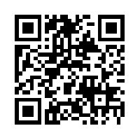 | 2  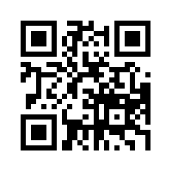
3  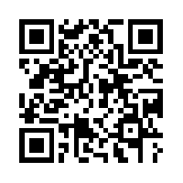 | 4  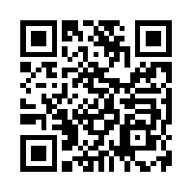

Handout 2:
Read the text and use all resources available on the net to write a small review:
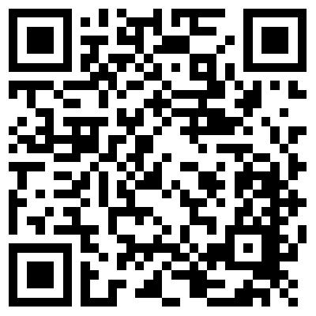
TASK:
Put into your own words what the future of QR CODES might be.
________________________________________________________
Read the text and use all resources available on the net to write a small review:

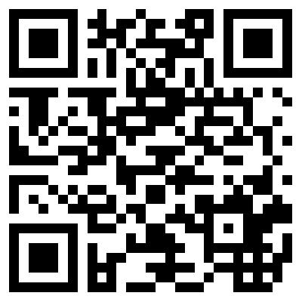
TASK:
Put into your own words what the future of QR CODES might be.

