LESSON PLAN

Subject: IT (Information Technology) and ICT(Information and Communication Technologies).

Topic: Introduction to basic parts of computer

Age of students: 16/17

Language level: B1

**Content aims**

After completing the lesson, the student will be able to:

Identify the basic parts of computer.

State the basic components of a computer and the computer peripheral devices.

List functionalities that the peripheral devices provide.

Explain the difference between the basic components of a computer and computer peripheral devices.

Demonstrate how to behave in the computer lab.

**Language aims**

After completing the lesson, the student will be able to:

Use essential vocabulary about basic parts of computer.

Use correctly new vocabulary through images and definitions.

Explain how to behave in the computer lab.

# Materials:

**Materials needed**

The basic components of a computer and the computer peripheral devices.

**Optional materials**

Network to access the Internet

# Organization of lesson:

**Introduction**

Teacher asks students questions:

* What are peripheral devices of a computer?
* What functionalities are provided by the peripheral device connects to a computer?
* What are some examples of computer peripheral devices?
* What is different between the basic components of a computer and computer peripheral devices?

**Procedure**

Lead-in:

* Teacher tells the students what the computer peripherals are.
* Teacher informs about types of peripheral devices.
* Teacher shows examples of the computer peripheral devices and the basic components of a computer.

Practice/task:

* Emphasize on the rules and regulation inside the computer lab.
* Teacher gives student printed materials (student handout).
* Teacher states and shows the basic parts of computer (component, peripheral devices of a computer).
* Teacher defines and demonstrates each of the basic parts of computer. Students shows each component in the open computer chassis.
* Teacher gives out the student material handout sheet and explains how to do tasks (student handout).

**Summary**

After finishing the lesson, student should know:

* What are the computer peripheral,
* Define the roles and the functionalities peripheral device connects to a computer,
* How to behave in the computer labs.

## Student handout

**FIRST TASK**

Identify and name the basic parts of computer:

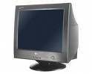

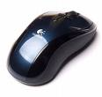

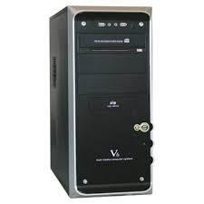

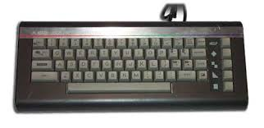

✁

**Second task**

Match the correct answers with picture

|  |  |  |
| --- | --- | --- |
| MONITOR | ⚫ ⚫ | MOUSE |
| SYSTEM UNIT | ⚫ ⚫ | ergonomic-computer-keyboard_~TEC_008 |
| MOUSE | ⚫ ⚫ | Monitor |
| KEYBOARD | ⚫ ⚫ | SYSTEM UNIT |