LESSON PLAN

Subject Art History

Topic Pablo Picasso's styles

Age of students 17/18

Language level B1

Time 2x45/60 minutes

Contents aims
After completing the lesson, the student will be able to:
Recognize Picasso's paintings.
List the elements of Cubist style.
Define the term Bohemianism.
Compare the styles Picasso used.
Draw parallels between Picasso's Blue and Rose Period.
Analyze Guernica and draw connections to historical events.
Write the critical review of the painting.

Language aims
After completing the lesson, the student will be able to:
Use new voacabulary in expressing his/her opinion about paintings.
Describe attitudes toward Picasso's styles.

Pre-requisites
Students have learned about Spanish Civil War in History
Students know the main features of art movements of the late 19th century: Symbolism, Impressionism (in particular Paul Cézanne). They have understood the importance of the crisis of the naturalistic approach to reality representation.
Students know about the birth of Avanguarde movements in the early 20th Century

Materials
Paper images/images of paintings from the Internet
handouts
A computer connected to the Internet and a projector (optional)

Procedure steps
1 Make copies of the handouts for each learner in the class and prepare a stack of sticky notes to handout in class.
2 If necessary, simplify the language of the text (Deller & Price, 2008) depending on the level of the class.

Lesson Procedure
1. Introduction activity (10 Minutes)
Purpose: To activate prior knowledge
Description: teacher shows pupils the painting Bathers (Attachment 3) by Pablo Picasso and ask them to try to guess who painted it. It is not likely pupils will recognize the painting so teacher shows the next painting in cubist style (Attachment 4, Dora Maar Au Chat). It is likely many pupils will recognize the painting as Picasso's work. Teacher tells pupils that today they are going to learn about Picasso and that Cubism is not the only style he used.
2. Reading activity (15 minutes)
Distribute handout 1 to all pupils.
Ask pupils to circle the correct choice in the first exercise, then to check their answers in the text.
Pupils read the text and the teacher helps them with unknown words. If there are more unknown words than in the glossary pupils add the words they do not know on the handout.

3. Ask pupils to check their answers in the first exercise

4. Handout 4 activity-writing
Teacher shows pupils Guernica and tells them to write a reflection without using more information than there is in handout 1 and what they personally feel when they look at the painting.

How does this painting suggest a war scene?
Picasso painted this during a war. Do you know which war it is about?
What reaction did the painter want to arise in making his work so dramatic?
Do the animals and objects depicted have a special meaning?
The painting is quite monochromatic: how does this color choice affect the mood?
Does the painting date back to the years of Cubism and its future developments?
Are there formal elements reminding of Cubist art?
Who was the painting commissioned by and where was it displayed?

Attachment * Classroom handout 1 & 2

Assessment grid
Formative assessment:
Oral Questioning at the beginning
Choosing correct statements
Post reading quiz

Assessing writing task:
1 | Little organization is apparent; the task has little structure and the argument is poorly developed.
2 | Some organization is apparent; the task has some structure, although it is not sustained. The argument has some development.
3 | The task is organized, and the structure is generally coherent. There is some development of the argument.
4 | The task is well organized; the structure is mostly coherent and the argument is clearly developed.
5 | The task is effectively organized; the structure is coherent and the argument is effectively developed.

ATTACHMENT 1

1. How much do you know about Pablo Picasso? Choose the correct alternative.

A. Picasso invented ❏ collage ❏ Fauvism
B. The style he was most famous for is called ❏ Pointillism ❏ Cubism
C. His most famous anti-war painting is called ❏ Guernica ❏ Les Demoiselles d'Avignon
D. Picasso's paintings ❏ are ❏ aren't organized according to the Renaissance prospective rules.
E. The main paintings by Picasso were painted in ❏ the second half of the 19th century ❏ the first half of the 20thcentury
F. Picasso's art was influenced by ❏ Paul Cézanne' s ❏ Dora Maar's art.

2. Read the article about the Picasso and check your answers:

Picasso's styles
Pablo Picasso was the most dominant and influential artist of the first half of the twentieth century. Associated most of allStarklyStarkly with pioneering Cubism, alongside Georges Braque, he also invented collage and made major contributions to Symbolism and Surrealism. He saw himself above all as a painter, yet his sculpture was greatly influential, and he also explored areas as diverse as printmaking and ceramics. Finally, he was a famously charismatic personality; his many relationships with women not only filtered into his art but also may have directed its course, and his behavior has come to embody that of the bohemian modern artist in the popular imagination.
Picasso first emerged as a Symbolist influenced by the likes of Edvard Munch and Henri de Toulouse-Lautrec. This tendency shaped his so-called Blue Period, in which he depicted beggars, prostitutes, and various urban misfits, and also the brighter moods of his subsequent Rose Period.
It was a confluence of influences - from Paul Cézanne and Henri Rousseau, to archaic and tribal art - that encouraged Picasso to lend his figures more weight and structure around 1906. And they ultimately set him on the path towards Cubism, in which he deconstructed the conventions of perspectival space that had dominated painting since the Renaissance. These innovations would have far-reaching consequences for practically all of modern art, revolutionizing attitudes to the depiction of form in space.
Picasso's immersion in Cubism also eventually led him to the invention of collage, in which he abandoned the idea of the picture as a window on objects in the world, and began to conceive of it merely as an arrangement of signs that used different, sometimes metaphorical means, to refer to those objects. This too would prove hugely influential for decades to come.
Picasso had an eclectic attitude to style, and although, at any one time, his work was usually characterized by a single dominant approach, he often moved interchangeably between different styles - sometimes even in the same artwork.
His encounter with Surrealism in the mid-1920s, although never transforming his work entirely, encouraged a new expressionism that had been suppressed throughout the years of experiment in Cubism and subsequently during the early 1920s when his style was predominantly classical. This development enabled not only the soft forms and tender eroticism of his portraits of his mistress Marie-Therese Walter, but also the starkly angular imagery of Guernica (1937), the century's most famous anti-war painting.
Picasso was always eager to place himself in history, and some of his greatest works, such as Les Demoiselles d'Avignon (1907), refer to a wealth of past precedents - even while overturning them. As he matured he became only more conscious of assuring his legacy, and his late work is characterized by a frank dialogue with Old Masters such as Jean-Auguste Dominique Ingres, Diego Velazquez, Francisco Goya, and Rembrandt van Rijn.
Glossary

Diverse Conventions Immersion Interchangeably Encounter
Starkly Frank

3. Match the words (1-6) from the text on p1 to the definitions (a-f) (There is an extra one)
1.______ Cubism | 2.______ Symbolism | 3.______ Surrealism | 4.______ precedents
5.______ legacy | 6.______ bohemianism | 7.______ Eclecticism | 8.______ Collage
A A late nineteenth-century art movement of French, Russian and Belgian origin in poetry and other art
B Going or coming before; preceding
C One of the most influential visual art styles of the early twentieth century. It was created by Pablo Picasso
D Anything handed down from the past, as from an ancestor or predecessor
E Tendency to welcome and merge together different styles and attitudes.
F The practice of an unconventional lifestyle, often in the company of like-minded people
G A cultural movement that began in the early 1920s, and is best known for its visual artworks and writings
H A late nineteenth-century art movement in Italy stating the importance of representing nature through tiny color spots.
I Use of different materials in the painting process.

4. WRITING TASK
Write a review (about 120 words) of the painting:

Use the questions below:
- How does this painting suggest a war scene?
- Picasso painted this during a war. Do you know which war it is about?
- What reaction did the painter want to arise in making his work so dramatic?
- Do the animals and objects depicted have a special meaning?
- The painting is quite monochromatic: how does this color choice affect the mood?
- Does the painting date back to the years of Cubism and its future developments?
- Are there formal elements reminding of Cubist art?
- Who was the painting commissioned by and where was it displayed?

ATTACHMENTS (Either shown on paper or projected on a classroom wall)

ATTACHMENT 1
1. How much do you know about Pablo Picasso? Choose the correct alternative.
A. Picasso invented ❏ collage ❏ Fauvism
B. The style he was most famous for is called ❏ Pointillism ❏ Cubism
C. His most famous anti-war painting is called ❏ Guernica ❏ Les Demoiselles d'Avignon
D. Picasso's paintings ❏ are ❏ aren't organized according to the Renaissance prospective rules.
E. The main paintings by Picasso were painted in ❏ the second half of the 19th century ❏ the first half of the 20thcentury
F. Picasso's art was influenced by ❏ Paul Cézanne' s ❏ Dora Maar's art.

ATTACHMENT 2
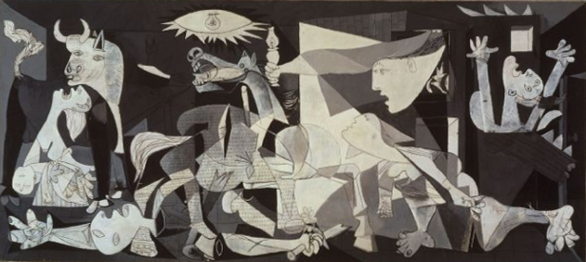 |  | Pablo Picasso, Guernica, 1937.l  Oil on canvas, 349,3x776,6 cm. Madrid, Centro de Arte Reina Sofia.
ATTACHMENT 3 | ATTACHMENT 4
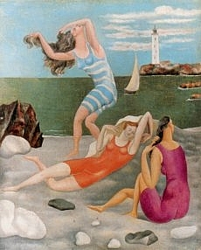  Pablo Picasso, Bathers, oil on canvas, 122x27 cm. Parigi, Musée Picasso | 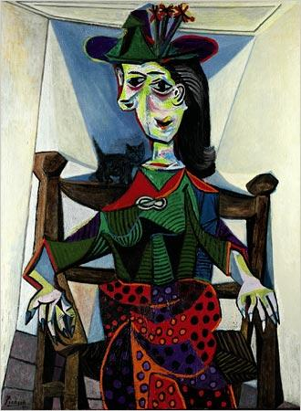  Pablo Picasso, Dora Maar with Cat, 1941

